Total word count excluding headline and tagline: 604
Spring is on its way ---- OK, need a better headline
Spring has not quite sprung, but it is coiled and ready. March 20 is the official calendar day when winter makes its exit, making room for the warm days, cool breezes, and fresh smells that tells us life is beginning its next cycle.
While we still have some days of winter-like temperatures to come, signs of spring are beginning to show here and there. I’ve been trying to act like a naturalist, and have been taking walks around my place studying the plants, and listening for sounds of insects, birds, and other animals.
The oak trees have tell-tale signs of buds, and even the pinkish white blossoms of the dogwood are visible within their buds. The buds seem sporadic. Not all trees have released their buds, as if they know a cold snap is still on the horizon.
The American Beautyberry is following the same pattern. Depending on whether the plant is deep in shade, or out in the open, seems to determine whether buds are developing. I noticed that the bushes I saw in the protective shade of trees have more buds than the bushes under full sun.
The tiny, delicate purple flowers of what I believe to be a Blue Field Madder are the first wildflowers I’ve seen bloom. They grow sporadically within the bluestem and my stand of blue grama.
The brown clumps of bluestem have green sprigs shooting up from the middle. And, of course, that first flush of weeds has popped up everywhere. I noticed the other day while driving through a Rockdale neighborhood that lots of people had really green lawns. Upon closer inspection the green turned out to be clover – that perennial harbinger of spring.
However, it’s not just the plants that are ready for spring. That lightness of the air triggers something within the animal-folk, including us, getting the metabolism jump started for all those things that spring brings.
Take the skunks, for example. I don’t know if anyone else has noticed, but it seems lately that every time I drive down the highway, I smell a skunk. They are in the middle of their breeding season, and so are on the move.
March is the popular breeding time for most animals. Some include animals featured previously in this column, like raccoons, ringtails, bobcats, cardinals, and mourning doves. Coyotes are at the tail-end of their breeding season.
As a matter of fact, I’ve seen a particular coyote cross the highway in the early morning on two separate occasions within the past week. Everyone’s out and about, and not too particular about being seen.
Frogs are also beginning their breeding season. As the nights move above fifty degrees, you will begin to hear them calling at night.
Early mornings are good times to listen for birds. Cardinals and Mourning Doves have become more vocal, and I’m actually hearing them almost continually throughout the day. I’ve also seen robins, mainly in fields pecking through the grass.
Mid-afternoon things seem to die down, except for the leaf-cutter ants. Their movements are quick and sure. Just a few weeks ago, if they dared venture out, they were sluggish, suffering from the torpor of hibernation.
Just yesterday as I was working in the garden, a yellow butterfly flew past my face. This is a good time to consider making a part of your yard butterfly-friendly, by planting natives like salvia, blue mist flower, and butterfly weed.
March is prime time for bird migrations. If you are interested in bird watching, here is a checklist of birds found in our area from TPWD: http://www.tpwd.state.tx.us/publications/pwdpubs/media/pwd_bk_w7000_0869.pdf. Another good one about migration in general: http://www.tpwd.state.tx.us/publications/pwdpubs/media/pwd_bk_w7000_0511.pdf.
+++++++++++++++++
walton.shawn@gmail.com; El Camino Real Master Naturalists: grovesite.com/tmn/ecrmn

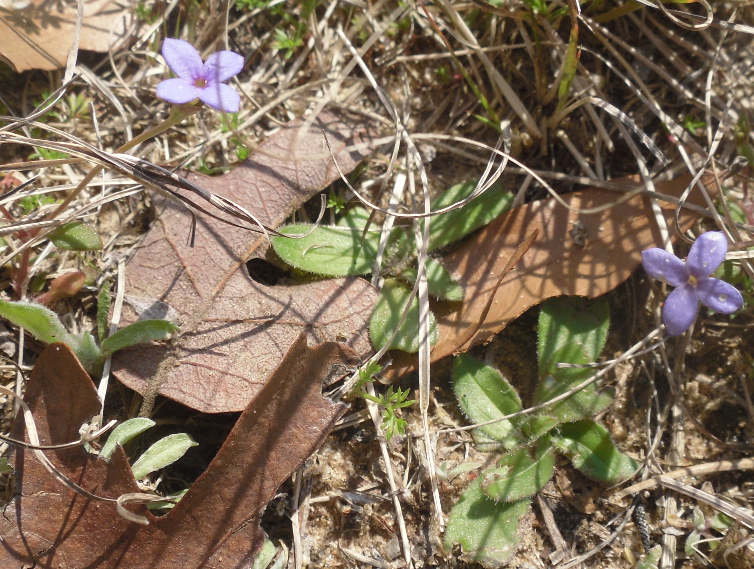
Is this Blue Field Madder?

