Corn Snake

Elaphe guttata

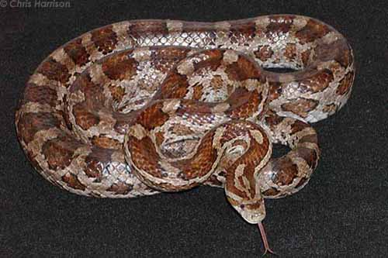
Photo by Chris Harrison, http://www.birdsandherps.com/bvsnakes/eguttata.html

DESCRIPTION

- Texas corn snakes are tan, grayish-tan, or orangish-tan
- Large brown to reddish-brown dark-edged blotches down the center of the back, below which is another row of smaller alternating blotches, followed by a third series of even smaller dots at the belly line
- black and white underbelly
- Adults grow to 3 to 4 feet.

LIFE CYCLE

- Breed after the first winter cooling.
- Egg-laying occurs slightly more than a month after mating, with 12–24 eggs deposited into a warm, moist, hidden location.
- Mother snake abandons the eggs and does not return to them.
- Approximately 10 weeks after laying, the young snakes use a specialized scale called an egg tooth to slice slits in the egg shell, from which they emerge at about 5 inches in length.
- Live 6-8 years in the wild.

BEHAVIOR

- Subdues its small prey by constriction.
- The name “corn snake” refers to the days when southern farmers stored harvested corn in a wooden crib. Rats and mice came to the crib to feed on the corn and the snakes came to feed on the rodents.

HABITAT

- Overgrown fields, forest openings, trees, abandoned buildings.
- Do not usually inhabit wet bottomlands.
- Usually remain on the ground, but can climb trees and cliffs.

FOOD

- Rats and mice.

SOURCES

- http://en.wikipedia.org/wiki/Corn_snake
- http://www.birdsandherps.com/bvsnakes/
- Texas Snakes; a Field Guide, James R. Dixon and John E. Werler, UT Press, Austin, 2005, pp. 134-137.

