Diamond-backed Watersnake

Nerodia rhombifer

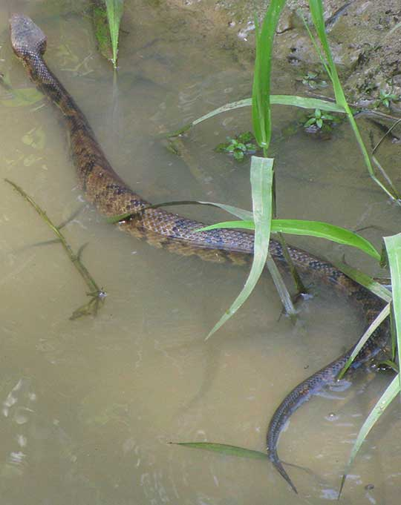
Photo by Jim Conrad, backyardnature.net

DESCRIPTION

- Light brown, yellowish or olive.
- Short dark crossbars down the middle of the back alternate with vertical lateral bars.
- Heavy-bodied.
- Head is wide, somewhat flattened and clearly wider than neck.
- Adult averages 4-6 feet.
- Non-venomous.

LIFE CYCLE

Ovoviviparous; give birth to live snakes.
Breed in spring; give birth in late summer or early fall

BEHAVIOR

- Very shy and will try to flee if startled or approached.
- Water is their preferred escape route and sanctuary.
- Will emit a foul smelling musk odor if caught.

HABITAT

- Close to or in water; prefers slow-moving water.
- Will take up residence in backyard fish ponds.

FOOD

- Fish
- Frogs, toads and other small amphibians

SOURCES

- http://www.austinreptileservice.net/diamonds.html
- http://www.birdsandherps.com/bvsnakes/
- Texas Snakes; a Field Guide, James R. Dixon and John E. Werler, UT Press, Austin, 2005, pp. 215-216.
- http://en.wikipedia.org/wiki/Nerodia_rhombifer
- http://www.backyardnature.net/n/a/nerodia2.htm

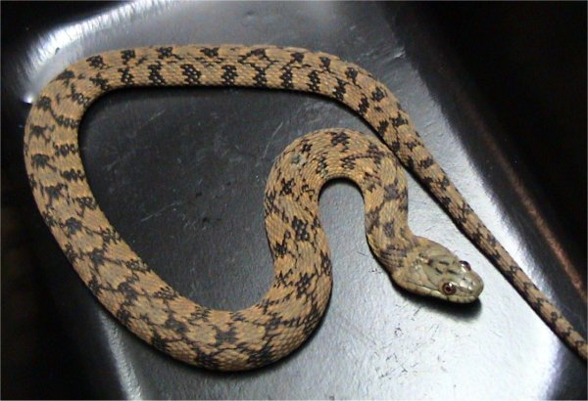
Source: Wikipedia

