Eastern Hognose Snake

Heterodon platirhinos

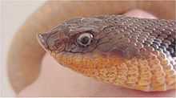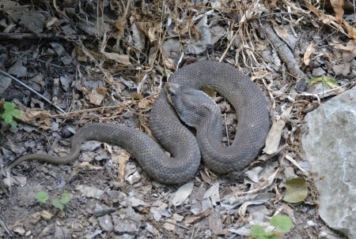

Source: Wikipedia Source: Balconesherping.com

DESCRIPTION
- Brown blotches on a background of various shades of red, gray, green, brown or yellow.
- Belly can be solid grey, yellow or cream colored.
- Easily recognized by its upturned snout.
- Males average 2 feet; females up to 4 feet.
- Stocky body, head somewhat wider than neck.
- Rear-fanged - venom is delivered by a pair of fangs in the rear of the mouth.

LIFE CYCLE
- Mate in April and May.
- Females lay 8-40 eggs in June or early July, but do not take care of the eggs or young.
- Eggs hatch from late July to September.

BEHAVIOR
- This snake will flare its head and neck to resemble a cobra’s hood and hiss very loudly.
- If this doesn’t work, it will roll over with its mouth open and “play dead.”
- Snout allows them to burrow easily into the soil for shelter or to seek their prey.
- Not considered dangerous to humans because they are not inclined to bite.
- Overwinters in burrows.

HABITAT
* Habitats with loose soil and amphibian prey.

FOOD
- Almost exclusively feeds on toads.
- May also eat other amphibians, like frogs and salamanders.
- Young snakes may eat crickets and other insects.

SOURCES
- http://www.austinreptileservice.net/blotches.html
- Chris Harper presentation to ECRC
- http://www.birdsandherps.com/bvsnakes/
- http://en.wikipedia.org/wiki/Heterodon_platirhinos
- http://bugsinthenews.com/Texas%20Snake%20Web/eastern_hognose_snake_web.htm
- http://www.austinreptileservice.net/blotches.html
- http://www.iucnredlist.org/details/63820/0

