Flat-headed (Flathead) Snake

Tantilla gracilis

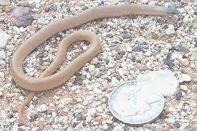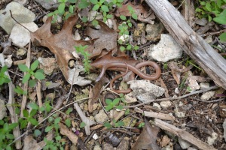

Source: Houstonherp.com Source: Balconesherping.com

DESCRIPTION

- Back is tan, yellowish brown, or reddish brown
- Unpatterned
- Head is a bit darker than body
- Belly is usually whitish with a pale salmon pink to coral red hue down its middle
- Head is moderately flattened, about the same width as the neck
- Snake is slender and 7-8 inches in length

LIFE CYCLE

- Females lay clutches of 1-4 eggs in late spring
- Young hatch in late summer or early fall

BEHAVIOR

- Described as a secretive burrower

HABITAT

- Favors habitats with loose, damp soil into which it can easily tunnel

FOOD

- Small insect larvae, scorpions, spiders, centipedes, sow bugs and snails

SOURCES

- http://www.birdsandherps.com/bvsnakes/
- Texas Snakes; a Field Guide, James R. Dixon and John E. Werler, UT Press, Austin, 2005, pp. 256-57.
- http://www.herpsofarkansas.com/Snake/TantillaGracilis
- http://www.herpsoftexas.org/content/flat-headed-snake
- Houstonherp.com
- https://webspace.utexas.edu/s681/webpage/LLSnakes2.html
- http://balconesherping.wordpress.com/

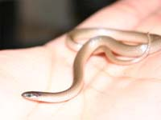

Source: https://webspace.utexas.edu/s681/webpage/LLSnakes2.html

