Plains Blind Snake

Leptotyphlops dulcis

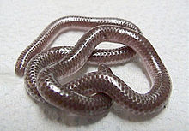
Source: Wikipedia

DESCRIPTION

- Solid pinkish-brown color, shiny.
- Adults average 8 inches; juveniles as small as 2-1/2 inches.
- They look like earthworms with tongues.
- Blunt head and stubby tail.
- Non-venomous.

LIFE CYCLE

- Mate in early spring
- Female lays 2-7 eggs in June or July and then coils around them
- Eggs hatch in late summer

BEHAVIOR

- Spend most of their time underground
- If handled, they squirm and try to poke the tip of their tail into the handler

HABITAT

- Arid to semi-arid regions
- Mostly underground in loose soil
- Emerge to feed or when their habitat floods after a rain
- Sometimes they enter a house in the spring through water pipes.

FOOD

- Ant and termite larvae

SOURCES

- http://www.austinreptileservice.net/solid.html
- http://en.wikipedia.org/wiki/Leptotyphlops_dulcis
- http://www.birdsandherps.com/bvsnakes/
- Texas Snakes; a Field Guide, James R. Dixon and John E. Werler, UT Press, 2005, pp. 78-79.
- http://animals.jrank.org/pages/3791/Slender-Blind-Snakes-Thread-Snakes-or-Worm-Snakes-Leptotyphlopidae-TEXAS-BLIND-SNAKE-Leptotyphlops-dulcis-SPECIES-ACCOUNT.html

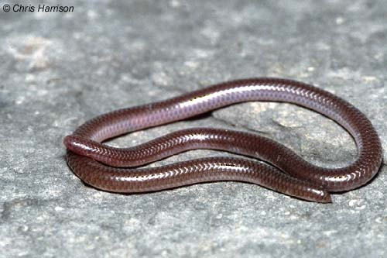
Photo by Chris Harrison

