Racer

Coluber constrictor
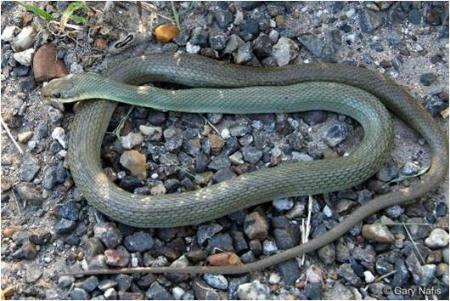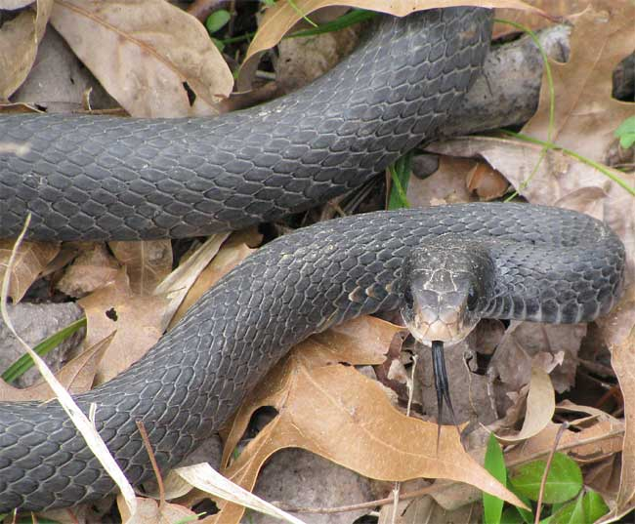
Photo by Gary Nafis Photo by Jim Conrad, http://www.backyardnature.net/n/a/racer.htm

DESCRIPTION
- Slender body
- Uniform pattern, solid color – brown, black, blue or green
- Lighter-colored belly
- Adults are typically 20 – 60 inches
- Non-venomous

LIFE CYCLE
- Mate in the spring, from April to early June
- About a month later the female lays 3-30 eggs in a hidden nest
- 8 – 10 inch juveniles hatch in early fall

BEHAVIOR
- Fast moving, highly active
- diurnal
- Nervous, flee from predators, but will strike or bite if captured
- Some will climb trees to eat eggs and young birds
- Not true constrictors, they subdue prey by pinning it down with one or two coils, rather than suffocating it.
- Curious, with excellent vision; sometimes raise their head above the grass to view what is around them.
- Rattling their tails in dry leaves, they can sound like rattlesnake

HABITAT
- Prefer open grasslands, but also light forest
- Common in suburban neighborhoods in brush, trash piles, roadsides
- Spends most of the time on the ground, but are good tree climbers

FOOD
- Small mammals
- Reptiles
- Amphibians
- Insects

SOURCES
- http://www.birdsandherps.com/bvsnakes/
- http://en.wikipedia.org/wiki/Coluber_constrictor
- http://www.backyardnature.net/n/a/racer.htm

