Rough Earth Snake

Virginia striatula
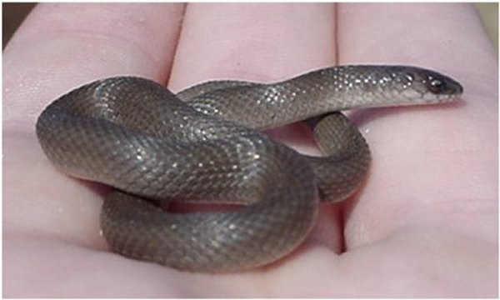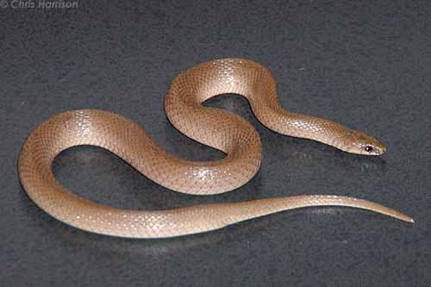
Photo by Adam Dawson, Austinreptileservice.net Photo by Chris Harrison, http://www.birdsandherps.com/bvsnakes/

DESCRIPTION

- Small brown unpatterned snake, usually 7-10 inches in length.
- Cone-shaped head.
- Non-venomous.

LIFE CYCLE

- Ovoviviparous, a mode of reproduction in which the embryos develop inside eggs, which are retained in the mother until they are ready to hatch, the unborn being nourished by egg yolk.
- Brood size is 3 – 8, with newborns being about 4 inches.

BEHAVIOR

- Harmless and not aggressive
- Defense is to defecate, making them less palatable to would-be predators

HABITAT

- Fossorial, burrowing into leaf litter, loose soil, or beneath rotting logs and other ground debris

- Habitats not prone to flooding
- Fares well in urban areas, along foundations, in gardens and cultivated soil.

FOOD

- Earthworms
- Soft-bodied arthropods
- Snails and slugs

SOURCES

- http://www.austinreptileservice.net/solid.html
- http://www.birdsandherps.com/bvsnakes/
- http://en.wikipedia.org/wiki/Virginia_striatula
- Texas Snakes; a Field Guide; James R. Dixon and John E. Werler, UT Press, 2005, pp. 292-93.

