Southern Copperhead
Agkistrodon contortrix

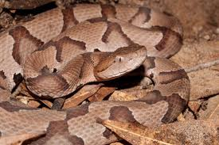
Photo by Bill Boothe, NatureInFocus.com
Reprinted with permission.

DESCRIPTION

- Pale brown to light tan body, pinkish tint.
- Series of dark bands on their backs, narrow across the back and wide on the sides – look like hour glasses when viewed from above.
- Heat-sensing pits between the eyes and nostrils.
- Bright yellow tale at birth, which fades as they age. Adults are usually 2-3 feet long.
- Venomous

BEHAVIOR

- Diurnal (active in daylight) in early spring and late fall.
- Nocturnal during summer heat.
- Hibernate in cold weather.

LIFE CYCLE

- Males are sexually mature at 2 years;
females at 3.
- Mating season is spring and fall.
- Incubation time 105-110 days.
- 4-8 young born live, 7-10” long, weighing less than an ounce.
- Females provide no parental care after birth.
- Lifespan 6-8 years.

HABITAT

- Mixed pasture and wooded lowlands, especially river bottoms.
- Present in wooded suburbs

FOOD

- Juveniles eat insects, small frogs and toads, fish, reptiles and rodents.
- Adults eat mostly rodents.
- Eat about every 3 weeks.

SOURCES
http://www.houstonherp.com/Copperhead.htm
http://www.tpwd.state.tx.us/huntwild/wild/species/southerncopperhead/
http://natureinfocus.com/galleries/fauna/reptiles/snakes/

!!! KATHERINE’S PHOTO !!!

