Texas Ratsnake, or Black Ratsnake

Elaphe obsoleta

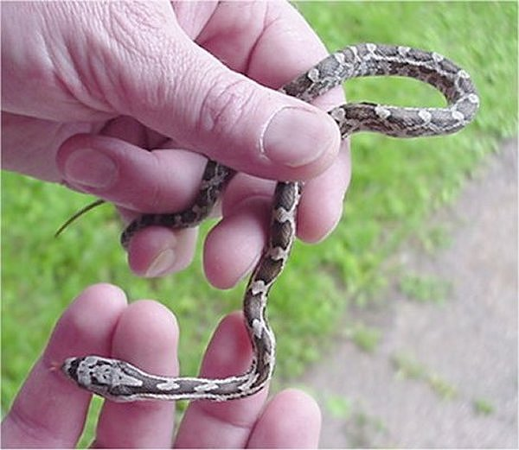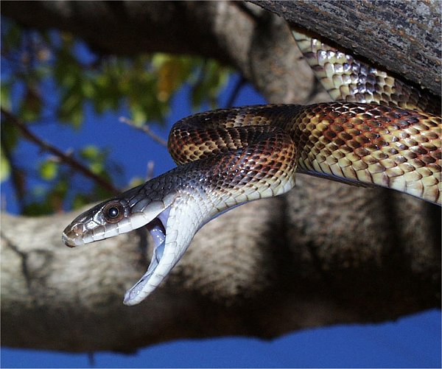
Photo by Adam Dawson (juvenile Texas Ratsnake) Photo by Steve Schwartzman
http://www.austinreptileservice.net/solid.html http://www.austinreptileservice.net/solid.html

DESCRIPTION
- Adult has dark gray to black blotches on a red, orange, yellow, or even white background. Juveniles have brown blotches on a gray background
- Slender but sturdy bodies, square heads, flat bellies
- Adults range from 4 to 6 feet long
- Non-venomous

LIFE CYCLE
Lifespan of 15 years
Mating occurs after emerging from hibernation in spring
Gestation is about 1.5 months
Females can lay up to 30 eggs

BEHAVIOR
- Mostly diurnal
- Very aggressive when cornered or captured, either coiling and rattling their tails in imitation of a rattler, or emitting a foul-smelling odor on their preators
- Constrictors
- Hibernate in cold months, usually with other snakes of the same or different species
- Non-venomous
- Excellent climbers, and will go into attics, barns, and under homes in search of prey

HABITAT
- rivers and streams
- heavily wooded areas

FOOD
- Any kind of rodent, especially mice and chipmonks
- Young birds and bird eggs.
- Fond of hen’s eggs, and for this reason is often incorrectly called a “chicken snake.”

SOURCES
- http://www.austinherpsociety.org/newsite/index.html
- Chris Harper PowerPoint presentation to ECRC
- http://en.wikipedia.org/wiki/Elaphe#Life_Cycle_and_Behaviors
- http://www.austinreptileservice.net/solid.html

