Texas Glossy Snake

Arizona elegans

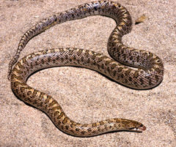
Source: Wikipedia

DESCRIPTION
- Overall hue is yellowish-tan to tannish red
- Dark-edged reddish-brown blotches down the center of back, contrasting with the paler background color
- On either side of the primary markings are two rows of smaller blotches
- Unmarked white abdomen
- Thin body, smooth scales, round pupils
- Adults range from 27 – 36 inches in length
- Non-venomous

LIFE CYCLE
- Oviparous, producing eggs that hatch outside the body.
- Breed in late spring and early summer
- Young hatch out in early fall
- Clutches average from 10-20 young

BEHAVIOR
- Nocturnal
- Stay in underground burrows during the day
- Pointed head allows them to burrow into loose soil quickly

HABITAT
- Habitat follows the Carrizo Sands geological formation, which runs southwest to northeast through Milam County
- Sandy soils, grasslands

FOOD
- Small mammals
- Lizards
- Other snakes

SOURCES
- Chris Harper Herpetology Slideshow to ECRC
- http://www.birdsandherps.com/bvsnakes/
- Texas Snakes; a Field Guide, James R. Dixon and John E. Werler, UT Press, Austin, 2005, pp. 90-91.
- http://en.wikipedia.org/wiki/Glossy_snake
- http://en.wikipedia.org/wiki/Arizona_elegans_arenicola

