Texas Long-nosed Snake

Rhinocheilus lecontei tesselatus

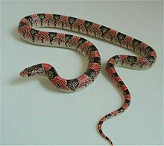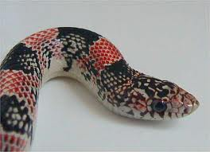
Source: Wikipedia Source: Wikipedia

DESCRIPTION
- Black, yellow-edged saddles alternate with red blotches, getting narrower until they come to blunt points on the belly. Cream-colored and black spots dot the sides and obscure the main pattern.
- Mostly black head tipped with long, pointed slightly upward-tilting red or pink snout, is speckled with yellow dots.
- 20 - 30 inches when full grown.
- Non-venomous

LIFE CYCLE
- Oviparous, laying clutches of 4-9 eggs in early summer
- Eggs hatch in late summer, early fall

BEHAVIOR
- Shy
- Nocturnal
- Burrowing
- Defense consists of releasing a foul smelling musk, or blood from the cloaca (posterior vent)

HABITAT
- Found over the western two-thirds of Texas
- Prefers dry habitats with sandy to gravelly soils

FOOD
- Lizards, amphibians
- Sometimes smaller snakes
- Infrequently, rodents

SOURCES
- http://en.wikipedia.org/wiki/Rhinocheilus_lecontei_tessellatus
- Texas Snakes; A Field Guide, James R. Dixon and John E. Werler, UT Press, Austin, 2005, pp.232-33.
- http://www.birdsandherps.com/bvsnakes/

