Texas Patch-nosed Snake

Salvadora grahamiae lineate

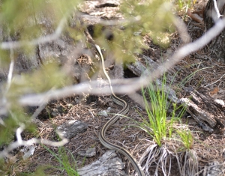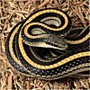

Photo by Thomas Marshall, balconesherping Photo by Adam Dawson

AustinReptileservice.net

DESCRIPTION
- Adults grow to 26-40 inches in length.
- Two dark lines run laterally down the length of the snake on a tannish background.
- Center lateral line is tan, orange, or yellow, but different from the tan sides of the body.
- Peach or cream colored belly.
- Enlarged rostral scale on its snout, for which it is named.
- Non-venomous

LIFE CYCLE
- Mating occurs in early spring, with clutches of eggs laid in May and June.
- Young hatch in August, measuring 10 inches.

BEHAVIOR
- Diurnal (active in daytime)
- Forage in the early morning for food.
- Emit a musk odor when threatened.

HABITAT
- Prairies, oak-juniper savanna, woodland-grassland-farmland mosaics, notably Blackland Prairie
- River and creek floodplains with rotting logs and decaying plants
- Terrestrial

FOOD
- Lizards, snakes and occasionally rodents.

SOURCES
- http://www.austinreptileservice.net/stripes.html
- http://www.herpsoftexas.org/content/eastern-patch-nosed-snake
- http://www.iucnredlist.org/details/63911/0
- http://balconesherping.wordpress.com/2012/04/17/a-day-at-hamilton-pool-and-pedernales-falls/
- Texas Snakes; A Field Guide, James R. Dixon and John E. Werler, UT Press, Austin, 2005, pp. 238-39.

