Western Diamond-backed Rattlesnake

Crotalus atrox

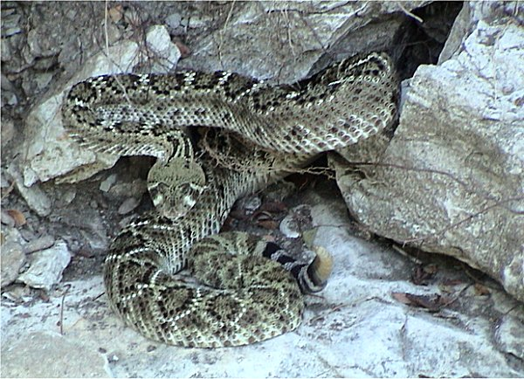
Photo by Adam Dawson, http://www.austinreptileservice.net/diamonds.html

DESCRIPTION
- Gray and brown, with the diamonds being a darker brown.
- Tail has broad black and white rings just before the rattle.
- Diamond markings down center of back are edged first in black, then white.
- Two parallel pale stripes run diagonally from front of eye to mouth on each side of face.
- Heat pits appearing as holes on either side of the head between the nostrils and eyes allow the snake to form a thermal image of its prey.
- Adults average 3 to 4 feet.
- Venomous

LIFE CYCLE
- Females may give birth to up to 20 live offspring every other year.
- Babies are venomous at birth.
- Life expectancy is more than 20 years, but human expansion and hunting thwart their longevity

BEHAVIOR
- Typically wait for prey to come to them, rather than chasing it down.
- Eat between 50% and 300% of their body weight each year, more in order to reproduce that year.

HABITAT
- Associated with many different vegetation types and elevations.
- Prefers sparsely vegetated, semi-arid terrain.
- Will inhabit stacks of logs or piled rocks, old buildings.
- Does not climb houses or trees.

FOOD
- Eats rodents or birds found on the ground.

INTERESTING
- Rattles are made of keratin, the same material as our fingernails.
- 3 pairs of muscles control the rattling, which can be as fast as 100 times back and forth a second.
- It is a myth that you can tell the age of the snake by the number of rattles; the segments can and do break off, just like our fingernails.
- The venom type found in rattlesnakes is proteolytic or hemotoxic venom, venom that breaks down or digests tissue. It not only helps subdue and kill prey, but it also helps to partially digest the prey before it is swallowed, allowing the viper to eat large meals and to digest those meals very quickly.

SOURCES
- http://www.esi.utexas.edu/outreach/ols/lectures/ppts/39.pdf - a thorough presentation of the life of rattlesnakes in Texas by Dr. Travis J. LaDuc, Assistant Curator of Herpetology, Texas Memorial Museum in Austin.
- http://www.austinreptileservice.net/diamonds.html
- http://en.wikipedia.org/wiki/Crotalus_atrox
- Texas Snakes; A Field Guide, James R. Dixon and John E. Werler, UT Press, Austin, 2005, pp 316-319.

