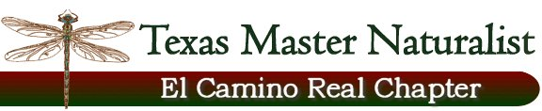

Floridus milamexa
April 14, 2015 – Extension Office, Cameron

Members: Don Travis, Linda Jo Conn, Katherine Bedrich, John Pruett

This meeting was called to revisit the purpose of the Floridus milamexa project. Members present discussed seed collecting and storage.

It was decided the objective at this time is to focus on observation, identification and collection of flora in its natural environment of Milam County. Cataloging of information gathered including photos, location, botanical nomenclature, pressing and vouchers are the interest of the group. Usage of iNaturalist and the Chapter website will compliment information collected. Seed collection for distribution and propagation may commit itself to the future.

John has cabinets at his place for storage of vouchers, etc. Floyd Ingram, Milam County Extension Agent, was asked if we could place a cabinet at the Ext. Office to store vouchers. This is a possibility; Mr. Ingram will let us know.

Ways of reaching the community will include the Website, iNaturalist, presentations and writing articles for the newspapers.

The June Chapter meeting program will be on collecting, pressing and mounting plants with Dale Kruse, Ann Collins and other project members.

Submitted by: Katherine Bedrich

