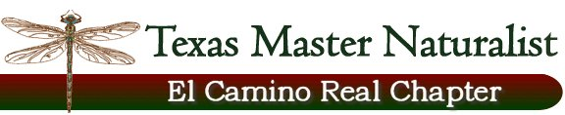

Floridus Milamexa
December 3, 2014 – Ann Collins’

Members: Ann Collins, Cindy and Don Travis, Linda Jo Conn, Katherine Bedrich,
John Pruett, Dale Kruse

- Katherine will contact Steven Gonzales about the Alamo Chapter Plant inventory.

- Work on a slide show with plant photos, project objectives – continue updating and have available for Chapter to use.

- Notebook with meeting notes, field trip info, plant pages, etc. – continue to update.

- Don discussed Website information on project. Group decided to work on setting this up. Meeting on Tuesday January 6, 2015 at Don’s to begin developing the pages.

- Members will contact County Commissioners and ask them to support the project.

- John is looking for a place to use when we start collecting plants for pressing.

- Linda Jo and Dale as setting up dates for Herbarium Trip and Training on keying plants.

- Field trip to Sugarloaf for plant identification – Dale will contact Monique Reed about a trip in the spring (April)

- Field trip to Chalk Prairie at Granger Lake – contact: Katherine – will set this up.

- Ann and Dale will lead a flower pressing and mounting training at the June 11th Chapter meeting.

- Seed identification was presented by Katherine

Submitted by: Katherine Bedrich

