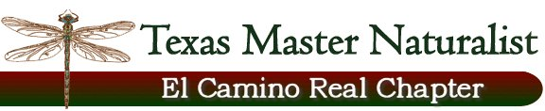
Floridus milamexa
February 19, 2015 – Don and Cindy Travis’
Members: Cindy and Don Travis, Katherine Bedrich, Linda Jo Conn, Ann Collins, John Pruett, Dorothy Mayer

Don presented an example on iNaturalist for the Floridus milamexa project. On this website we could provide information on flora identified in the county. Discussion on how this site would be available for the community and others interested in what flora is in the county and on El Camino Real de los Tejas National Historic Trail.

The group decided this would be favorable to use this iNaturalist for identification and information.

Separate plant pages will also be developed for presentations and visual display.

Next meeting: March 10, 2015 – 1:30pm – Cindy and Don’s.
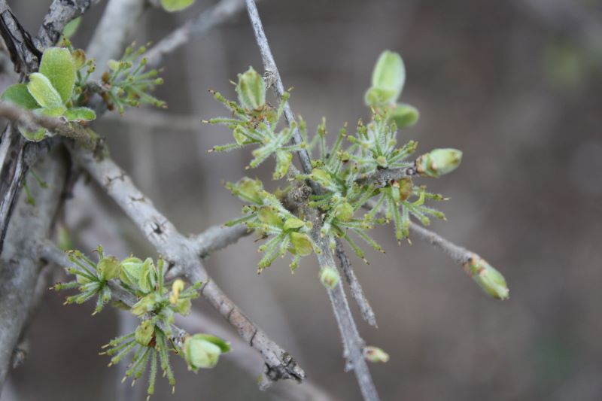
female

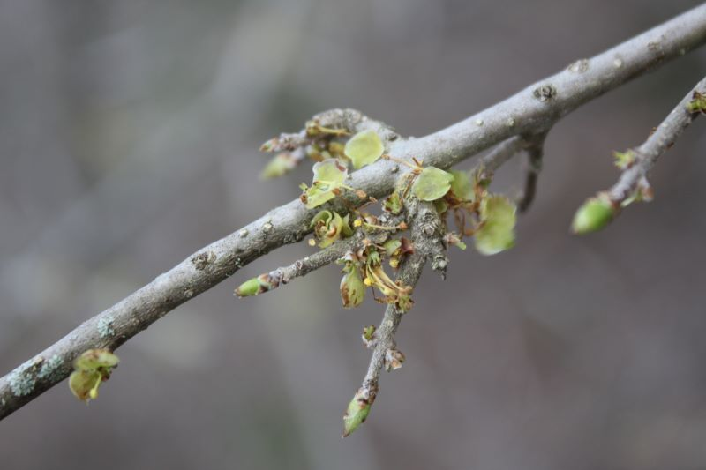
male

Forestiera pubescens
OLEACEAE / Olive Family
Elbowbush, herald of spring

County Road 216A
February 2015

