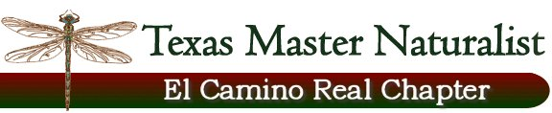
Floridus Milamexa
January 6, 2015 – Don and Cindy Travis’
Members: Cindy and Don Travis, Katherine Bedrich, Linda Jo Conn, Ann Collins, John Pruett

The purpose of having information available on the website was discussed. Learning the flora of Milam County through field observations, photos, location, and data collection is a major part of the project. Plant identification, value and habitat will help us obtain knowledge needed to follow the mission statement of providing education and outreach to our community. Having this information on the website will give the community a tool they can use to become aware of the flora in the county.

Don presented two collection and logging process’. The group decided using Google Sheets would serve the best. Information would include photos, data (GPS, altitude, etc.), log sheet, voucher specimen photos, seed collecting, and other links.

We will begin by developing a word template for the individual species. We picked several species to bring information about to the next meeting:

1. Sophora affinis - Eve's necklace (On the Trail; Big Elm Creek CR 147)

2. Euphorbia bicolor - Snow-on-the-prairie (On the Trail; Prairie Tracks CR 145)

3. Rivina humilis - Pigeon-berry (On the Trail; Big Elm Creek CR 147)

4. Nemophila phaceliodes - Baby blue-eyes (Big Elm Creek CR 147)

5. Bouteloua rigidiseta - Texas grama (Prairie Tracks CR 145; FM 1600)

Next meeting: Feb19, 2015 – 1:30pm – Don and Cindy’s

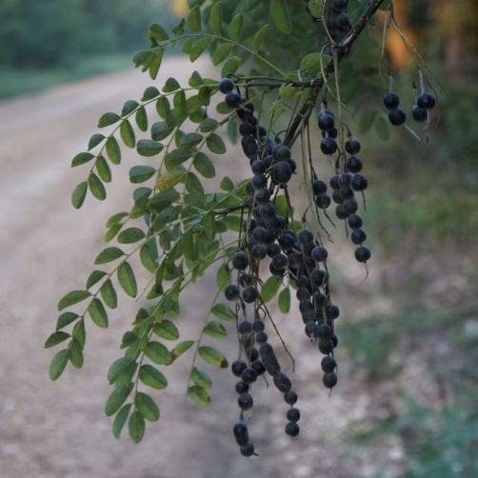
Sophora affinis – Eve’s necklace
(Big Elm Creek CR147)

