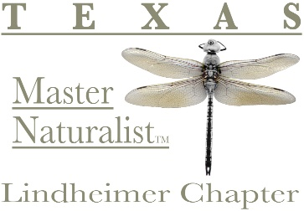
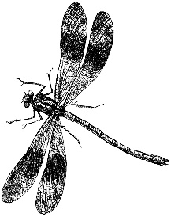
The Lindheimer Quarterly
4th Quarter 2025

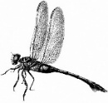
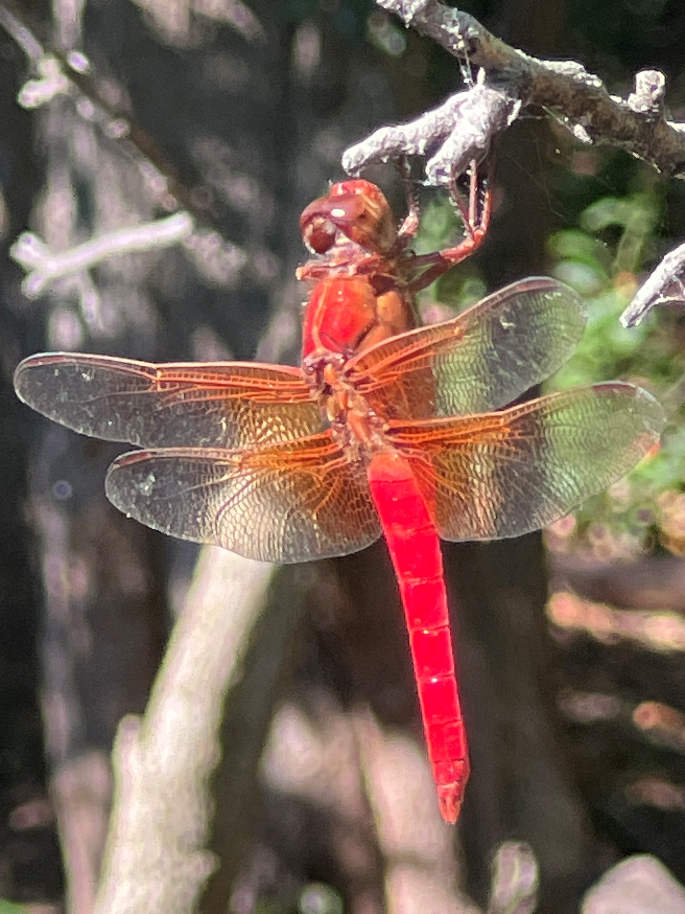

“Neon Skimmer” by Michael Buley
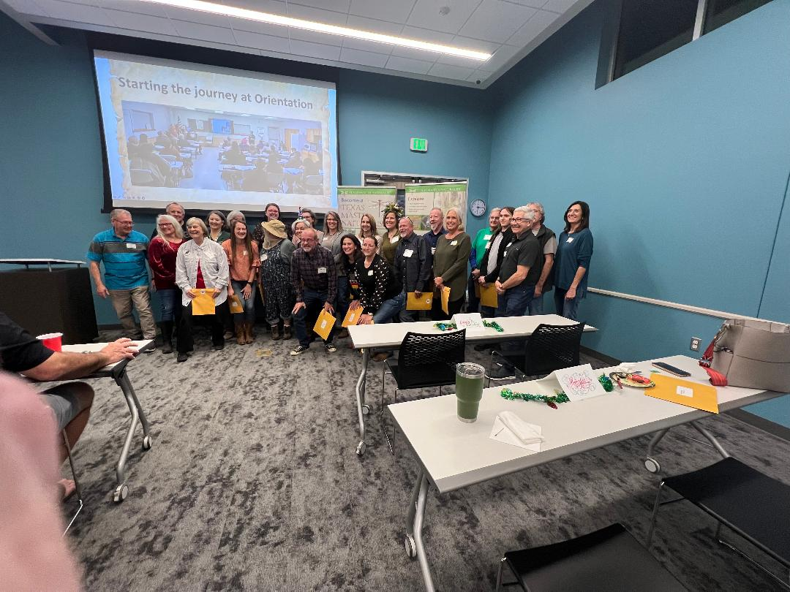
2025 Lindheimer Chapter Graduates –
Painted Buntings!
Congratulations & Welcome!
Annual Election Results for 2026

President Sue Sommer
Vice President Laurie Dugan
Secretary Rob Kyrouac
Treasurer Don Epps

Lindheimer Chapter Class Names

Here are the great class names throughout the years.
No class in 2002 &
from 2004 – 2006 there were two classes a year

2001 | Founders
2003 | Founders II
2004 | Roadrunners (March)
 | Trailblazers (October)
2005 | Riparians (March)
 | Advocates (September)
2006 | Lone Star Guardians (April)
 | Fountain Darters (October)
2007 | Prickly Pears
2008 | Grass Roots
2009 | Pond Meisters
2010 | Free Mesquiteers
2011 | Comal Seeders
2012 | Canyon Spirits
2013 | Wildscapers
2014 | Green Team
2015 | Stone Rangers
2016 | Horned Lizards
2017 | N2Nature
2018 | Mud Daubers
2019 | Rock Stars
2020 | Red-tailed Hawks
2021 | Free-tailed Bats
2022 | Nine-banded Armadillos
2023 | Gray Foxes
2024 | Texas Yellow Stars
2025 | Painted Buntings

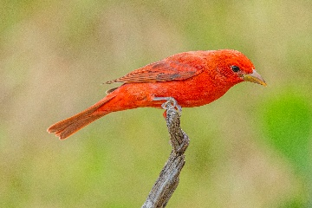
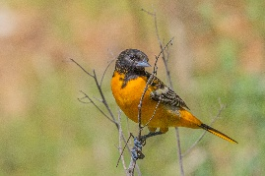
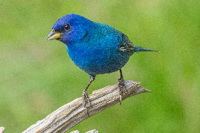
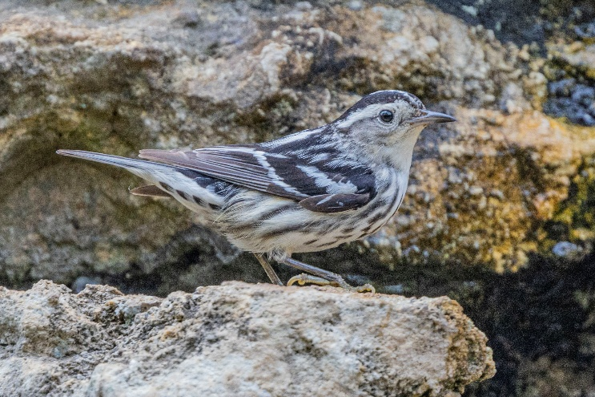
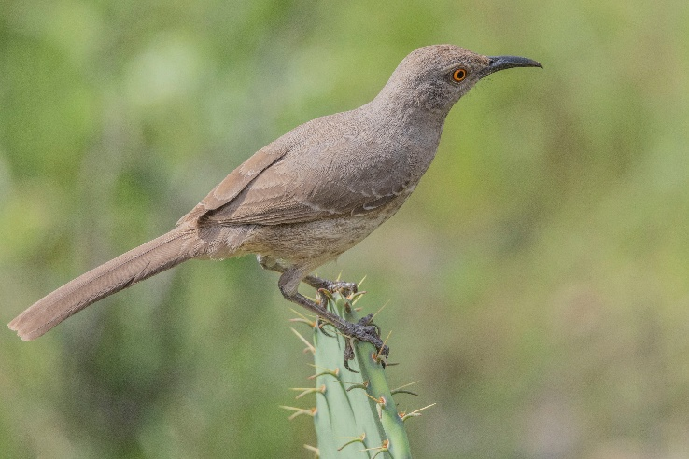
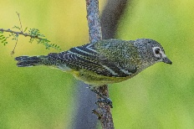
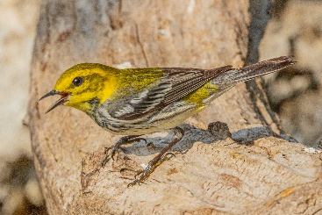
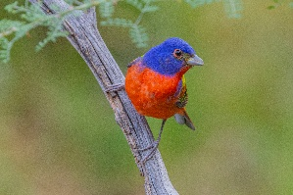
Chapter Information Page
2025 CHAPTER LEADERSHIP

OFFICERS

PRESIDENT Sue Sommer
VICE PRESIDENT Laurie Dugan
SECRETARY Rob Kyrouac
TREASURER Don Epps

COMMITTEES
Standing Committees
Education – Amy Sharp, Director
Membership & Records – BrianTrock, Cheryl Trock
Outreach – Debbie Kyrouac
Projects & Opportunities - Jeanie Springer

Subcommittees
Trunks – Deb Kyrouac
Program to Assist Landowners (PAL) – Caroline Broderick
Community Recognition – Michael Buley, Past President
Hospitality – Joni McGhee
New Class
Rep – William Netherland
Photographer – Jessica Farrer

COMMUNICATIONS
Director – MJ McFarland
Out & About – Sara Riggs

CHAPTER ADVISORS
Jason Mangold
Rachel Grotte

The Lindheimer Quarterly Newsletter
MJ McFarland – Editor
Newsletter published quarterly by the Lindheimer Chapter, Texas Master Naturalist™ to communicate, educate & inform chapter members & the Hill Country Community. Current and previous issues of The Quarterly are posted on the website https://txmn.org/lindheimer/whats-new

How to CONTACT Us
Email: LindheimerMNContact@gmail.com

Website: https://txmn.org/lindheimer

Facebook: https://www.facebook.com/txmn.lindheimer/

Snail Mail: Lindheimer Chapter
c/o Comal County AgriLife
325 Resource Dr.
New Braunfels, TX 78132

2025 Board of Directors Meetings
Every 4th Monday at 5:00 PM
Meetings are via Zoom
All members welcome

Zoom Link:
https://us06web.zoom.us/j/7461036858

Board Minutes available at:
https://txmn.org/lindheimer/chapter-info/lmn-board-members/lmn-board-minutes-archive/

2025 MONTHLY CHAPTER MEETINGS

Meetings are held in-person
or online every 3rd Thursday
(unless otherwise noted)
5:45 pm – 7:30pm

Sign-up to bring snacks:
https://www.signupgenius.com/go/508084EABAF23A7F49-55530945-lindheimer

All photos ©Darlene Varga

Communications Photo Awards – October2025
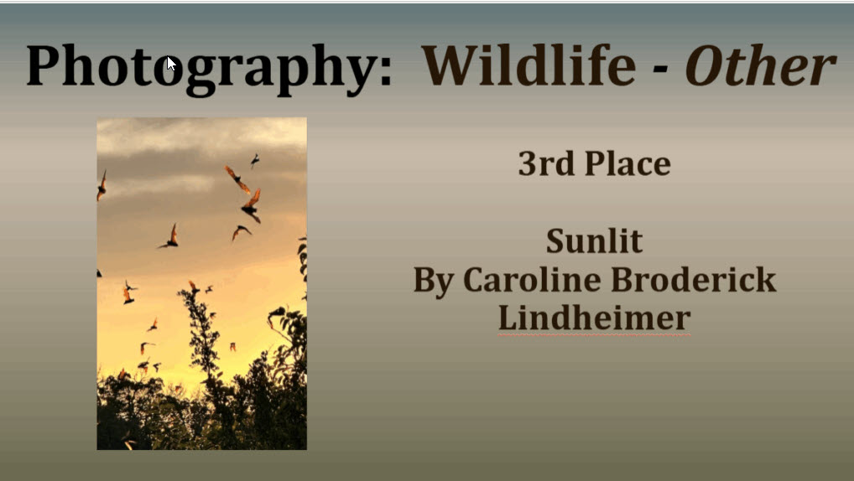
Caroline Broderick won “3rd Place – Wildlife-Other” at the Annual State Meeting in 2025 with this photo! Congrats!


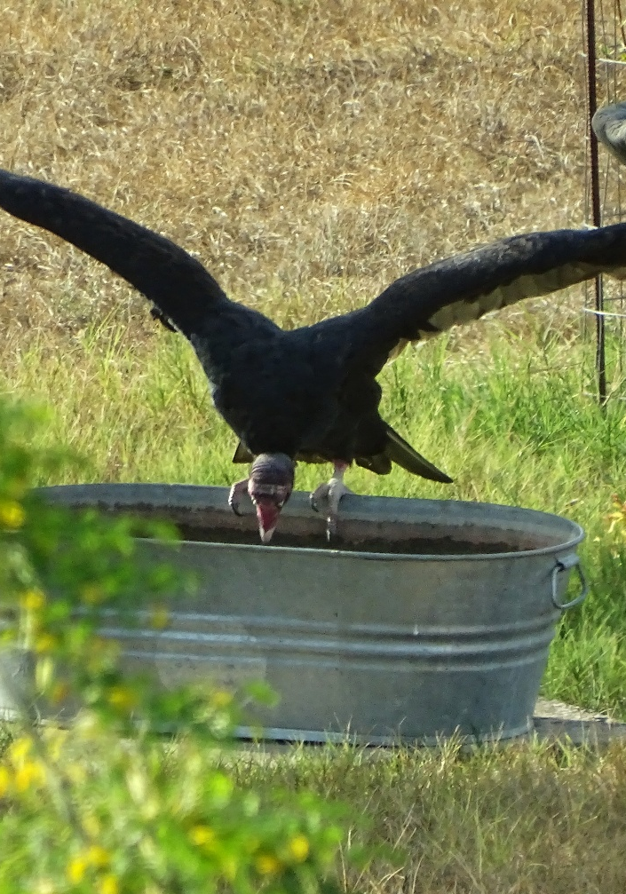
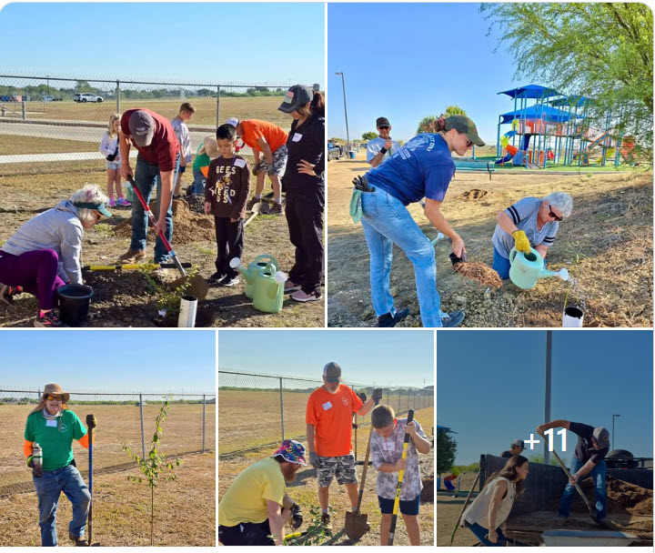

1st Place – Caroline Broderick
2nd Place – Don Bergquist
3rd Place – Launa Poppaditch
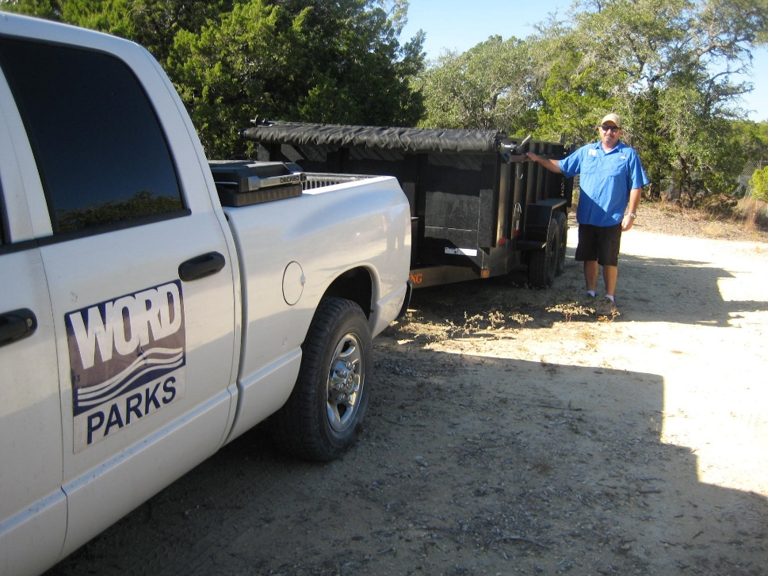
Communications Photo Awards – November 2025
1st Place – Susan Bogle
2nd Place – Kris Moore
3rd – Michael Laffey

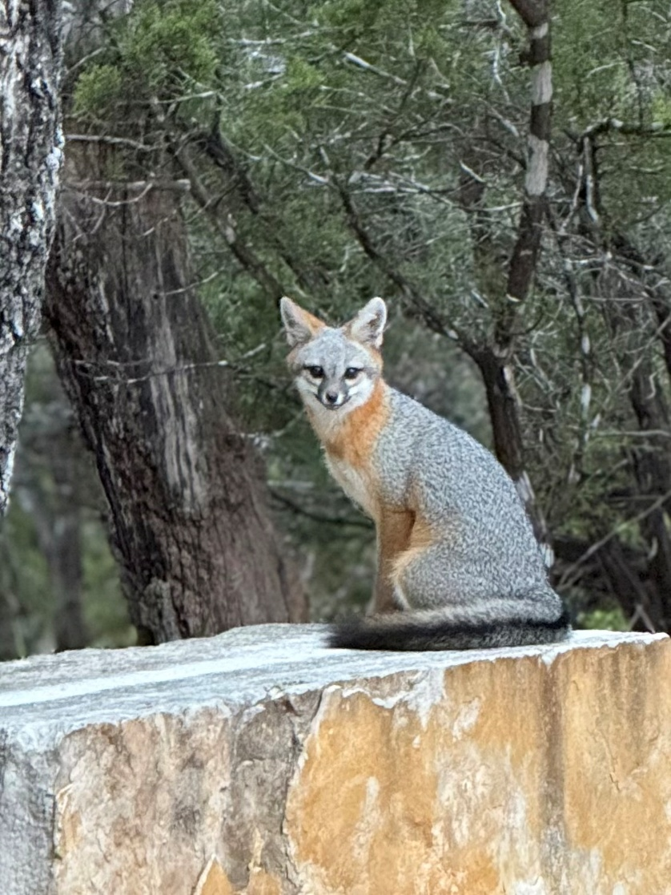

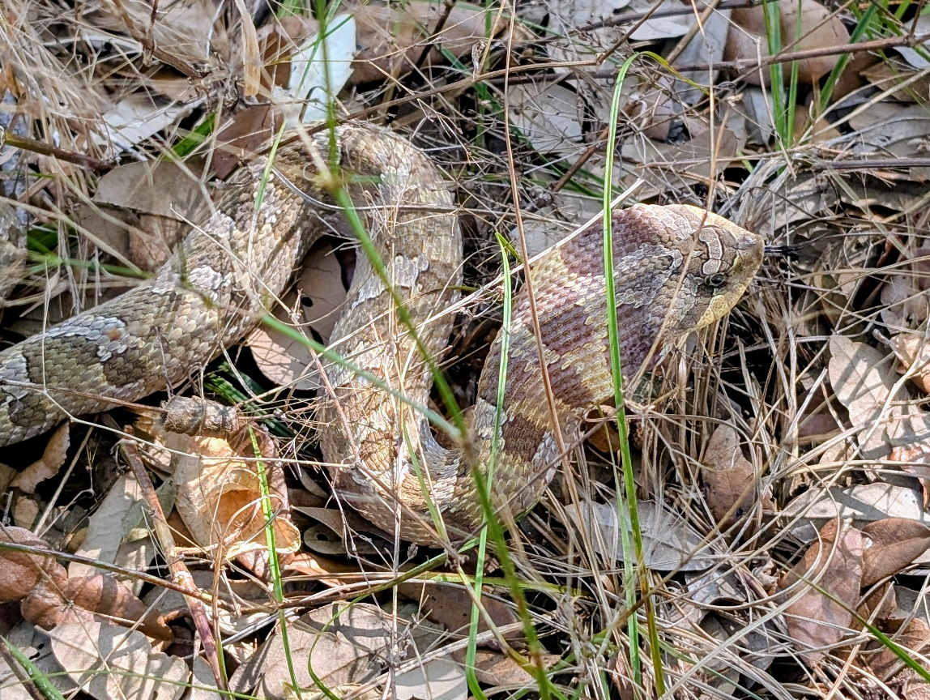

Ribbons are awarded to the members whose photos are the most popular (receive the most “views” on our FaceBook page) each month. 1st, 2nd, and 3rd place ribbons will be presented at the monthly meetings. All you have to do is submit your photos to LindheimerMNContact@gmail.com.
Your photo will be posted on our page. If you don’t have a FB account – no problem! I can take a screenshot & send it to you so you’ll know what it looks like!
Thanks! Marilyn McFarland
Director, Communications

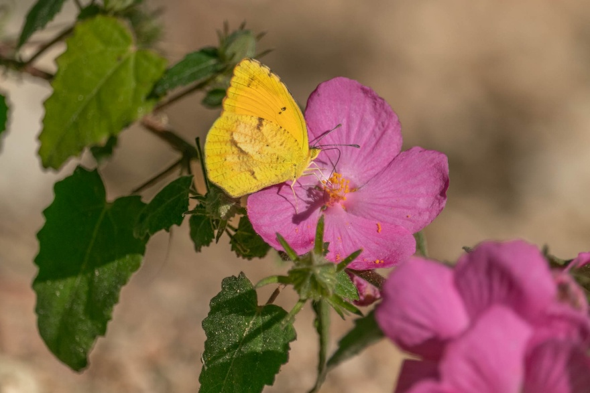
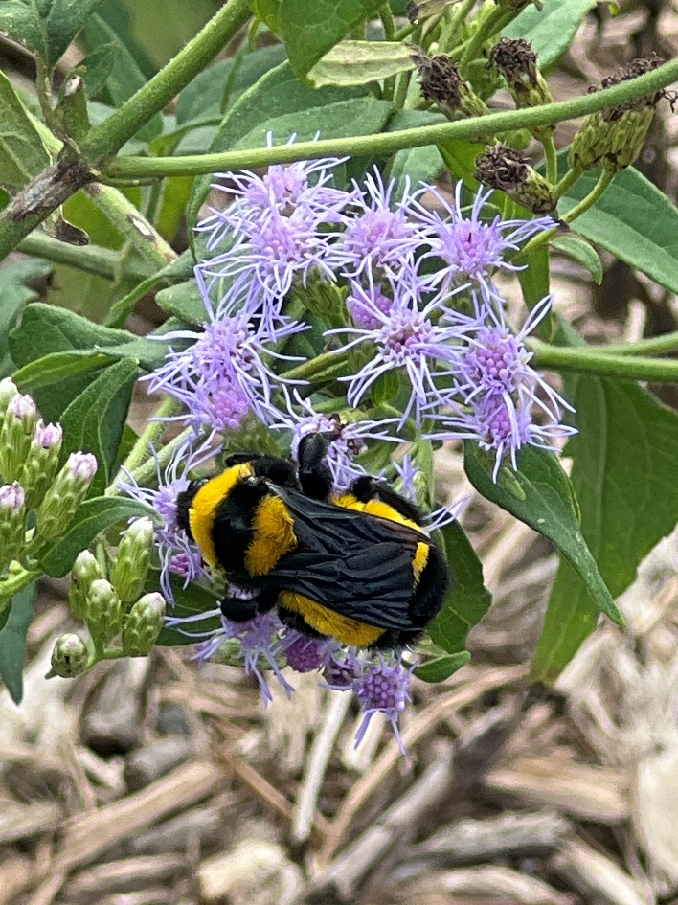
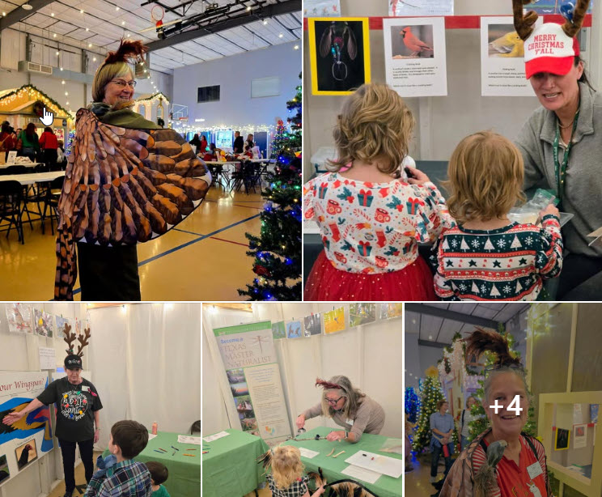
Communications Photo Awards – December 2025
1st Place – Sue Sommer
2nd Place – Nancy DeMarco
3rd Place – Michael Buley
Web & Facebook Stats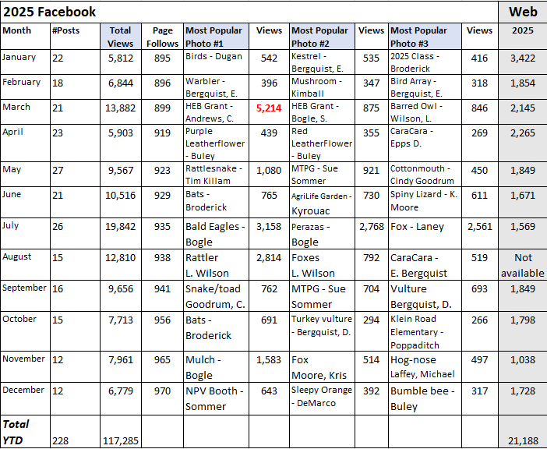
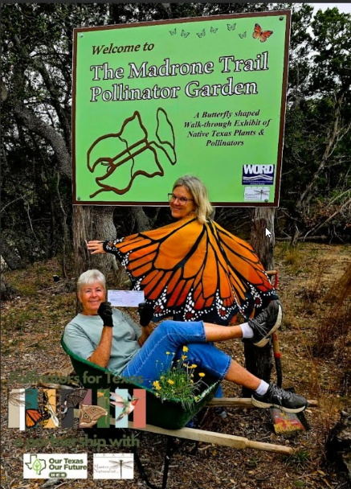

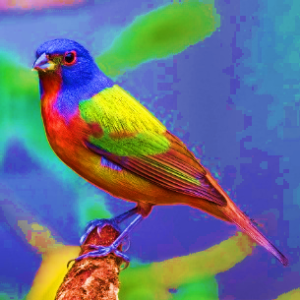
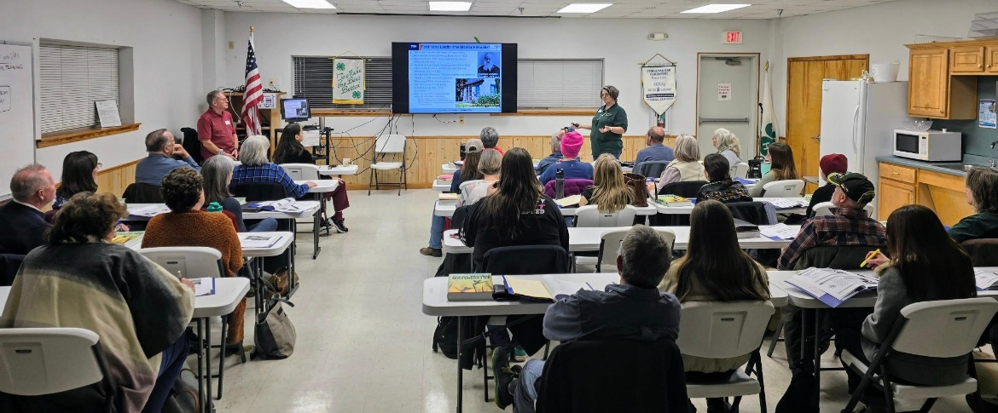
Top row: Sue Sommer
Bottom row: Skylar Rightmire

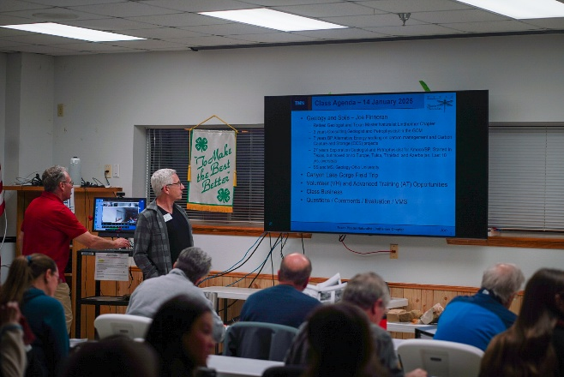
Twenty-five members of the community have committed to the year-long training to become Certified Texas Master Naturalists!
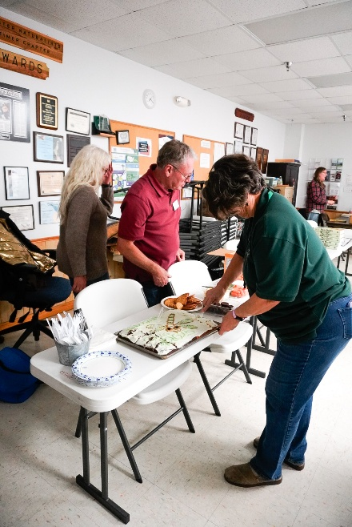
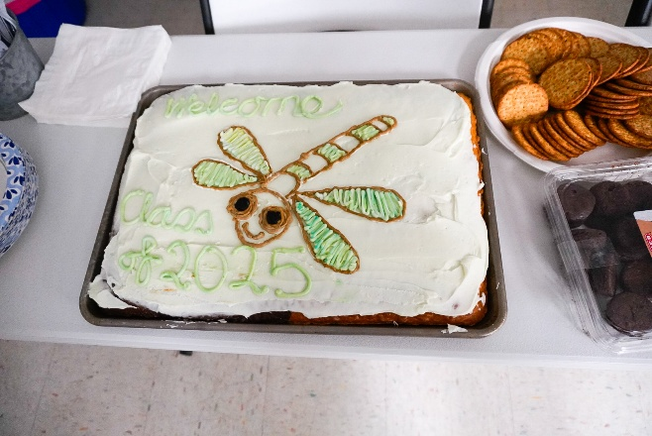

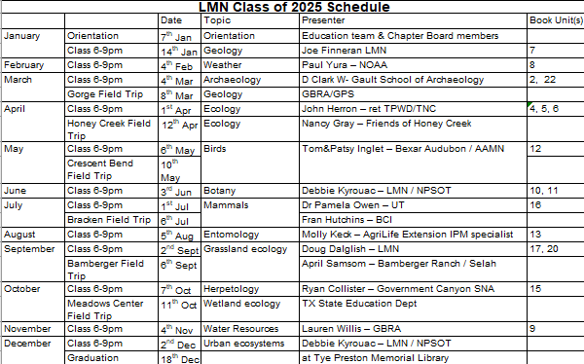
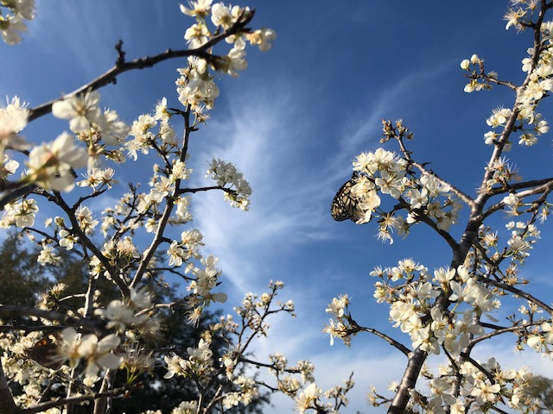

Chapter Recertifications and Milestone Awards
THANK YOU TO OUR VOLUNTEERS!
CONGRATULATIONS ON YOUR ACHIEVEMENT!
 | Recertifications | Milestone Awards
Jan | Ellen Anderson, Susan Bogle, Ron Lucik, Jeanie Springer, Brian Trock, Darlene Varga | 250 HOURS: Ricky Corbell, Rosemary Melody
Feb | Don Bergquist, Edith Berquist, Caroline Broderick, Trish Coons, Don Epps, Wendy Harter, Tom Petray, Lois Ricci, Cheryl Trock | 250 HOURS: Wendy Harter  1,000 HOURS: Trish Coons, Dave Wright  5,000 HOURS: Lois Ricci
  Mar | Carolyn Andrews, Richard Andrews, John Davis, Marian Henderson, Wendy Hill, Jim Jameson, Tim Killam, Anne-Marie Kimball, Deb Kyrouac, Jane Miller, Rhonda Neel, Ellen Petray, Mike Poffenberger, Amy Sharp, Teresa Turko |   4,000 HOURS: John Davis
April | Tom Jones, Judy Henfey, Patricia Porterfield, Lisa Smith, Teresa St. John, Rich Nielson, David Meyer, Marilyn McFarland | 250 HOURS: Thomas Oldham  500 HOURS: Pat Carnes
May | Keith Landry, David Gruener, Christine Gruener, Joni McGhee, Jim Doyle, Evelyn Nielson, Susan Sommer | 250 HOURS: Tim Killam, Anne-Marie Kimball  500 HOURS: Margaret Oliver  1,000 HOURS: Caroline Broderick
June | Linda Bolano, Ron Butts, Heidi Case, Julie Crouch, Nancy DeMarco, Harry Ferrell, Pat Fletcher, Rob Kyrouac, Tom Oldham, Mike Roberts | 250 HOURS: Laurie Dugan
July | Gretchen Ferrell, Don Fletcher, Gail Groves, Tommy Lanier, Lori Largen, Kelly Stinnette, Dwaine Vann | 1,000 HOURS: Mike Roberts
August | Lauri Gleaves, Vanessa Brown, Brenda Stoeck, Pat Carnes, Howard Grove, Scott Ofsdahl, Christy Martinez, Marcia Kelly | 1,000 HOURS: Ron Lucik
September  October | Craig Dillion, John Corkill, Toni Wayne, Aleta Meyer, Debbie Subke, Mary Barr-Gilbert, Elizabeth Bowerman, Margaret Oliver, Phillip Brown, Cindy Goodrum, Sarah Mato, Kathy Lamon, Kathy Laney, Dave Wright, Steve Mato, Rosemary Melody, Dick Bigelow, Jim Luera, Patty Luera, Vickie Baldwin | 250 HOURS: Kathy Lamon  500 HOURS: John Corkill, Aleta Meyer  1,000 HOURS: Rob Kyrouac
November | Irene Betts, Beth Jameson, Kathy Olfsdahl, Mary Williams, Dana Murray, Sydney Sharp, Rick Guzman, Leslie Guzman, Loran Wilson | 250 HOURS: Amy Sharp, Tommy Lanier  500 HOURS: Wendy Harter
December | Recertifications  Cynthia DeWitt, Monica Anthes (DC), Lynn Jones, Christina Campbell (DC), Diane Kime, Debbie Caraway (DC), Linda Valdez, Jennifer Clark (DC), Sharon Carewell Levitt, Robyn Cooke (DC), Karla Roch, Jonathan Gulick (DC), Camille Tyler, David Hughes (DC), Sherri Green, John Hughes (DC), Kris Moore, Larry Jackson (DC), Leslie Prather-Forbes, Michael Laffey (DC), Ben Pfeiffer, Karen Meyer (DC), Shari Ferguson, Melauni Poppaditch (DC), Dave Skasik, Skyler Rightmire (DC), Melissa Skasik, Rae Stromboe (DC), Cheryl Bordovsky, Doug Starasinic (DC) = Double Certification | Milestone Awards  250 HOURS: Thomas Jones
Monthly Chapter Meetings
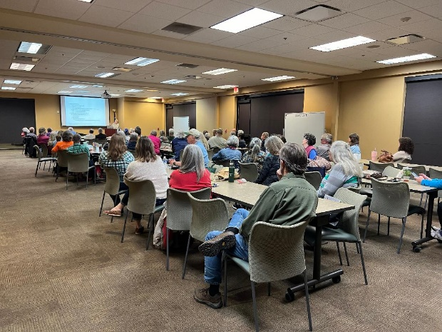
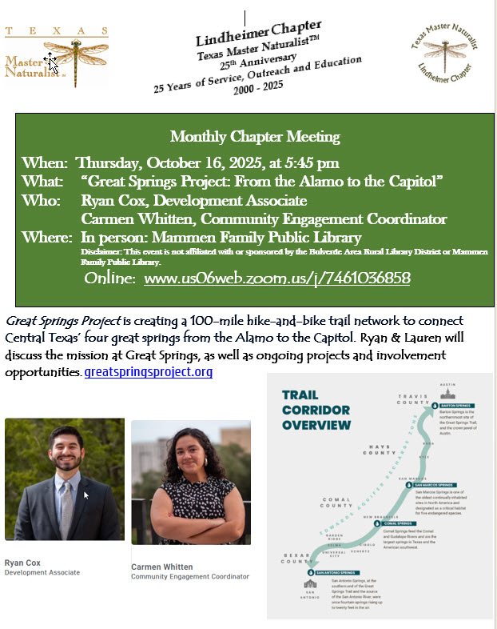

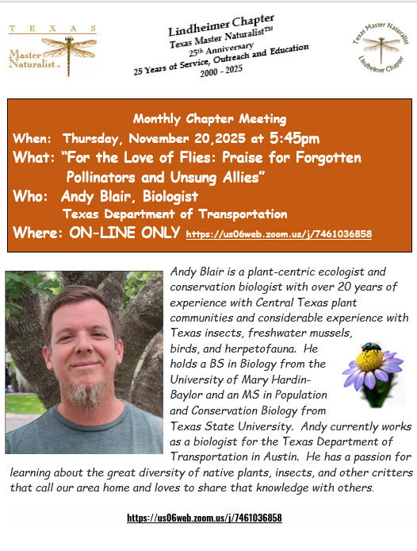

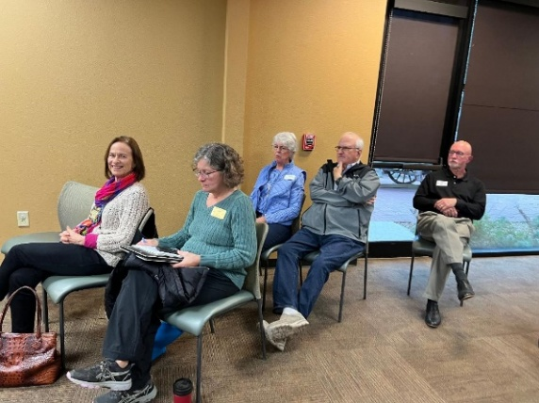

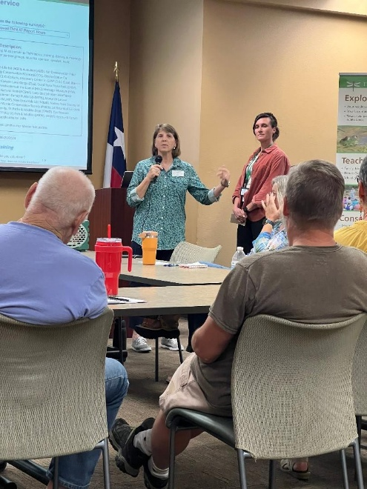


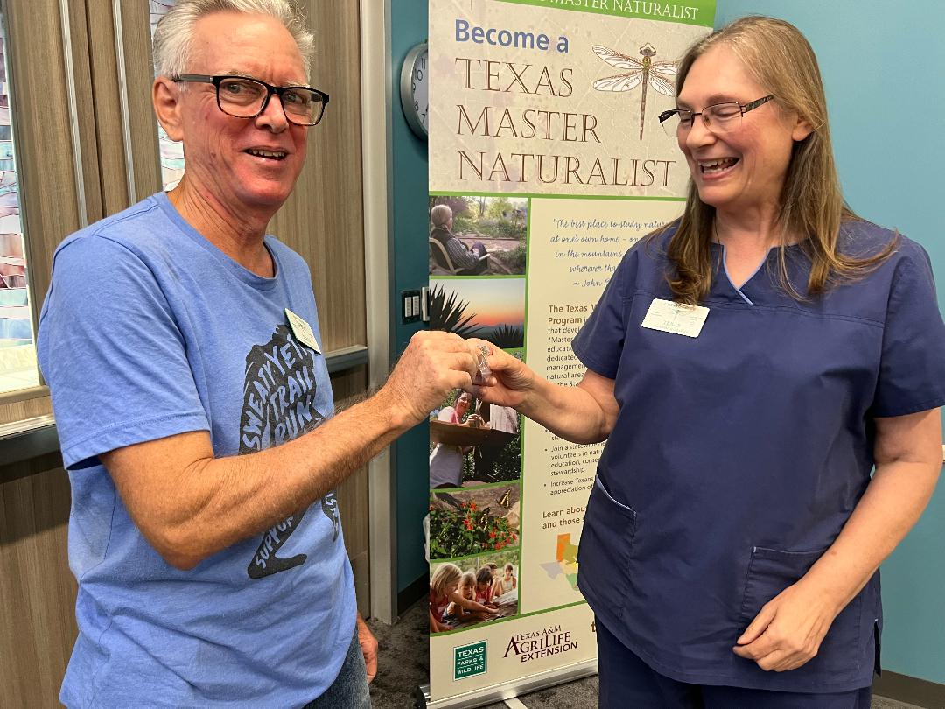
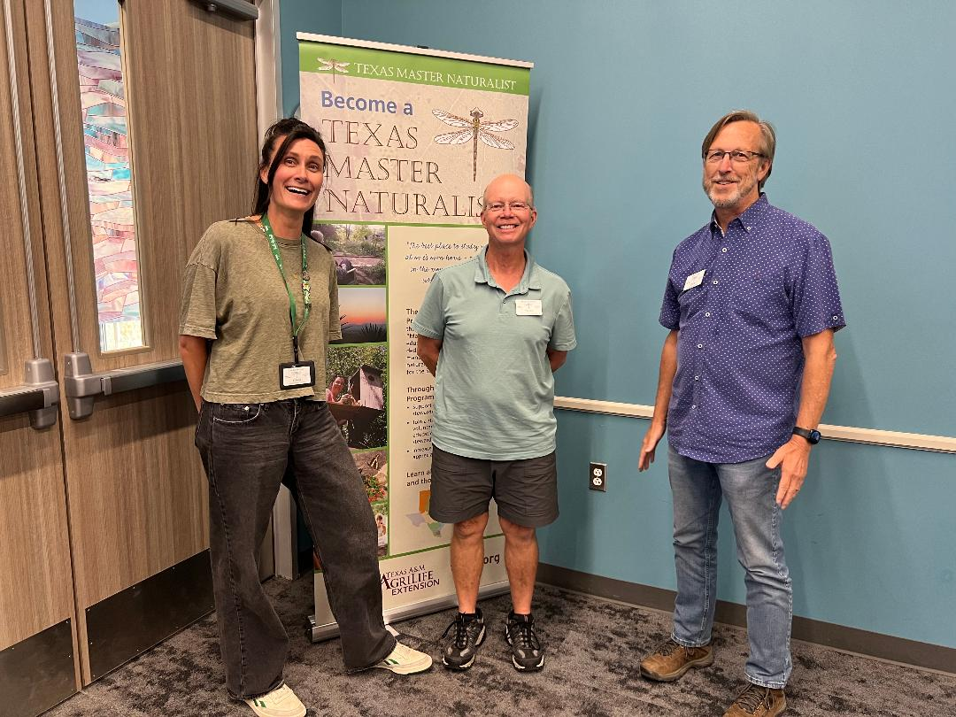
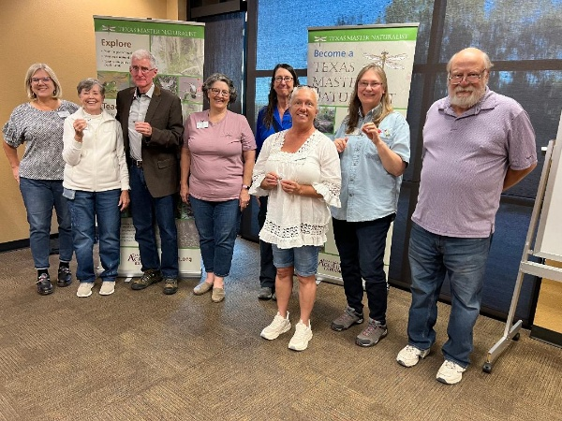
Members receiving pins & milestone awards at monthly meetings
Contributing to Citizen Science: iNaturalist.org

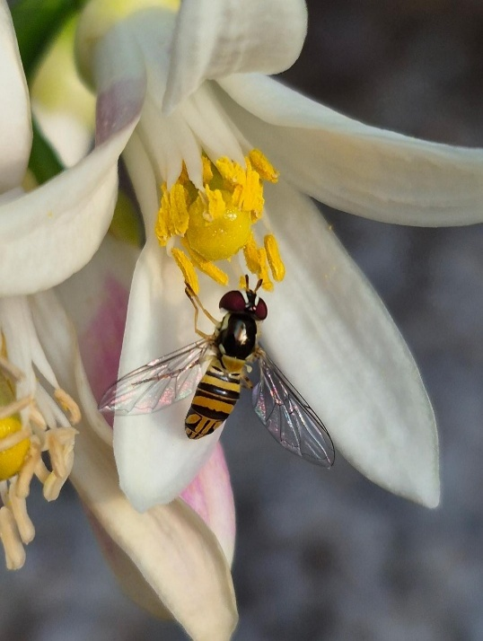
“Citizen” Science is the participation of non-scientists in scientific research. As naturalists, many of us already participate in community science projects that contribute to the body of scientific knowledge about plants, animals & insects: butterfly surveys, bird counts, plant identification. And we take pictures – LOTS of pictures! Each picture is an observation and represents an opportunity to increase the scientific knowledge of what, where & when. One of the largest community science projects is iNaturalist, a world-wide, on-line database of observations provided by community scientists like Master Naturalists.
“If enough people recorded their observations, it would be like a living record of life on Earth that scientists and land managers could use to monitor changes in biodiversity, and that anyone could use to learn more about nature.”
Photo by Teresa Turko

How to get started? Go to www.inaturalist.org and sign up!
Here are the iNaturalist numbers as of January 14, 2026. Take a look at Comal County!!!
Location | Observations | Species | Observers
World | 292,012,392 | 549,095 | 4,000,108
Texas | 14,173,539 | 30,606 | 212,702
Comal County | 231,307 | 6,076 | 8,439

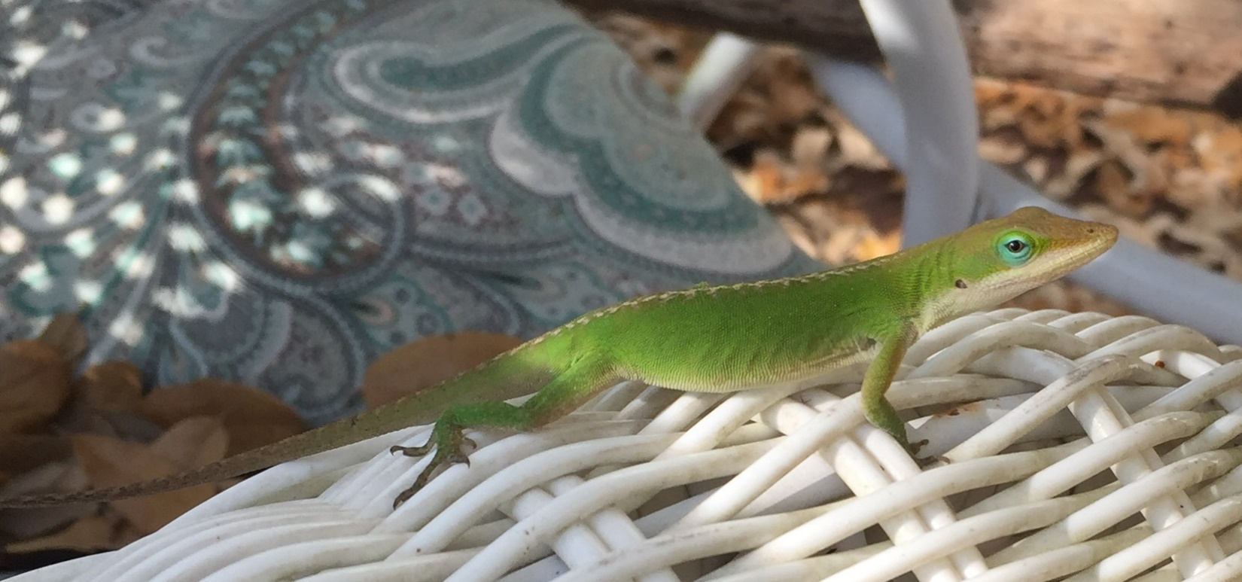
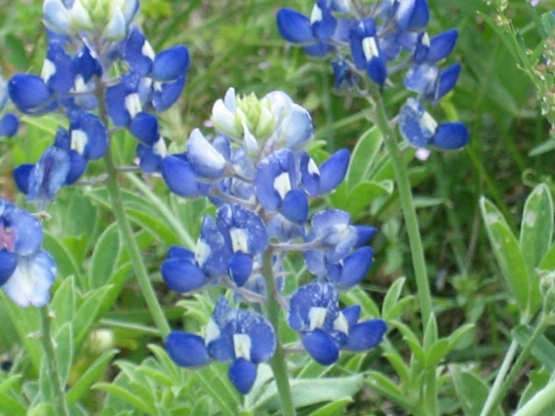
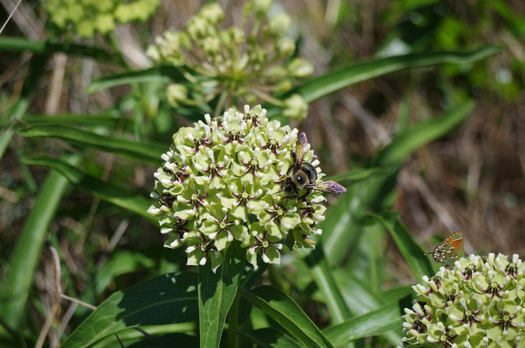

Four of the top ten Naturalist observers in Comal County are Lindheimer Chapter members! Wow! That’s dedication to citizen science!

Observations
Darlene Varga 27,421
Edith Bergquist 7,598
Don Bergquist 4,335
Brian Trock 2,570


The Electronic Lindheimer

Website: www://txmn.org/lindheimer/ Take a look around our website to see what’s available!
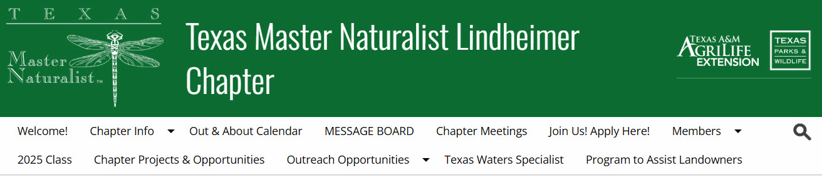

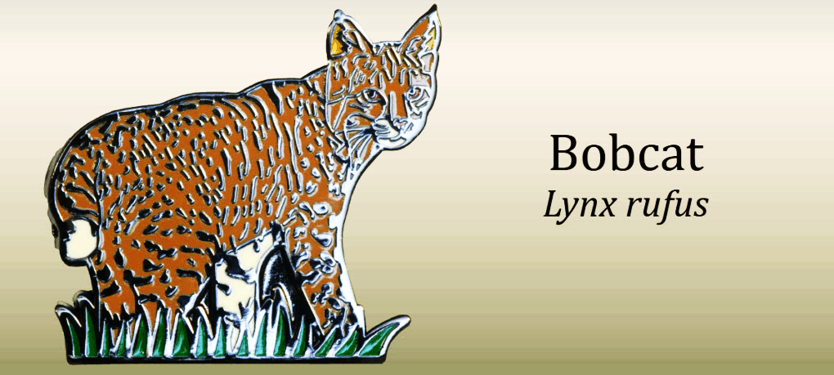
Facebook: www://facebook.com/txmn.lindheimer

2026 TMN Recertification Pin: The Bobcat

