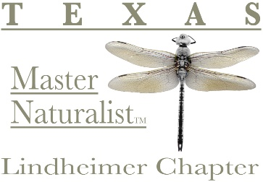
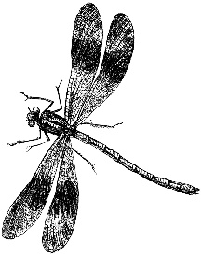
The Lindheimer Quarterly
1st Quarter 2026

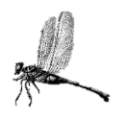

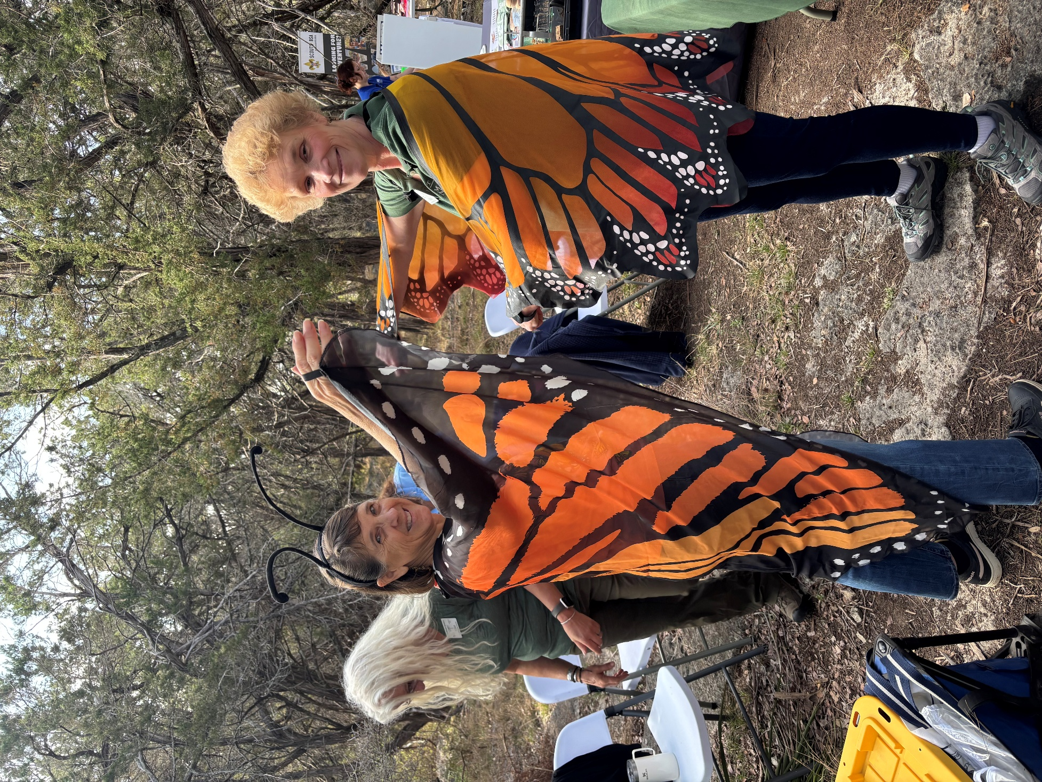
Photo by Judy Henfey
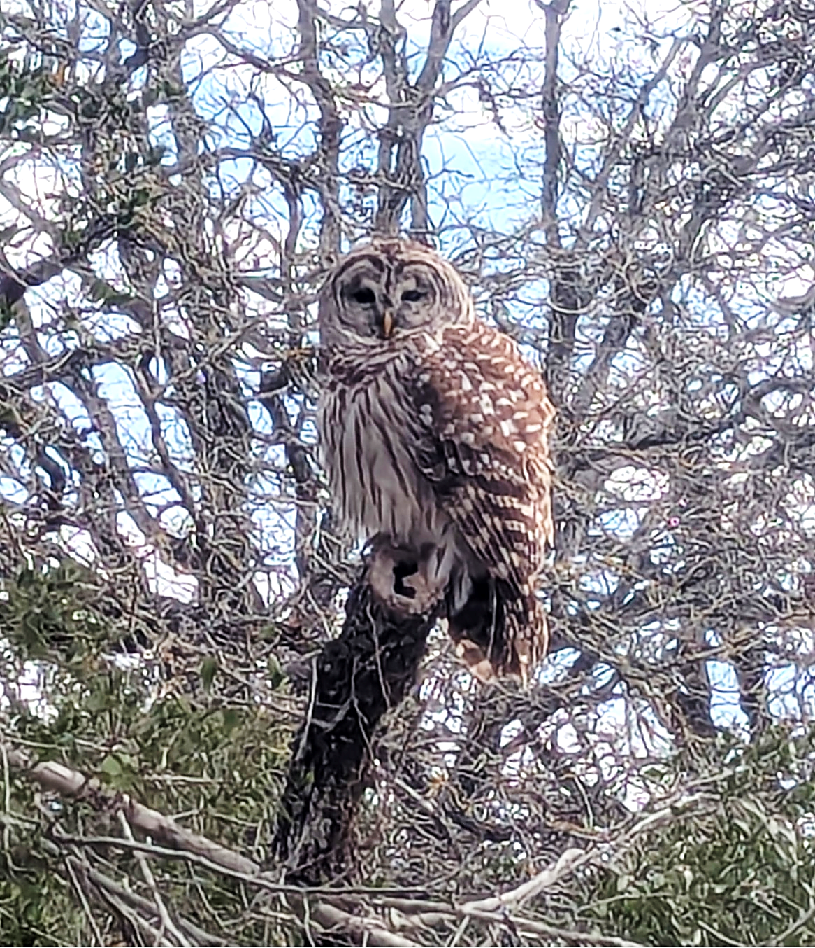

The Barred Owl
Description

“Barred Owl” Brenda Stoeck

The Barred Owl
by MJ McFarland
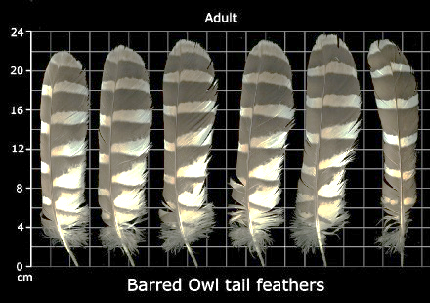
The Barred Owl, Strix varia, is a true owl. It is named for its feather patterns, which are “barred” with alternating colors of white and brown, along its head, chest, and back. In the United States, barred owls, like all native migratory birds, are protected under the Migratory Bird Treaty Act (MBTA). This means it is illegal to collect, keep, or sell their feathers without a special permit—even if the feather is found on the ground. Barred owls don’t migrate. (https://www.audubon.org/news/the-migratory-bird-treaty-act-explained)
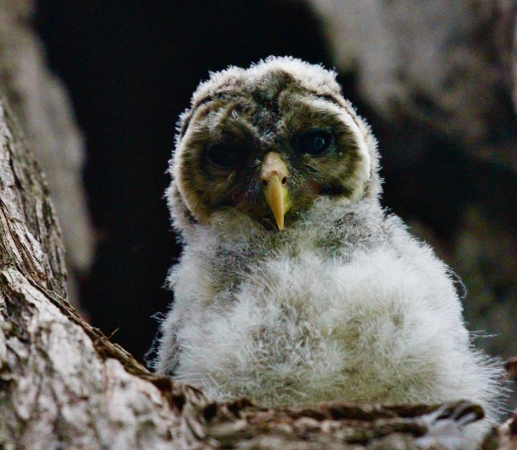
The barred owl has dark brown eyes – uncommon from other true owls whose eyes are yellow. This bird was originally only found in the east, but during the 20th century, it spread through the Pacific Northwest and southward into California. They are highly adaptable. They are found in central Texas in moderate numbers. Their preferred habitat is “coniferous forests with dense foliage and large trees with cavities.” They aren’t fond of ashe juniper! (https://www.animalspot.net/barred-owl.html) (Photo by Laurie Dugan)

Characteristics: They’re smaller than a Great Horned Owl and larger than a Barn Owl. They can pass by completely unnoticed due to their ability to fly silently. Their wingspan is 38 to 49 inches, and weight is 1.03 pounds to 2.54 pounds. Females are large than males, as is common with owls. They are generalist predators, hunting birds such as barn swallows, grouses, purple martins, and indigo buntings, as well as fish, frogs, lizards, mice, rats, squirrels, voles, muskrats, pocket gophers etc. They like to swallow their prey whole. These owls, while mostly nocturnal, will hunt at dawn and dusk and occasionally cloudy days. Their most significant predator is the Great Horned Owl. They will abandon territory that becomes home to one. Their average life span is 8 – 10 years.

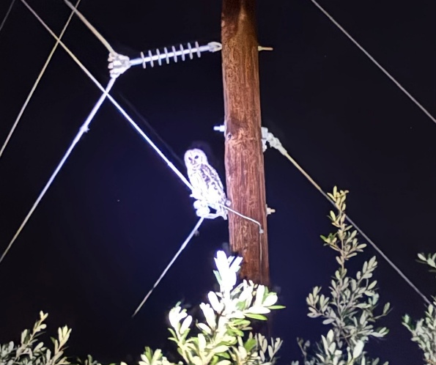
Mating and Nesting: Barred owls do not build nests per se, but are opportunistic, using existing tree cavities, occasionally on stick platforms and in nest boxes that are at least 20 feet off the ground. They will evaluate a potential nest abandoned hawk nests. They may watch a potential nest for up to a year, to ensure that it is truly empty and without predators around. They rarely re-use a nest.
Barred owls are usually monogamous and mate for life. They come back together at the beginning of courtship season early in the year. Barred Owls are highly vocal, and their calls play a vital role in attracting mates and establishing territory. The male owl will often bring food to the female as a sign of his ability to provide for her and the future offspring. The female typically lays 2-4 eggs, which she incubates for approximately 28-33 days. Both parents participate in feeding and protecting the owlets until they fledge, which occurs around 4-6 weeks after hatching (https://iere.org/what-month-do-barred-owls-mate/) (Photo by Loran Wilson)
Vocalization: Barred Owls have a distinctive hooting call of 8–9 notes, described as “Who cooks for you? Who cooks for you-all?” This call carries well through the woods and is fairly easy to imitate. During courtship, mated pairs perform a riotous duet of cackles, hoots, caws and gurgles. Both adults and young may snap their bills during squabbles. Listen to their calls here: https://www.allaboutbirds.org/guide/Barred_Owl/sounds
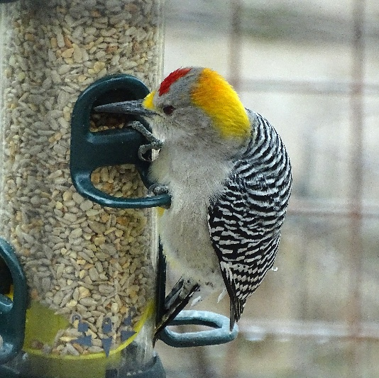
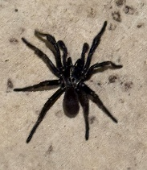
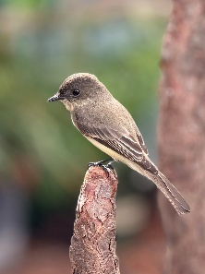
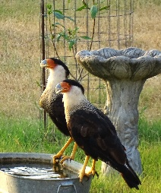
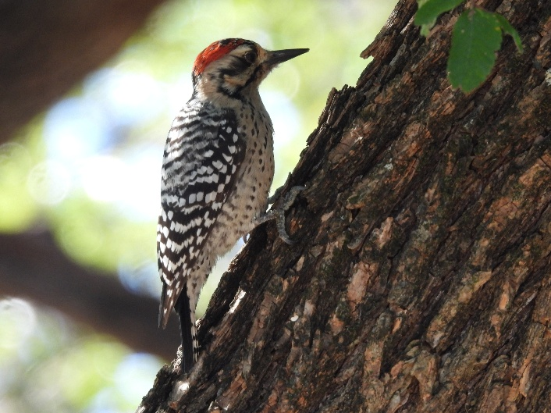
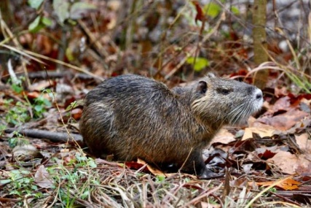
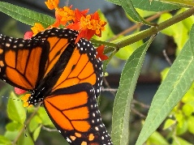
Chapter Information Page
2026 CHAPTER LEADERSHIP

OFFICERS

PRESIDENT Sue Sommer
VICE PRESIDENT Laurie Dugan
SECRETARY Rob Kyrouac
TREASURER Don Epps

COMMITTEES
Standing Committees
Education – Amy Sharp, Director
Membership & Records – Brian Trock, Cheryl Trock
Outreach – Debbie Kyrouac
Projects & Opportunities - Jeanie Springer

Subcommittees
Trunks – Deb Kyrouac
Program to Assist Landowners (PAL) – Caroline Broderick
Community Recognition – Michael Buley, Past President
Hospitality – Joni McGhee
New Class
Rep – William Netherland
Photographer – Jessica Farrer

COMMUNICATIONS
Director – MJ McFarland
Out & About – Sara Riggs

CHAPTER ADVISORS
Jason Mangold
Rachel Grotte

The Lindheimer Quarterly Newsletter
MJ McFarland – Editor
Newsletter published quarterly by the Lindheimer Chapter, Texas Master Naturalist™ to communicate, educate & inform chapter members & the Hill Country Community. Current and previous issues of The Quarterly are posted on the website https://txmn.org/lindheimer/whats-new

How to CONTACT Us
Email: LindheimerMNContact@gmail.com

Website: https://txmn.org/lindheimer

Facebook: https://www.facebook.com/txmn.lindheimer/

Snail Mail: Lindheimer Chapter
c/o Comal County AgriLife
325 Resource Dr.
New Braunfels, TX 78132

2026 Board of Directors Meetings
Every 4th Monday at 5:00 PM
Meetings are via Zoom
All members welcome

Zoom Link:
https://us06web.zoom.us/j/7461036858
Board Minutes available at:
https://txmn.org/lindheimer/chapter-info/lmn-board-members/lmn-board-minutes-archive/

2026 MONTHLY CHAPTER MEETINGS

Meetings are held in-person
& online every 3rd Thursday
(unless otherwise noted)
5:45 pm – 7:30pm

Sign-up to bring snacks: Lindheimer Master Naturalists: Lindheimer Master Naturalist Chapter Meeting Snacks

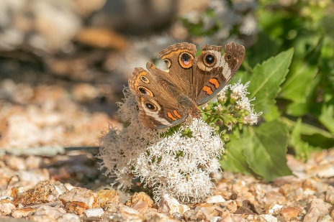
Communications Photo Awards – January 2026
January 2026 Communications Photo Awards
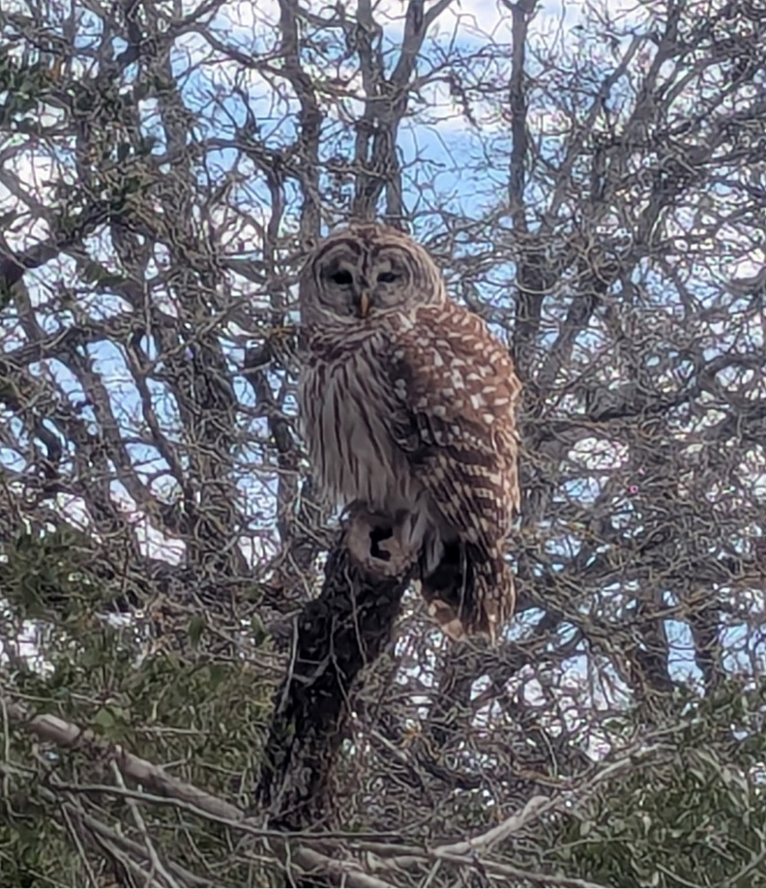
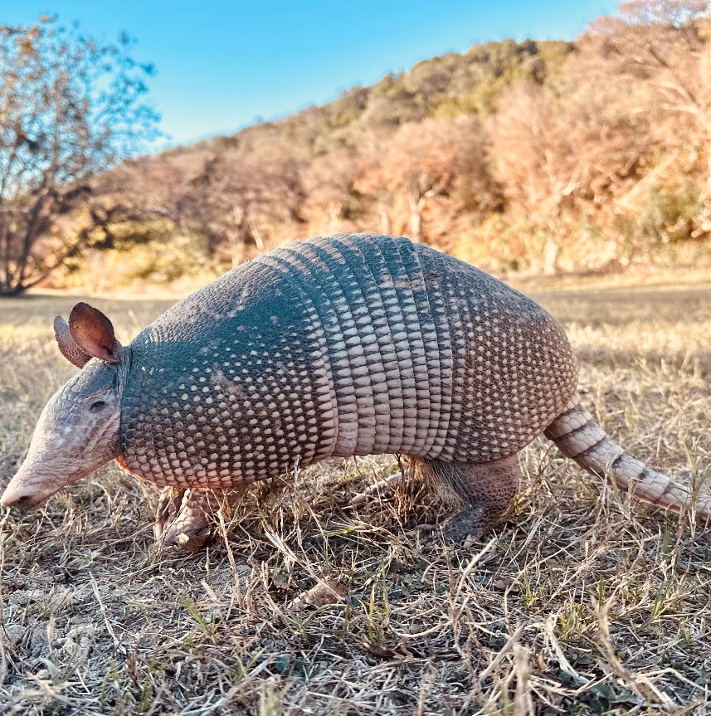
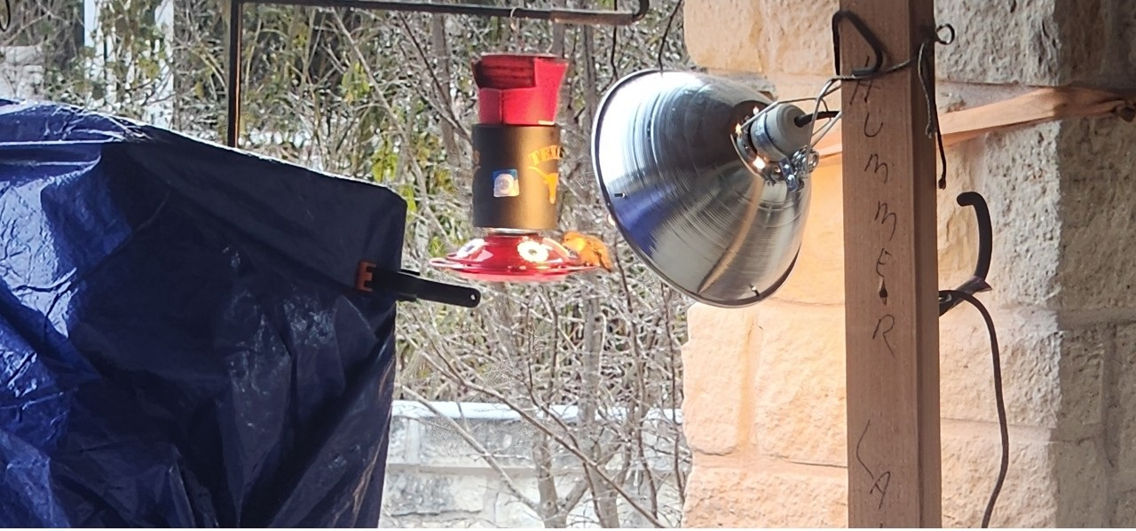
1st Place – Debbie Caraway “Warming Station”
2nd Place – Launi Poppaditch “Mexican Long-nosed
Armadillo”
3rd Place – Brenda Stoeck “Barred Owl”
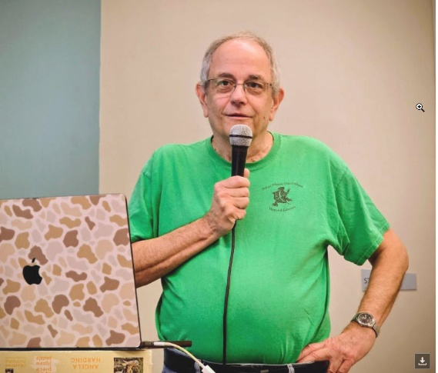
Communications Photo Awards – February 2026
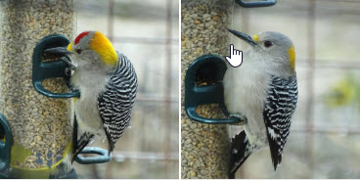
1st Place – Sue Sommer “February Speaker Jim Doyle”
2nd Place – Don Bergquist ”Golden fronted Woodpecker”
3rd – Michael Buley “Coral Snake”

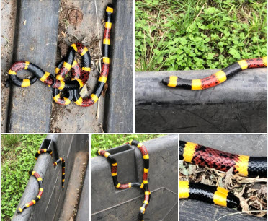
Ribbons are awarded to the members whose photos are the most popular (receive the most “views” on our FaceBook page) each month. 1st, 2nd, and 3rd place ribbons will be presented at the monthly meetings. All you have to do is submit your photos to LindheimerMNContact@gmail.com.
Thanks! Marilyn McFarland
Director, Communications
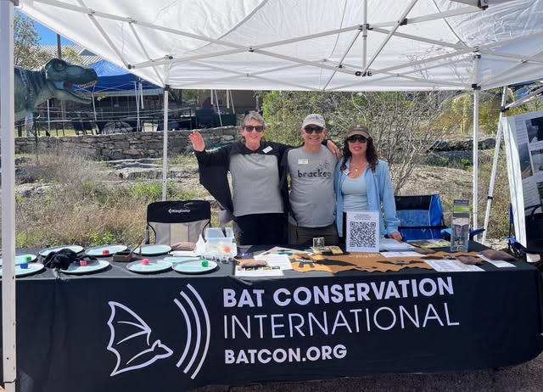
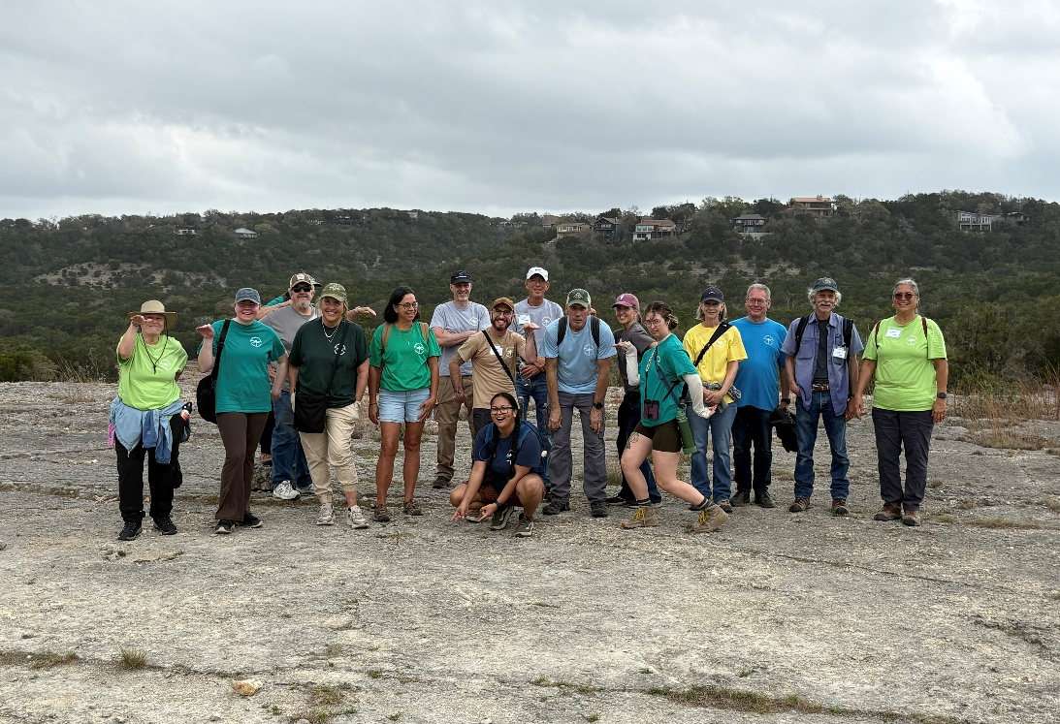
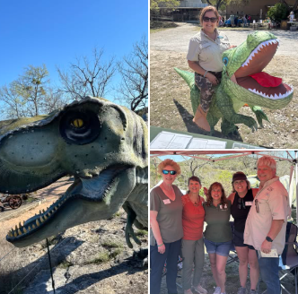
Communications Photo Awards – March 2026
1st Place – Mike Poffenberger “BatCon”
2nd Place – Amy Sharp “Bluebonnets at the Gorge”
3rd Place – Judy Henfey “DinoDays” Collage
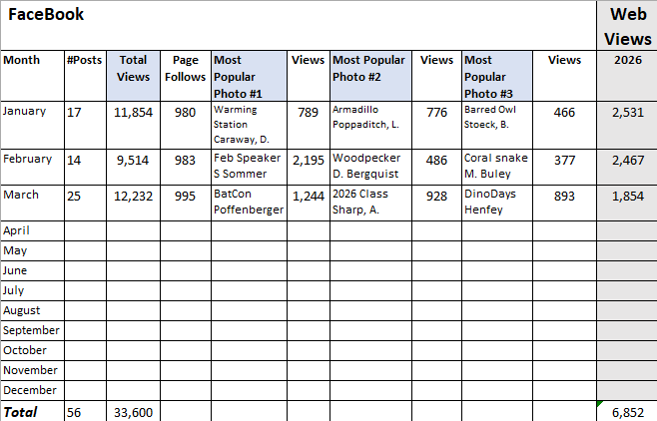
Web & Facebook Stats
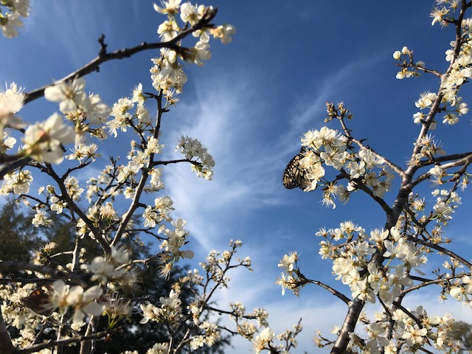

Chapter Recertifications and Milestone Awards
THANK YOU TO OUR VOLUNTEERS!
CONGRATULATIONS ON YOUR ACHIEVEMENT!

 | Recertifications | Milestone Awards
Jan | Susan Bogle, Jeanie Springer, Darlene Varga | 500 HOURS: Denise Miner-Williams, Tom Petray  25,000 HOURS: Susan Bogle
Feb | Trish Coons, Don Epps, Marian Henderson, Deb Kyrouac, Rob Kyrouac, Ron Lucik, Marilyn McFarland, Mike Poffenberger, Lois Ricci | 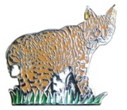  250 HOURS: David Meyer  1,000 Hours: Linda Valdez
Mar | Ellen Anderson, Jim Jameson, Brian Trock, Cheryl Trock, Caroline Broderick, Tim Killam, Teresa Turko, Debra Caraway, Don Bergquist, Edith Bergquist, Carolyn Andrews, Lisa Smith | 250 HOURS: Richard Andrews  500 HOURS: Miguelita Scanio, Mary Williams  5,000 Hours: Jim Jameson



2026 Class: The Bluebonnets

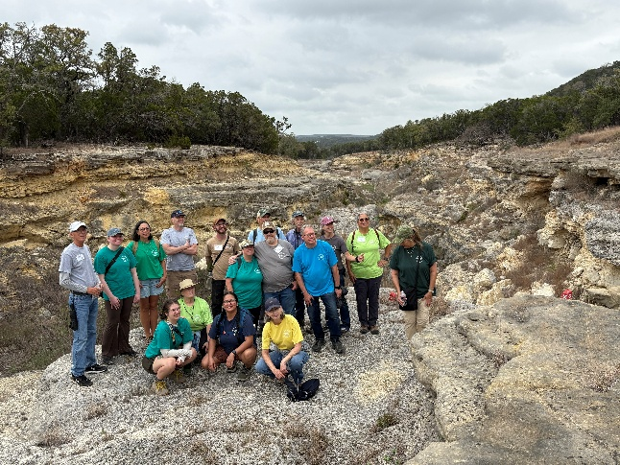

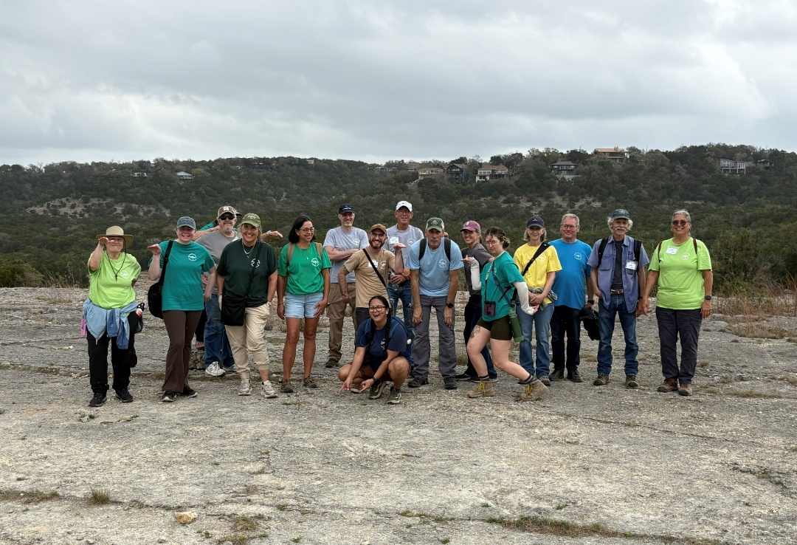

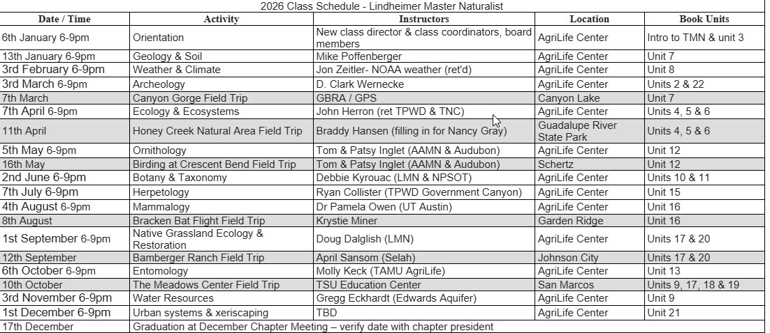

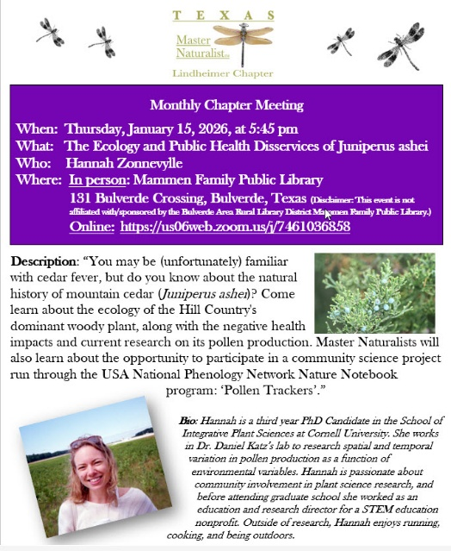
Monthly
Chapter
Meetings

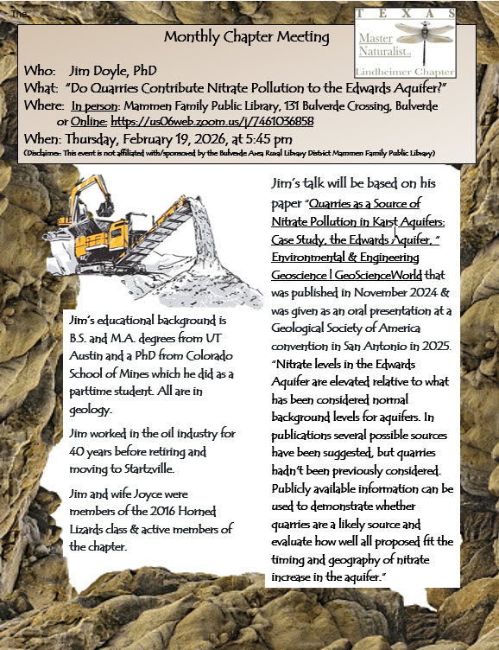

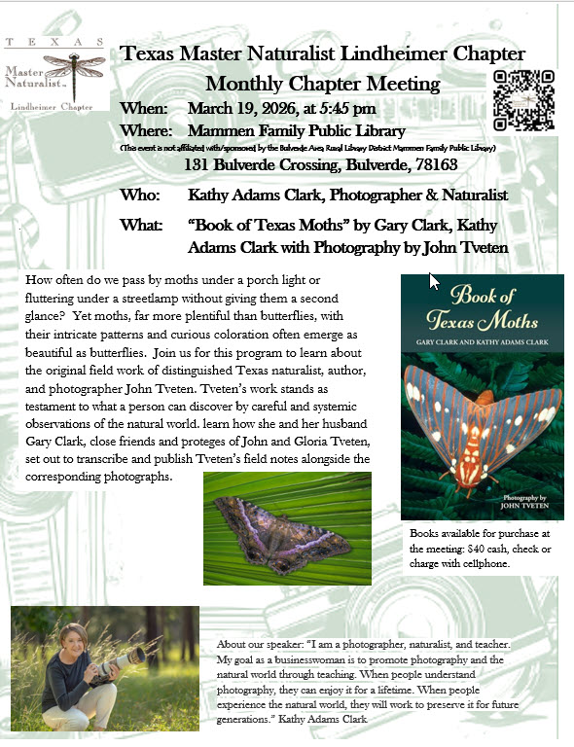

Contributing to Citizen Science: iNaturalist.org

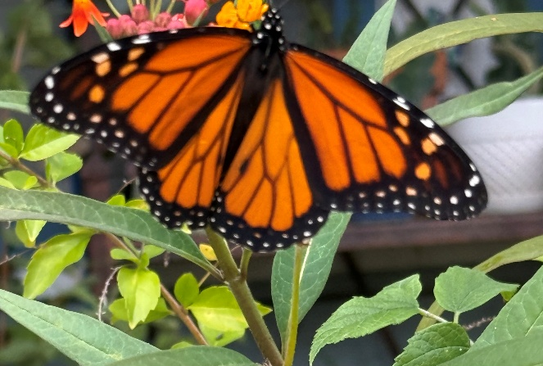
“Citizen Science” is the participation of non-scientists in scientific research. As naturalists, many of us already participate in community science projects that contribute to the body of scientific knowledge about plants, animals & insects: butterfly surveys, bird counts, plant identification. And we take pictures – LOTS of pictures! Each picture is an observation and represents an opportunity to increase the scientific knowledge of what, where & when. One of the largest community science projects is iNaturalist, a world-wide, on-line database of observations provided by community scientists like Master Naturalists.
“If enough people recorded their observations, it would be like a living record of life on Earth that scientists and land managers could use to monitor changes in biodiversity, and that anyone could use to learn more about nature.”
Photo by Laura Cavaretti

How to get started? Go to www.inaturalist.org and sign up!
Here are the iNaturalist numbers as of April 3, 2026. Take a look at Comal County!!!
Location | Observations | Species | Observers
World | 302,917,643 | 559,142 | 4,081,096
Texas | 14,635,598 | 30,920 | 218,319
Comal County | 238,370 | 6,140 | 8,679

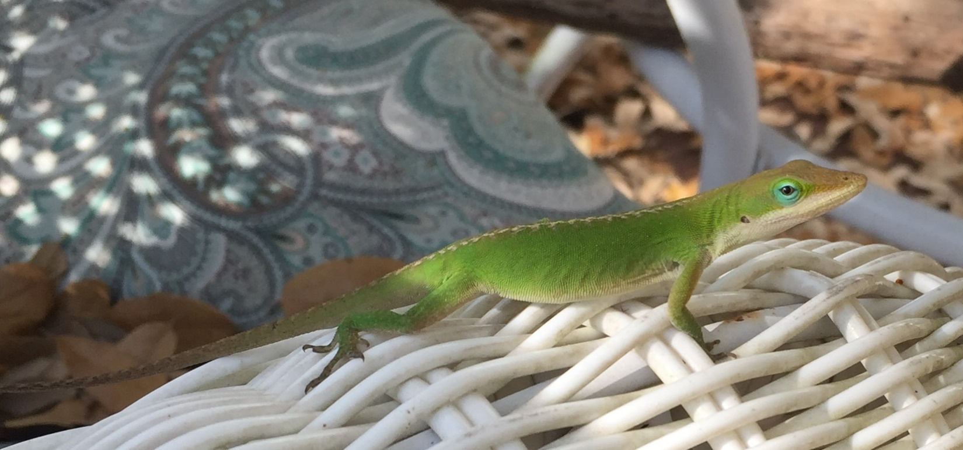
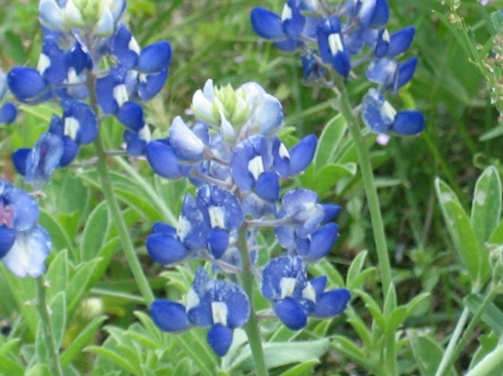
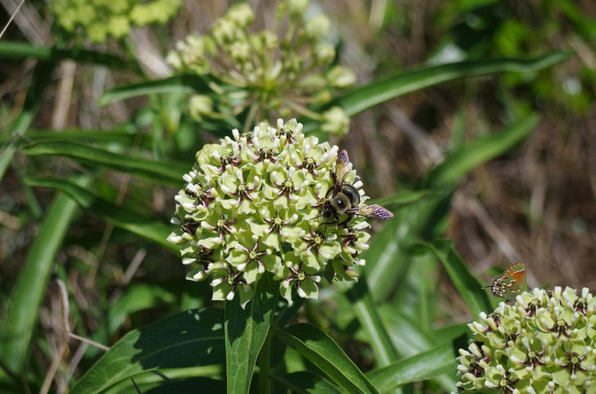

Four of the top ten iNaturalist observers in Comal County are Lindheimer Chapter members! Wow! That’s dedication to citizen science!

Observations
Darlene Varga 28,178
Edith Bergquist 7,220
Don Bergquist 4,426
Brian Trock 2,572


The Electronic Lindheimer

Website: www://txmn.org/lindheimer/ Take a look around our website to see what’s available!
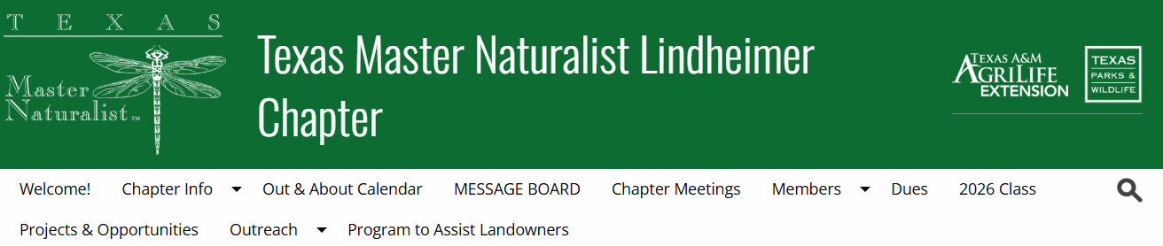

Facebook: www://facebook.com/txmn.lindheimer

