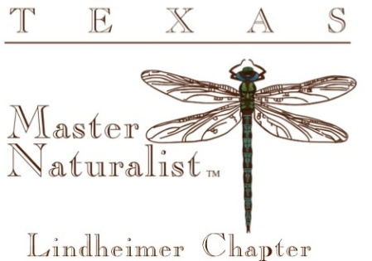
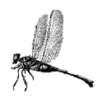
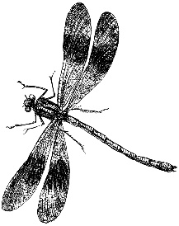
The Lindheimer Quarterly
2nd Quarter 2026

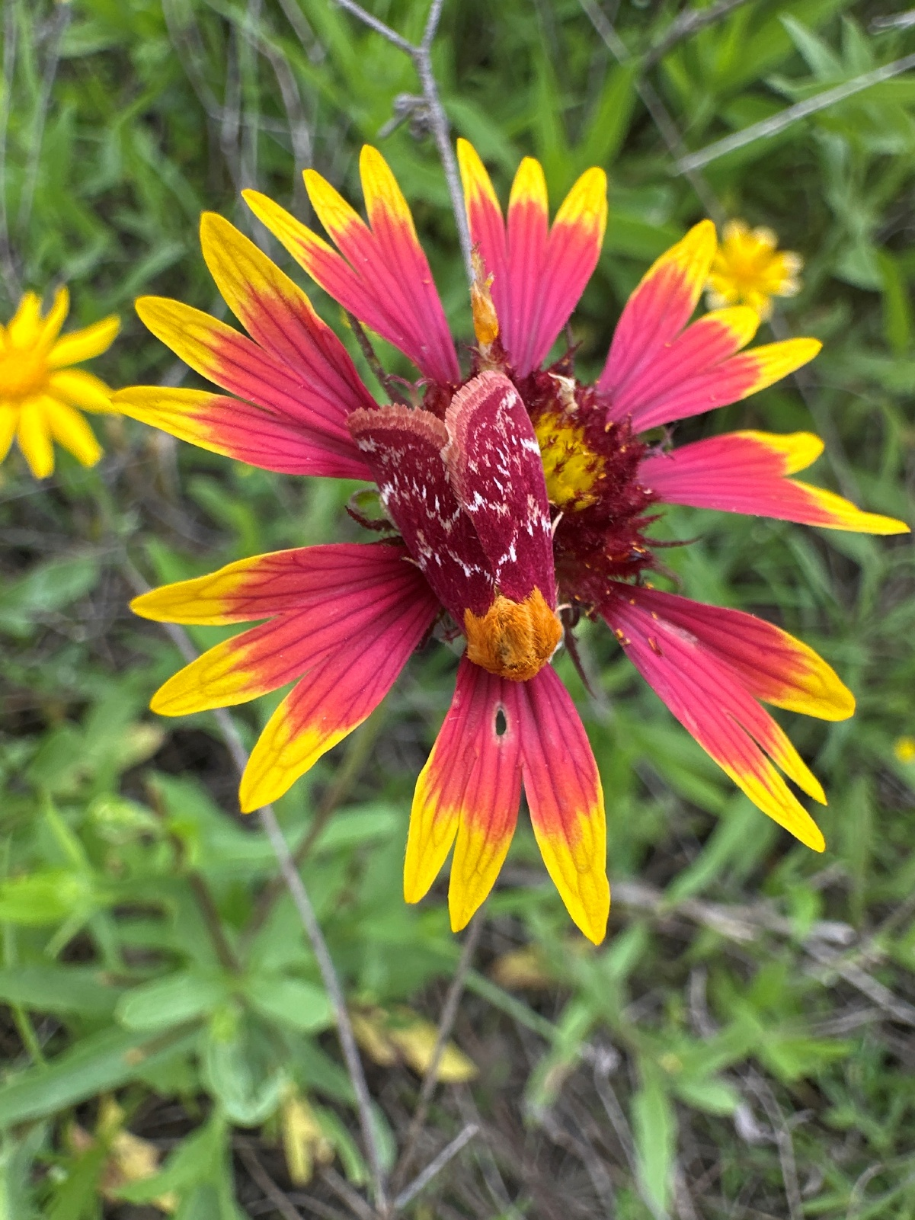
Photo by Caroline Broderick
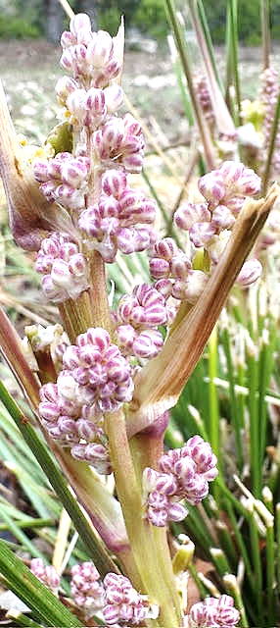

Sacahuiste nolina texana by Shari Ferguson The species name is from the state of Texas. Common names include "Texas sacahuiste", "bunchgrass", and "Texas beargrass".[
Nolina texana (Texas sacahuista) | Native Plants of North America

‘
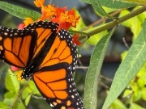
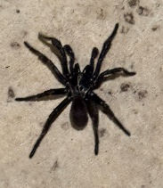
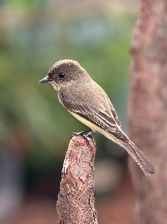
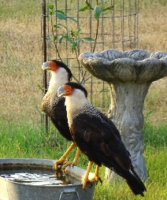
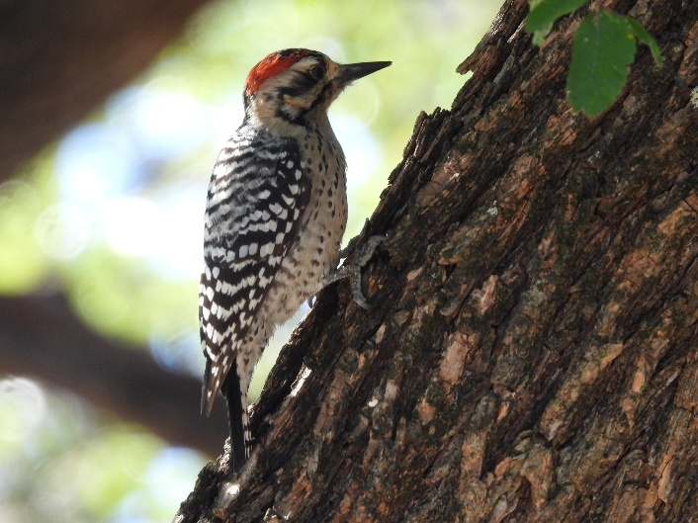
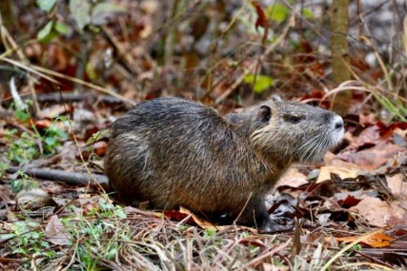
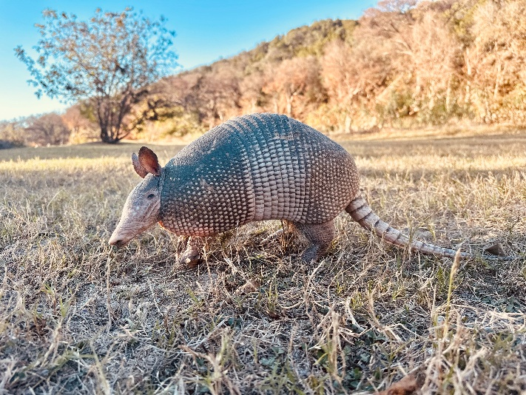
Chapter Information Page
2026 CHAPTER LEADERSHIP

OFFICERS

PRESIDENT Sue Sommer
VICE PRESIDENT Laurie Dugan
SECRETARY Rob Kyrouac
TREASURER Don Epps

COMMITTEES
Standing Committees
Education – Amy Sharp, Director
Membership & Records – Brian Trock, Cheryl Trock
Outreach – Debbie Kyrouac
Projects & Opportunities - Jeanie Springer

Subcommittees
Trunks – Deb Kyrouac
Program to Assist Landowners (PAL) – Caroline Broderick
Community Recognition – Michael Buley, Past President
Hospitality – Joni McGhee
New Class
Rep – William Netherland
Photographer – Jessica Farrer

COMMUNICATIONS
Director – MJ McFarland
Out & About – Sara Riggs

CHAPTER ADVISORS
Jason Mangold
Rachel Grotte

The Lindheimer Quarterly Newsletter
MJ McFarland – Editor
Newsletter published quarterly by the Lindheimer Chapter, Texas Master Naturalist™ to communicate, educate & inform chapter members & the Hill Country Community. Current and previous issues of The Quarterly are posted on the website https://txmn.org/lindheimer/whats-new

How to CONTACT Us
Email: LindheimerMNContact@gmail.com

Website: https://txmn.org/lindheimer

Facebook: https://www.facebook.com/txmn.lindheimer/

Snail Mail: Lindheimer Chapter
c/o Comal County AgriLife
325 Resource Dr.
New Braunfels, TX 78132

2026 Board of Directors Meetings
Every 4th Monday at 5:00 PM
Meetings are via Zoom
All members welcome

Zoom Link:
https://us06web.zoom.us/j/7461036858
Board Minutes available at:
https://txmn.org/lindheimer/chapter-info/lmn-board-members/lmn-board-minutes-archive/

2026 MONTHLY CHAPTER MEETINGS

Meetings are held in-person
or online every 3rd Thursday
(unless otherwise noted)
Click here Monthly Chapter Meeting
for the most up-to-date info

Sign-up to bring snacks: Lindheimer Master Naturalists: Lindheimer Master Naturalist Chapter Meeting Snacks

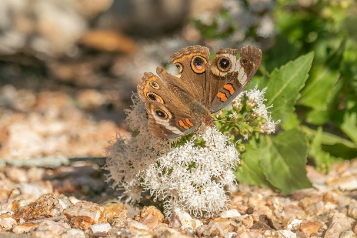
Photos clockwise from top L: Laura Cavaretta; Kris Moore, Laurie Dugan, Kris Moore, Nancy DeMarco, Cindy Goodrum, Launi Poppaditch, Edith Bergquist
The Black Bee Assassin Bug
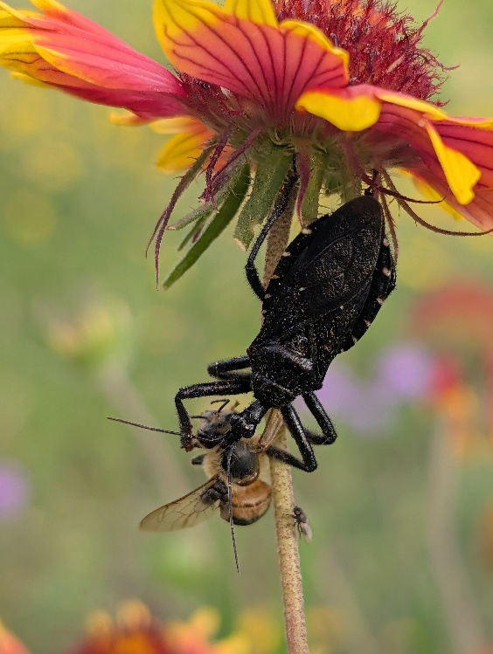
Lurking in the shadows of your garden is a deadly creature with the intimidating name of Apiomerus longispinis, the Black Bee Assassin Bug. The more you learn about this true bug, the more you realize it lives up to its name.

How do they stalk and kill their prey? Assassin bugs employ various specialized hunting strategies. Many are ambush predators, patiently waiting for unsuspecting insects. Others actively stalk prey, using camouflage. Some exhibit aggressive mimicry, such as spider-hunting species that pluck webs to lure arachnids, or those that secrete sticky substances to ensnare ants. Once prey is detected, the assassin bug uses its piercing-sucking mouthparts, called a rostrum, to deliver a quick strike. The bug injects venomous saliva through this rostrum, containing paralytic and digestive enzymes. This potent cocktail quickly immobilizes the prey and liquefies its internal tissues. The assassin bug then sucks out the digested contents because they don’t have chewing mouthparts. Their diet is varied, consisting of a wide range of insects and small arthropods. Common prey include flies, caterpillars, beetles, aphids, and leafhoppers. Some are specialized, like bee assassins that target bees, or those that prey on spiders. From “What Do Assassin Bugs Do? And Are They Dangerous? - Biology Insights”
Photo by Michael Laffey

For photos of assassin bugs, click here: Assassin Bugs of Texas

April 2026 Photo Winners
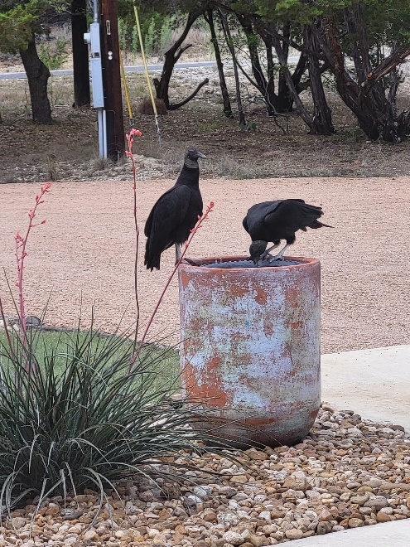
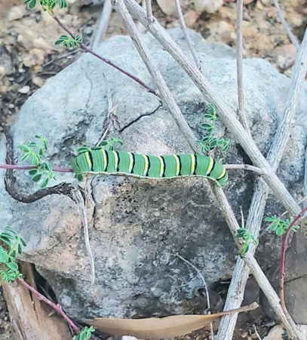
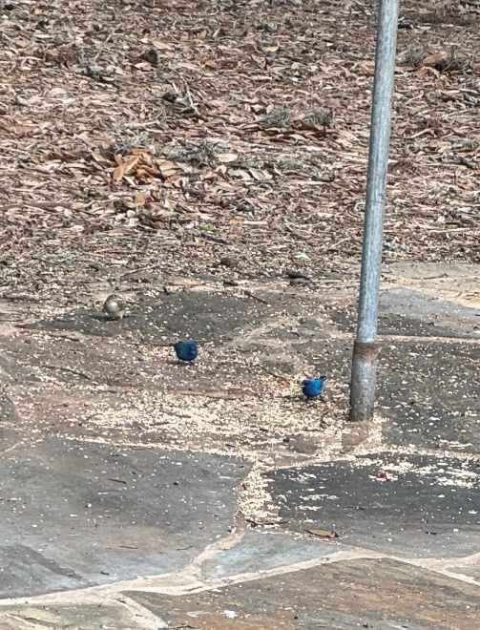
Photos by:
1st Loran Wilson
2nd Nancy DeMarco
3rd Caroline Andrews
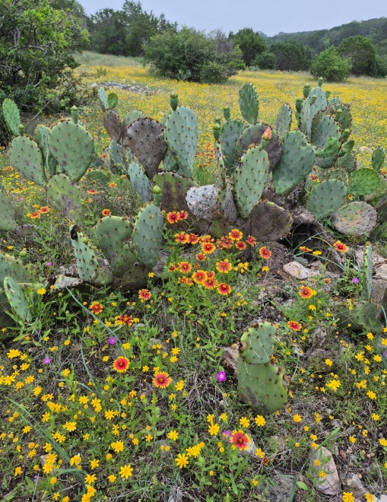
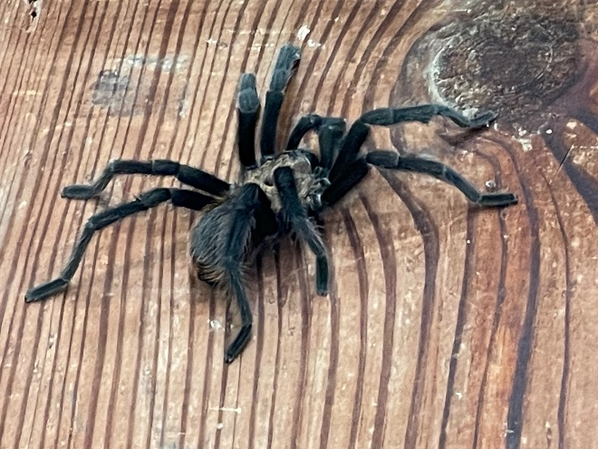
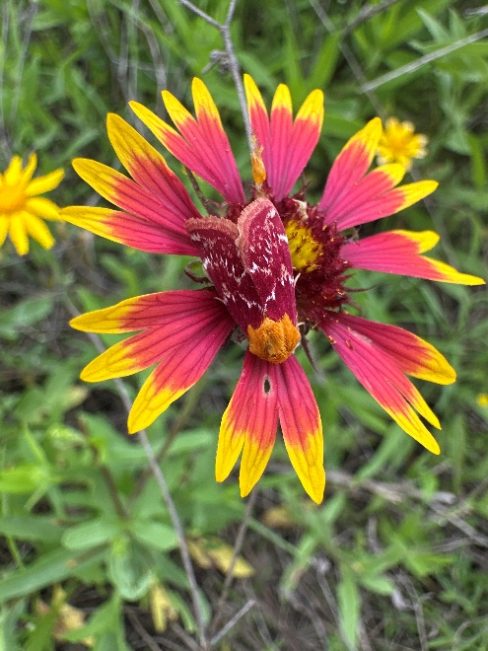
May 2026 Photo Winners
Photos by:
1st Teresa Turko
2nd Caroline Broderick
3rd Dwain Vann
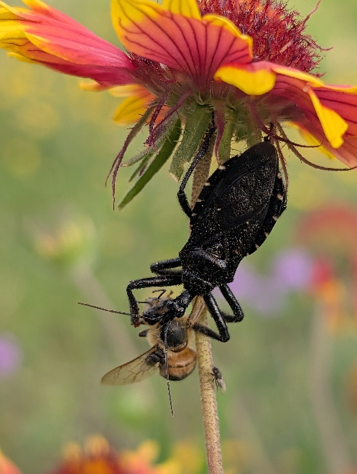
June 2026
Photo Winners
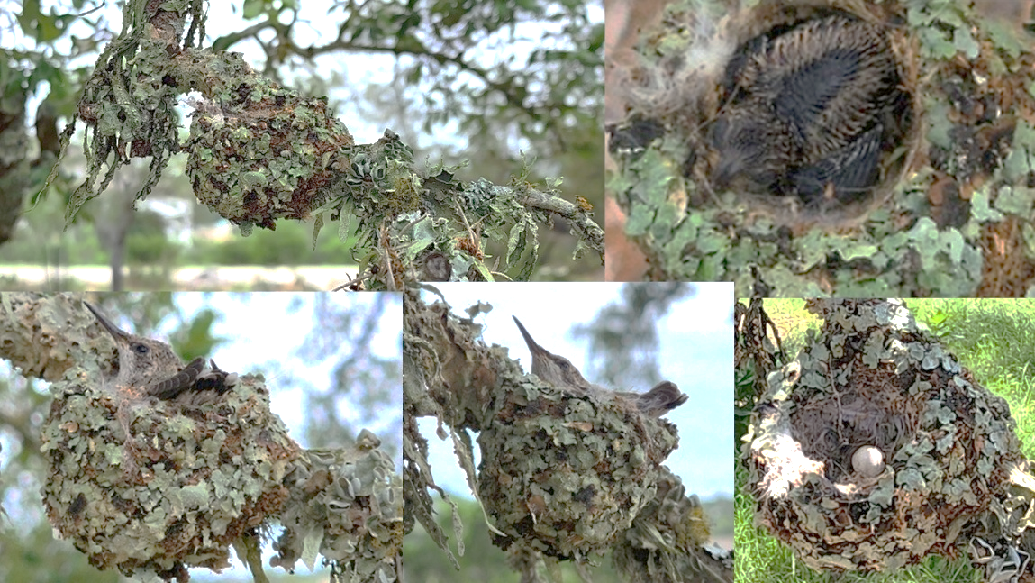
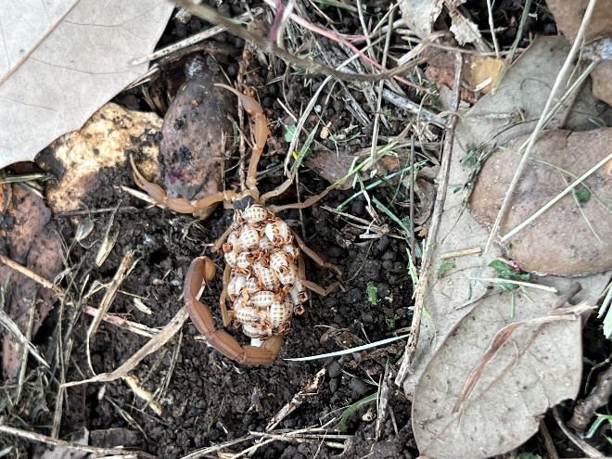
Photos by:
1st Michael Laffey
2nd Michael Buley
3rd Debbie Caraway

i

2026 Class: Bluebonnets

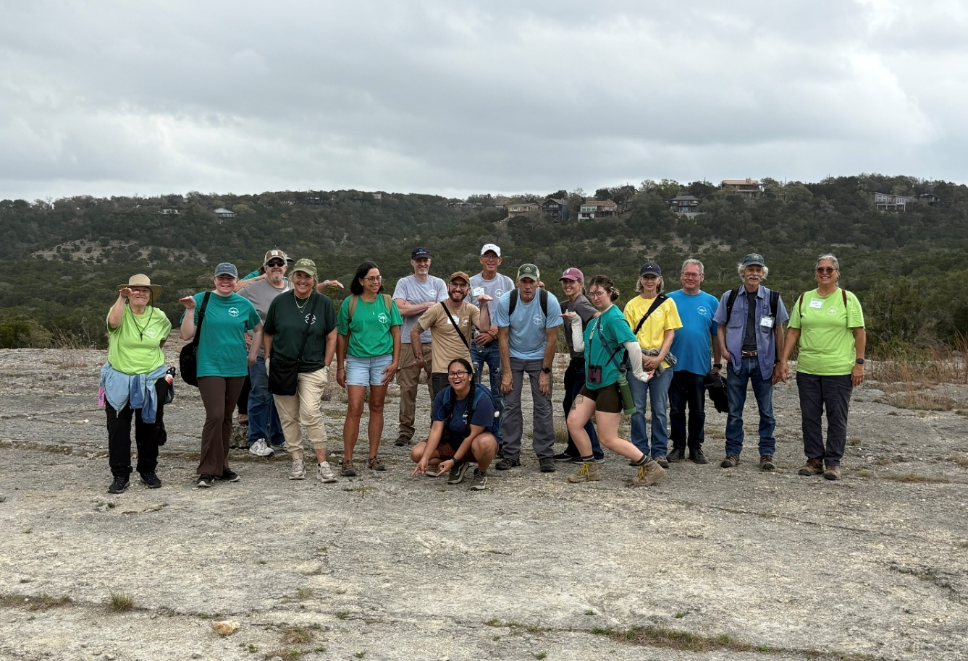

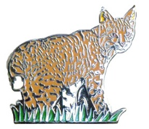
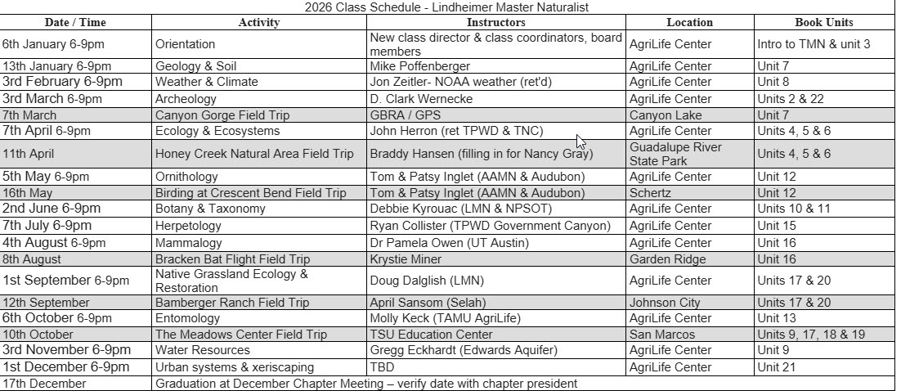
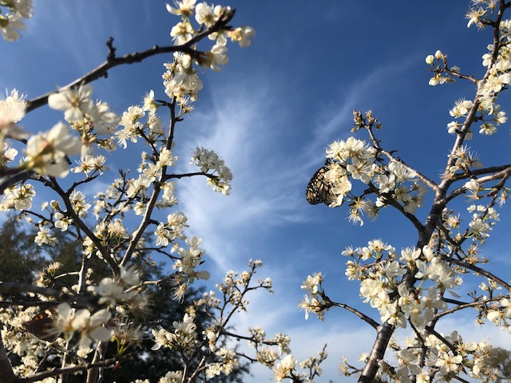
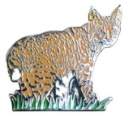
Chapter Recertifications and Milestone Awards
THANK YOU TO OUR VOLUNTEERS!
CONGRATULATIONS ON YOUR ACHIEVEMENT
Jan | Susan Bogle, Jeanie Springer, Darlene Varga | 500 HOURS: Denise Miner-Williams, Tom Petray  25,000 HOURS: Susan Bogle
Feb | Trish Coons, Don Epps, Marian Henderson, Deb Kyrouac, Rob Kyrouac, Ron Lucik, Marilyn McFarland, Mike Poffenberger, Lois Ricci | 250 HOURS: David Meyer  1,000 Hours: Linda Valdez
Mar | Ellen Anderson, Jim Jameson, Brian Trock, Cheryl Trock, Caroline Broderick, Tim Killam, Teresa Turko, Debra Caraway, Don Bergquist, Edith Bergquist, Carolyn Andrews, Lisa Smith | 250 HOURS: Richard Andrews  500 HOURS: Miguelita Scanio, Mary Williams  5,000 Hours: Jim Jameson
Apr | Robyn Cooke, Wendy Harter, Wendy Hill, Anne-Marie Kimball, Christy Martinez, Hazel McCarthy, Karen Meyer, Patricia Porterfield, Susan Sommer | 250 HOURS: Debra Caraway  500 HOURS: Carolyn Andrews  4,000 Hours: Ellen Anderson
May | Richard Andrews, Christina Campbell, Jennifer Clark, John Davis, Nancy DeMarco, Craig Dillion, Laurie Dugan, Gail Groves, Rhonda Neel, Ellen Petray, Tom Petray, Sara Riggs, Mike Roberts, Miguelita Scanio, Kelly Stinnette | 250 HOURS: Dick Bigelow  500 HOURS: Tim Killam
Jun | No recertifications this month. | 250 HOURS: Camille Tyler

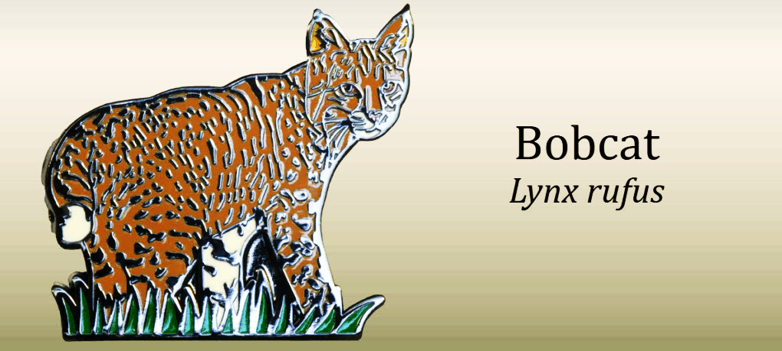

2026 TMN Recertification Pin: The Bobcat

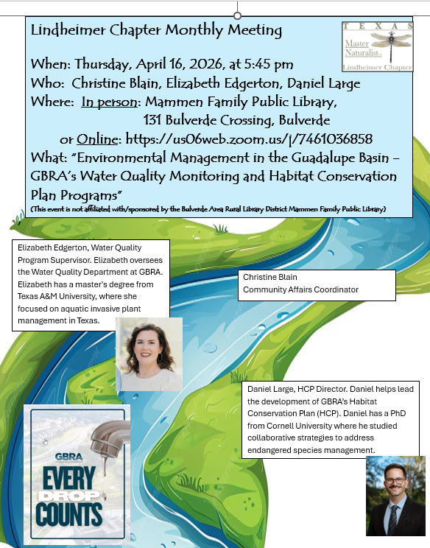
Monthly
Chapter
Meetings

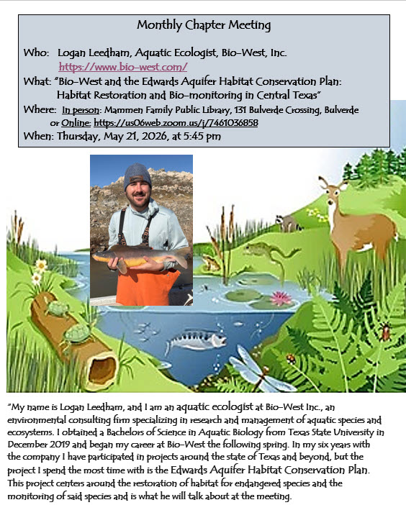

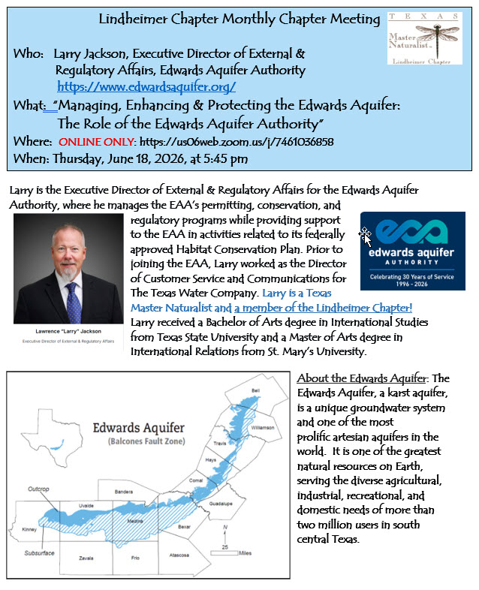

Chapter Meetings are every 3rd Thursday at 5:45 PM unless otherwise noted. Meetings are in person and online. Most current information and online address can be found on our website here: Monthly Chapter Meeting

Contributing to Citizen Science: iNaturalist.org

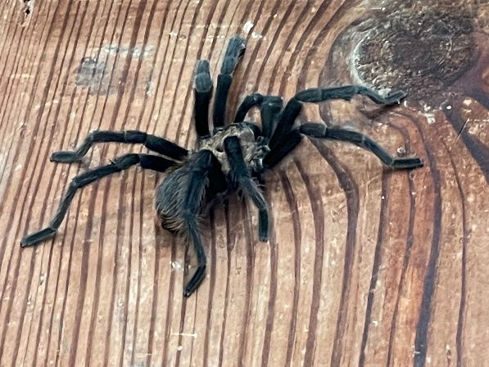
“Citizen” Science is the participation of non-scientists in scientific research. As naturalists, many of us already participate in community science projects that contribute to the body of scientific knowledge about plants, animals & insects: butterfly surveys, bird counts, plant identification. And we take pictures – LOTS of pictures! Each picture is an observation and represents an opportunity to increase the scientific knowledge of what, where & when. One of the largest community science projects is iNaturalist, a world-wide, on-line database of observations provided by community scientists like Master Naturalists.
“If enough people recorded their observations, it would be like a living record of life on Earth that scientists and land managers could use to monitor changes in biodiversity, and that anyone could use to learn more about nature.”
Photo by Dwain Vann

How to get started? Go to www.inaturalist.org and sign up!
Here are the iNaturalist numbers as of July 3, 2026. Take a look at Comal County!!!
Location | Observations | Species | Observers
World | 330,650,368 | 571,924 | 4,285,619
Texas | 15,911,469 | 31,748 | 228,299
Comal County | 262,798 | 6,355 | 9,314

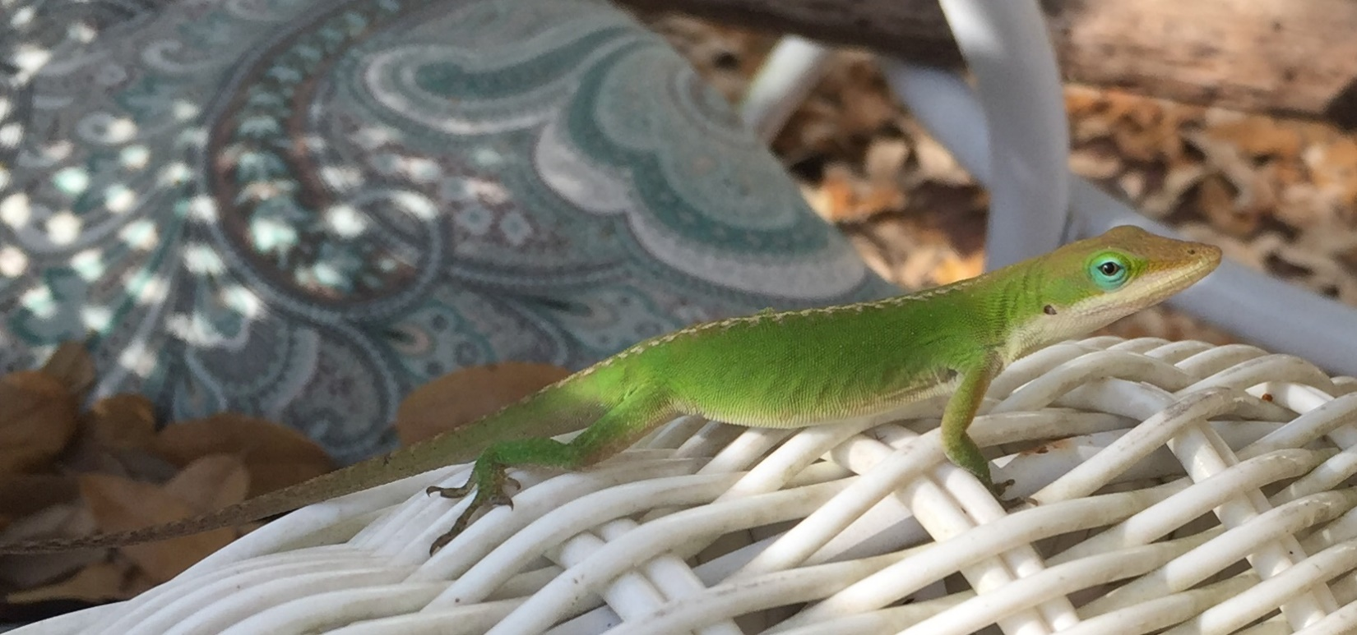
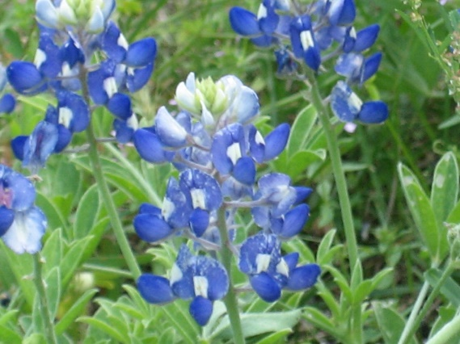
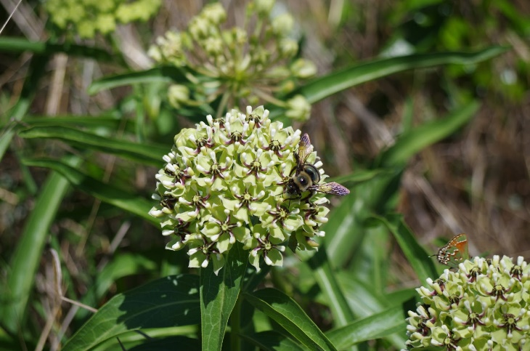

Many of our members contribute to iNaturalist! Four of the top ten iNaturalist observers in Comal County are Lindheimer Chapter members! That’s dedication to citizen science!
Observations in Comal County as of July 3, 2026
1 Darlene Varga 29,607
2 Edith Bergquist 7,220
3 Don Bergquist 4,426
4 Brian Trock 2,572

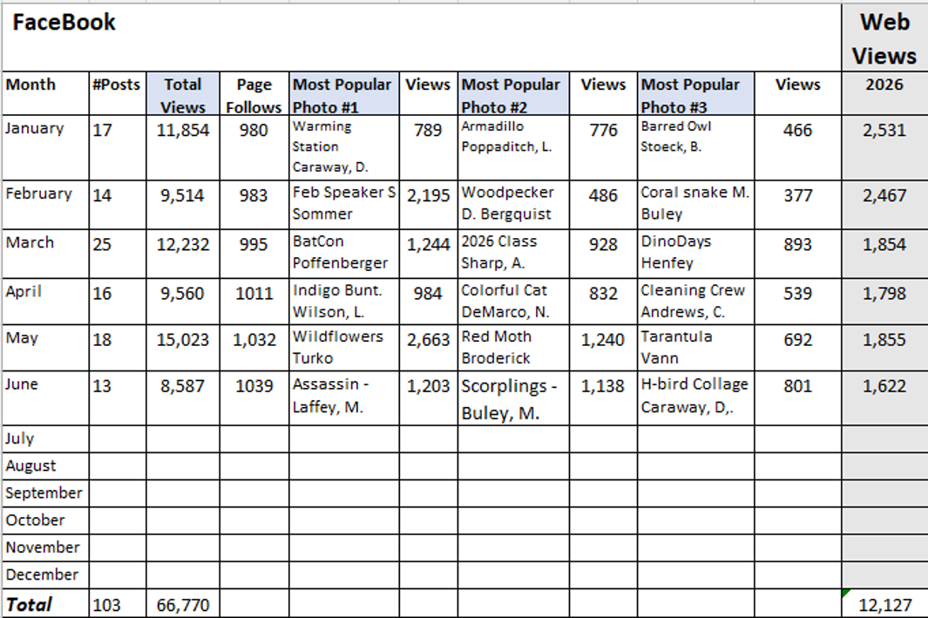
Web & Facebook Stats


The Electronic Lindheimer

Website: www://txmn.org/lindheimer/ Take a look around our website to see what’s available!
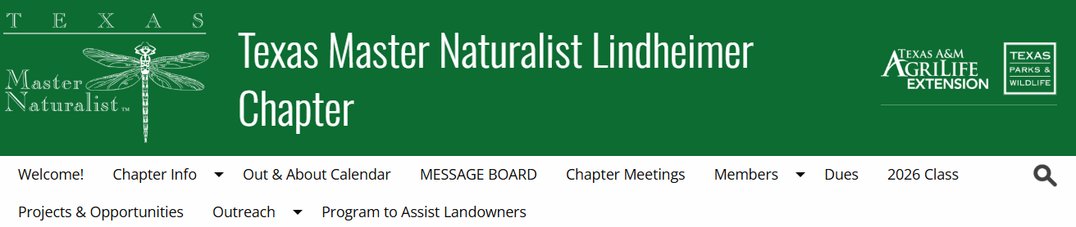

Facebook: www://facebook.com/txmn.lindheimer

