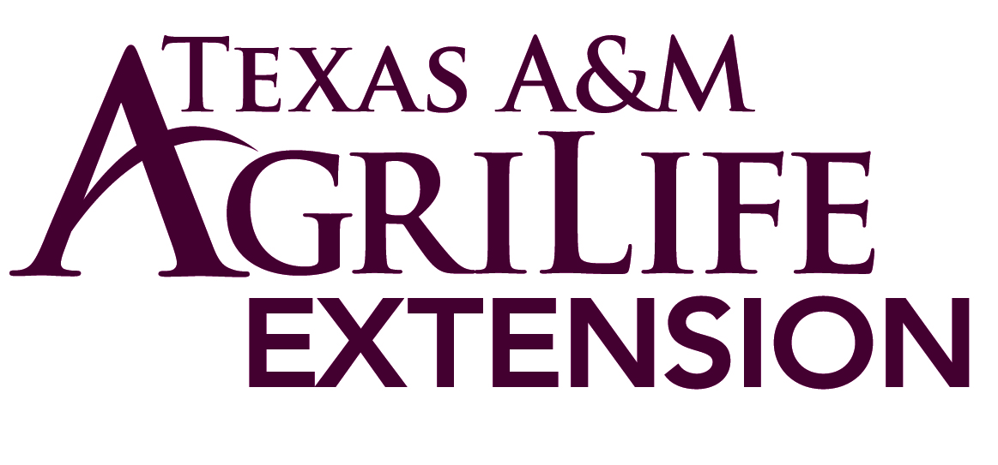
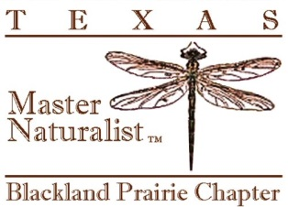
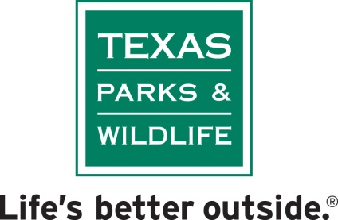
Volunteer Service Agreement
We appreciate your commitment to the Blackland Prairie Texas Master Naturalist Program. Your satisfaction and progress in this volunteer position is important to us. Please read the following expectations and indicate your willingness to volunteer by signing the end of this form. Volunteers who can’t adhere to all items in this agreement may forfeit their certification as a Master Naturalist.
I understand that I am trained in the field of Master Naturalist and I am expected to extend research based information to the public on behalf of the Texas A&M AgriLife Extension, the Texas Parks & Wildlife and the Blackland Prairie Master Naturalists. In exchange for the training received I will:
- Commit to a minimum of 40 hours of Volunteer Service to the program each year
- Commit to a minimum of 8 hours of Advanced Training in the program each year
- Provide a record of service and training as directed by the Master Naturalist Program
- Comply with the Texas A&M AgriLife Extension Service Criminal Background Check policy which will be renewed every three years
When acting as a Master Naturalist volunteer I agree to:
- Consistently exhibit a positive professional manner to volunteers and clients
- Avoid conflict of interest – not use my Master Naturalist status to promote any commercial activity or private business
- Act in accordance with the highest standards of ethics:
  - Not physically, verbally or sexually harass/abuse anyone
  - Refrain from illegal or unsafe behavior
  - Dress appropriately and not use harsh language
I understand that, as a volunteer, I will not receive pay or employee benefits. I also understand that I am not covered by worker’s compensation laws in connection with my volunteer affiliation.
______________________________ _________________
Signature Date
_______________________________
Printed Name

