Texas Master Naturalists Mission Statement
To develop a corps of
well-informed volunteers
who provide education, outreach and service, dedicated to the beneficial management of natural resources and natural areas within their communities for the
State of Texas.
Dr. Rick Maxwell
825 N. McDonald Street Suite 150
McKinney, TX 75069
972.548.4232
r-maxwell@tamu.edu

- Conservation & Restoration
- Community Education & Outreach
- Independent or Group Projects
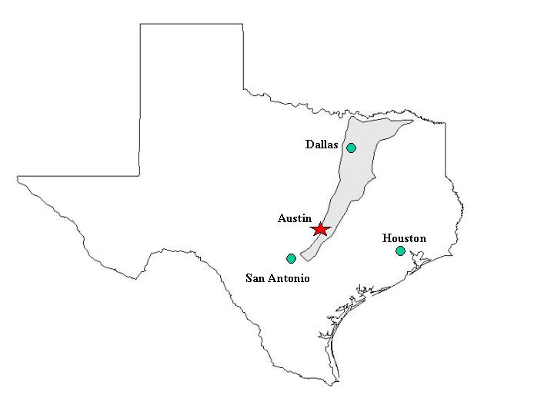
Texas’ Blackland Prairie
Like all 43 Chapters of Texas Master Naturalists, the Blackland Prairie Chapter is sponsored by:

Texas A&M AgriLife Extension
825 N. McDonald, Suite 150
McKinney, TX 75069
972.548.4232

Texas Parks and Wildlife Department

State Coordinator:

Michelle Haggerty, TPWD
Master Naturalist Program Coordinator
309 Sidney Baker South
Kerrville, TX 78028
830.896.2500
mhaggerty@wfscgate.tamu.edu

Blackland Prairie Chapter of
Texas Master Naturalists
P.O. Box 863175
Plano, TX 75086-3175
Visit www.bptmn.org
or email education@bptmn.org

Become a Texas Master Naturalist
2019 Certification Training
Presented by:
The Blackland Prairie Chapter of
Texas Master Naturalists
Visitors are welcome at Blackland Prairie Chapter meetings, held the second Tuesday of each month from 7 to 9 p.m., at
The Heard Museum
1 Science Place
McKinney, Texas 75069

2019 Certification Training Schedule
Feb 13 | Welcome  Ethics of a Texas Master Naturalist-CMDR Michael Mitchell TPWD, The Joy of Volunteering, Carol Clark BPTMN Member
Feb 20 | Green Fire- Aldo Leopold and a Land Ethic of Our Time. Film and discussion.
Feb 27 | Blackland Prairie: Geology  Diane Brownlee, Registered Professional Geologist
Mar 6 | Blackland Prairie Ecology – Sam Kieschnick, TPWD Urban Biologist
Mar 13 | Blackland Prairie Mammals and DFW Urban Wildlife – Brett Johnson, City of Dallas Urban Wildlife Biologist
Mar 20 | Blackland Prairie Soils and Rocks - BPTMN members Dick Zartler and Lorelei Stierlen
Mar 27 | What is a Plant and Plant Defenses – Dr. George Diggs, Austin College (retired)
Apr 3 | Birds of the Blackland Prairie – Gailon Brehm, BPTMN member and Prairie & Timber Audubon Society member
Apr 10 | Meteorology: North Texas Weather –  Dr. David Baker, Austin College
Apr 17 | Entomology: North Texas Insects  Dr. Mike Merchant, TAMU Professor & Extension Urban Entomologist
Apr 24 | Macroinvertebrates & Water Quality – LuAnne Ray, BPTMN member
May 1 | Trees of Collin County – David Powell, Mike Roome, Rick Travis, BPTMN members
May 8 | Heard Trail Walks – Carol Clark, Melanie Schuchart, LuAnne Ray, Bill Woodfin and David Powell, BPTMN members
Class Field Trips - Saturdays
Feb. 16– Holifield Science and
Learning Center 9:30-11:30am
Mar.16–Birding in the Connemara 8-11am
Mar. 23-Lewisville Lake Environmental Learning Area 9am -noon
Apr. 6 – Blackland Prairie Raptor Center
10:30am-3:30pm
May 4 –Parkhill Prairie Walk–Rich Jaynes
9am-11:30am
TBD – Erwin Prairie Restoration Tour and
TBD - Woodfin Farm Wildflower Walk

Make A Difference!
Interested in Nature?
Care about our environment?
Enjoy volunteering?
How do I become a
Certified Texas Master Naturalist?
Tuition is $150.
- Complete 12 Classes and 3 Field Trips
- Obtain a minimum of 8 hours of approved advanced training
- Complete a minimum of 40 hours of
chapter-approved volunteer service
Applications available at www.bptmn.org
Class size limited, apply now.
Top Ten Reasons
to Become a
Master Naturalist
- To gain an appreciation for and an understanding of natural environments
- To build new friendships and working relationships
- To impress your friends with your ability to analyze scat
- To increase your knowledge of the “ologies” – ecology, geology, entomology, ichthyology, herpetology, ornithology and more
- To create a wildlife haven in your backyard
- To receive in-depth training from recognized experts in the field
- To wear grubby clothes and get your hands dirty
- To help children and adults in your community learn about Texas’ natural resources
- To learn how to conserve resources through rainwater harvesting or composting
- To make a difference in our world – today and tomorrow

