Kimberlie’s Recommended Setup for Backyard Mothing

Thank you to everyone who attended my presentation on Backyard Mothing at the July chapter meeting! (If you missed it, the recording is available at xxxxxxxxxxx.) I hope you are excited to see what moths and night-flying insects are in your own yard. Some first-time moth’ers have seen new DFW species, and you could be next! National Moth Week is the perfect time to visit a public event and get some ideas the easy way, but if you want to start in your own yard, I’ve come up with a list of equipment that I recommend. Feel free to email me at kimberlietx@gmail.com with any questions or for personalized recommendations.

Note: I am not endorsing these actual products and they do not include affiliate links. These are just examples, and I recommend you do your own search to find the best value. And definitely use what you already have around the house!

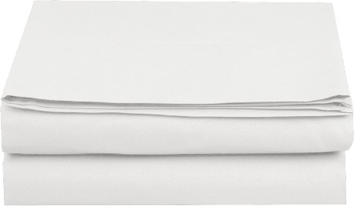
Queen size white cotton FLAT bedsheet / $15 est
Thread-count isn’t important here, so go for cheap! I recommend a white queen size flat sheet.

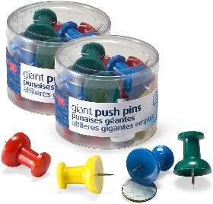
Large thumbtacks, clips, tape, or other way to hang the sheet / $8
https://amzn.to/3icnsYY
I prefer jumbo-size, brightly colored thumbtacks in case they drop in the grass. If you go with tape, make sure it won’t leave sticky residue when you remove it. Something like painters tape or masking tape.

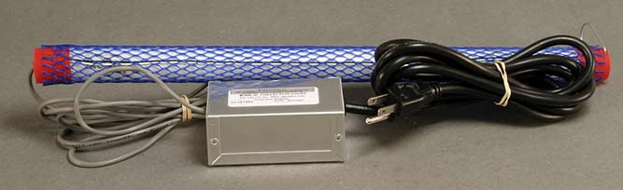
1 or 2 UV tube lights /$79 each
bit.ly/3AZ8w98
I use the Bioquip.net Night Collecting Light, AC, 120 V., 15 Watt BL Item#2806 1 will work fine, 2 will be better.

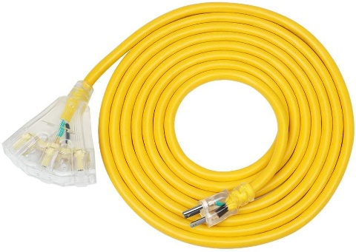
50’ Outdoor 3-prong Extension Cord with 3 outlets / $46
https://amzn.to/3z2lm4E
The tube lights will require an electrical outlet (or strong battery pack with 3-prong outlet.) I recommend 50 feet long, and choose a yellow or orange one for brightness so you don’t trip in the dark. You can also purchase a multiple prong attachment for your existing extension cord.

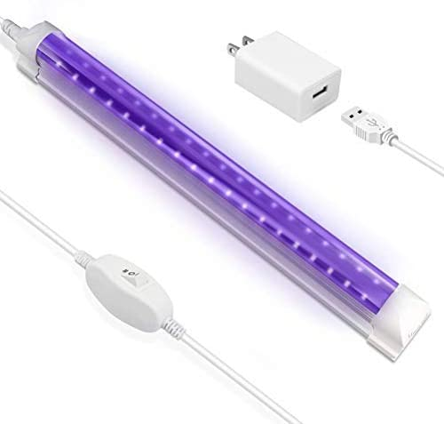
Ultraviolet Blacklight LED light bars /$13 per foot
https://amzn.to/3xN4UoM
First let me say the kind I use is not available anymore. They were cheap! Look around, as product availability will change. The link above is what I would choose if I had to buy today without price shopping, but it’s more expensive than I like!
LED light bars are not as moth-attractive as the tube lights, but they are available at more stores. (Check your home improvement store.) They are also super portable and don’t draw as much power to run. I recommend 4-8 feet total, connectable, USB connection with optional plug adapter.

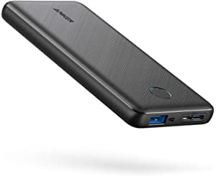
Portable battery charger / $20
https://amzn.to/3elS0Xe
If you go with the LED light bars, you’ll want a portable power source too. 10,000mAh should be plenty to run 10 feet of light bar all evening. In fact, if you google “Battery Life Calculator” you can see exactly what you need.

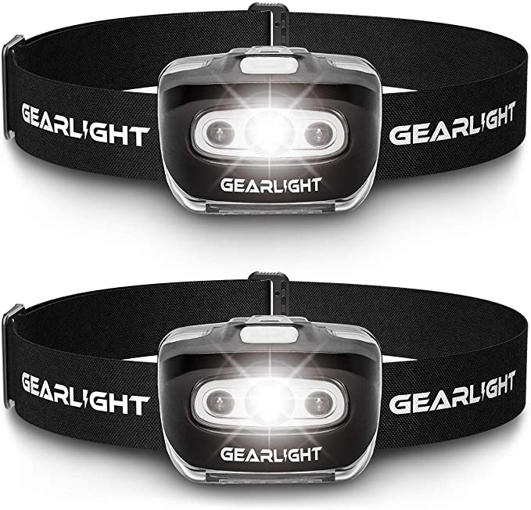
Headlamp / $14
https://amzn.to/3r8UeOQ
I prefer to wrap these around my wrist instead of my head so I don’t blind my mothing friends. If you can find one with only 3 modes, you can turn it off/on easily instead of having to click it 7 times to cycle through to off. Remember not to point it directly on the moth if you are taking a picture. Point it slightly off to the side so your camera will get the correct exposure setting.

Upcoming Public Events
- July 17 - Spring Creek Forest, Garland
- July 21 – Stephenville (Hosted by @pfau_tarleton)
- July 22 - John Bunker Sands, Seagoville
- July 24 - Acton Nature Center, Granbury
- August 21-22 - Maddin Prairie in Colorado City

I will be out at the Spring Creek Forest event in Garland. (As will Sam Kieshnick, of course.) I hope you’ll come by! And be sure to say hello!! Happy Mothing! ~Kimberlie

Websites
Bioquip.com (Scientific Supply Company)
MothPhotographersGroup.msstate.edu
nationalmothweek.org
iNaturalist.org
BugGuide.net

