Cyanotype

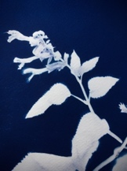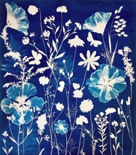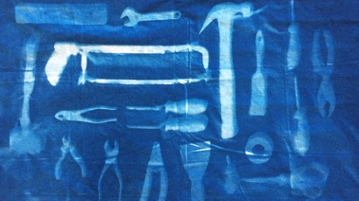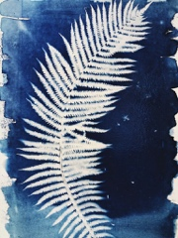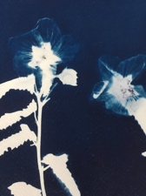

Cyanotype is a photographic process where ferric ammonium citrate is broken down by the action of light to form ferrous salt. These ferrous salts act as reducers on the potassium ferricyanide producing a precipitate of insoluble blue pigment (ferrous ferricyanide) known as Turnbull’s blue. The areas not exposed to light remain in their ferric state and are washed away in development.

Steps:
- Prepare your composition.
- Think of objects that let light through – marbles, thin petal flowers, feathers, lace, etc.
- Solid objects like a coin will block all light and make a solid white circle.
- Place paper yellow/green side up on the cardboard
- Place objects on paper (on yellow/green side)
- Place Plexiglass on top of everything
- Objects that cannot fit under Plexi, place on top of Plexi
- It is best to arrange your composition inside then take outside. That way the paper is not being exposed to sunlight while you are setting the objects on place.
- Place in FULL SUN (not the shade) Best time is between 10am-4pm
- Expose in sun for 20 minutes
- The longer the time the darker everything will be. Thicker objects will become less white and have a little more blue variations (such as thick flowers).
- The less time the lighter the blue, very thin objects will show better with less light (such as cicada wings).
- Wash the paper in running water for 5 minutes or until all yellow is off the paper and the water is clean.
- Optional – wash the paper in a hydrogen peroxide bath (1 cap of hydrogen peroxide in a small bucket of water) this will make the blues darker.
- Rinse in water – just a quick rinse to wash the hydrogen peroxide off.
- Let dry – best to dry inside- the sun is intense right now and can burn the wet chemistry.

Trouble Shooting
•faint image – needs more sun. Stronger sun and/or more time
•yellow or green stains. Wash in running water longer
•Dark blue but no image waited too long after coating or light tight bag didn’t keep light out.

You can find chemistry and precoated paper at the following stores. If you purchase chemistry, you will need to weight the dry chemicals and mix. Precoated paper is prepared sheets.
B&H Photo www.bhphotovideo.com/
Photographers Formulary https://stores.photoformulary.com
Adorama www.adorama.com
Bostick and Sullivan www.bostick-sullivan.com

