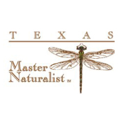
Texas Master Naturalist
Coastal Prairie Chapter

Public Outreach Report
- Instructions: IMPORTANT: Email a copy of this report and Sign In Sheet within 7 Days of event to:

Margo “Mac” McDowell - mmcdowell@ag.tamu.edu
Michelle Sullivan – michellesullivancpctmn@gmail.com

- If a volunteer service activity includes interaction with the public, it is considered an outreach event.
- There are two kinds of outreach:
  - DIRECT—meaning there was an actual hands-on or active teaching component for the majority of the event with a captive audience.
  - INDIRECT—manning a booth or display sponsored by your chapter.
- One member should be responsible for capturing and reporting the headcount.
- If an accurate count is not possible, an estimate is better than no data at all.
- Please complete ALL questions.
___________________________________________________________________________

Name of Event or Activity (Direct or Indirect):

Location:

Date of Event or Activity (month, date & year):

Chapter Member Submitting Report:

Number of Children (19 years and younger):

Number of Adults:

Total Number of Persons Reached:

Please tell us about the Event:

