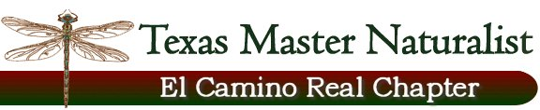
Executive Board Meeting
June 29, 2015

Time: 11:00am in Cameron, Texas

Members: Barb Cromwell, Cindy Bolch, Katherine Bedrich, Sandra Dworaczyk

Meeting was called to order by President Cromwell.

The updated By-Laws, issued by the State issued last December were discussed. The Executive Board accepted the By-Laws unanimously with inclusion of:
- Article V Section G – Terms and Limits – to read … shall serve for a period of 24 months…

- The Addendum for 501 ( c ) ( 3 ) Chapter.

President Cromwell will send acceptance to State Program Coordinator Michelle Haggerty for approval. A copy will be sent to our Chapter Advisor, Timothy Siegmund and to the Board.

An Ad Hoc committee will be formed to review the re-drafted Chapter Operating Handbook. The committee will present the new COH to the Board by August 28, 2015.

A Board meeting is scheduled for Monday, July 13th at 11:00am in Rockdale. The agenda will include the new Volunteer System for recording hours, forming a nominating committee, and members involvement in the standing committees.

Progress of the Bird Brochure / List was discussed. President Cromwell will form an Ad Hoc Committee to complete the project by the end of October 2015.

Meeting adjourned at 2:00pm. Motion by Sandra Dworaczyk, seconded by Cindy Bolch. Motion carried.

Minutes submitted by:
Katherine Bedrich

