Blotched Water Snake

Nerodia erythrogaster transversa

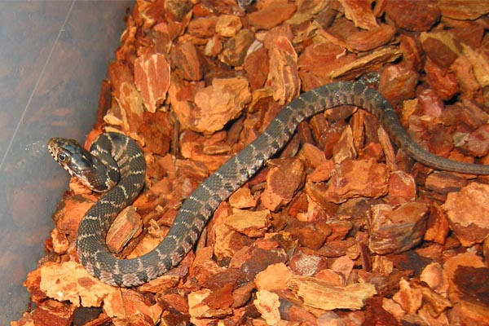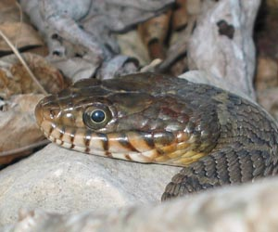

Source of Photos: www.blairsociety.com

DESCRIPTION

- Brown body with faint lines forming a pattern on its back
- Solid yellow chin and belly
- Small eyes with round pupils
- Average 3 feet long

LIFE CYCLE

- Breed in spring
- Young born in late summer or fall
- Ovoviviparous (Live-bearers) – young are 8”-10” in length
- Capable of bearing a brood of 90, but usually less.

BEHAVIOR

- Non-venomous
- Nasty disposition - sometimes mistaken for the venomous “water moccasin” or “cottonmouth.” Upon approach, it will coil up, vibrate its tail, assume a strike posture, and flatten its body near the head to appear larger than it is.
- When threatened, it will strike and bite, drawing blood.
- Exudes a foul-smelling musk odor
HABITAT

- In or near bodies of water
- Backyard fish ponds
- On tree branches over water

FOOD

- Fish, amphibians

SOURCES

- http://bugsinthenews.com/blotched_water_snake%20042803.html
- http://www.austinreptileservice.net/blotches.html
- http://www.blairsociety.com/Nerodiaerythrogastertransversa.html
- http://hartmanprehistoricgarden.com/sa-nerodia_ery.html
- http://www.birdsandherps.com/bvsnakes/
- http://www.blairsociety.com/Herpetology.html

