Broad-banded Water Snake

Nerodia fasciata confluens

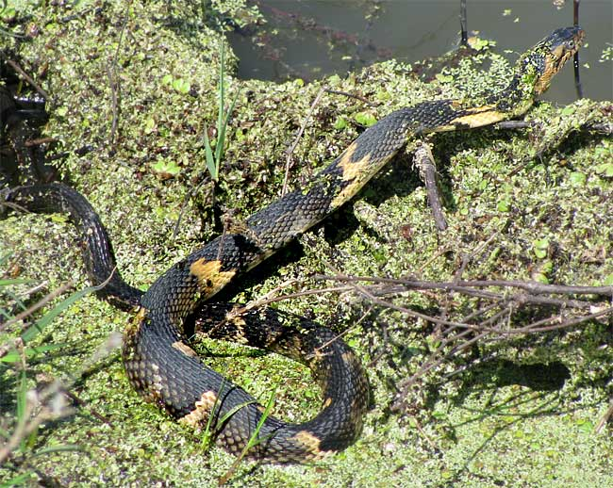

Photo by Jim Conrad, http://www.backyardnature.net

DESCRIPTION

- A subspecies of the Southern Watersnake.
- a medium-bodied species.
- Patterned with dark, wide, brown, olive or black bands, separated by lighter, irregular-shaped bands.
- The lighter bands are usually tan or light orange.
- Reddish-brown blotches are sometimes present on the sides.
- Round eyes with round pupils.
- The belly is boldly patterned in checkerboard blotches of dark red/brown and lighter tan/orange.
- 20-30 inches long

LIFE CYCLE

- Mate in the spring
- Live birth in the summer

BEHAVIOR

- Generally shy; will try to flee through the water rather than fight.
- When threatened, one will usually coil up, and flatten its head, making it look arrowhead-shaped.
- They will also vibrate their tail (which has no rattles) and emit foul smelling musk.
- They will strike out repeatedly at whatever is threatening them.
- Active day or night, but most foraging is done at night.

HABITAT

- In and around water, preferably quiet, shallow waters
- and in yards that are frequently watered.

FOOD

- Toads and frogs.

SOURCES

- http://www.houstonherp.com/BroadBandedWS.html
- http://herpsofarkansas.com/Snake/NerodiaFasciata
- http://www.bugsinthenews.com/Texas%20Snake%20Web/Broad-banded%20Water%20Snake%20(Nerodia%20fasciata%20confluens)%20041107%20Cinco%20Ranch%20Katy%20Texas%20Christer%20R.htm
- http://www.birdsandherps.com/bvsnakes/
- http://www.backyardnature.net
- Texas Snakes; a Field Guide, James R. Dixon and John E. Werler, UT Press, Austin, 2005, pp. 206-207.

