Coachwhip

Masticophis flagellum ssp.

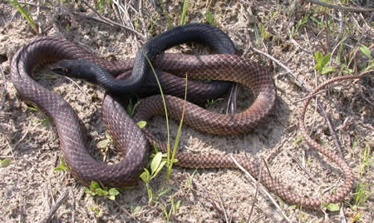

Photo by J.D. Willson, reprinted with permission.

DESCRIPTION

- Color ranges from solid brown to solid tan, to wide brown and tan bands.
- Thin-bodied, small heads, large eyes with round pupils.
- 4 – 6 feet in length.
- Non-venomous.

LIFE CYCLE

- Mate in the spring
- Females lay up to 24 eggs in early summer.
- Eggs hatch in the late summer or early fall.
- Predators include hawks, coyotes, and raccoons.

BEHAVIOR

- Diurnal (active in daytime).
- Very heat tolerant – often seen in the hottest months when other snakes are inactive.
- Very fast.
- When cornered, they can raise the front third of their bodies off the ground.
- They will bite.
- Sometimes “play dead” by hiding their head under their coils or under the ground.
- In tall grass, they often hold their head up high for observation.
- Able to climb small trees and brush.

HABITAT

- Open areas with sandy soil
- Post oak savanna
- Open pine forests
- Old fields
- Prairies

FOOD

- Reptiles
- Rodents
- Birds

SOURCES

- http://www.austinreptileservice.net/bands.html
- http://en.wikipedia.org/wiki/Masticophis_flagellum
- http://www.srs.fs.usda.gov/pubs/ja/ja_johnson026.pdf (“Spatial Ecology of the Coachwhip, Masticophis flagellum (Squamata: Colubridae), in Eastern Texas,” in Southern Naturalist 6(1):111–124 2007, by Richard W. Johnson, Robert R. Fleet, Michael B. Keck, and D. Craig Rudolph.)
- http://srelherp.uga.edu/snakes/masfla.htm

