Intergraded Kingsnake
Lampropeltis getula

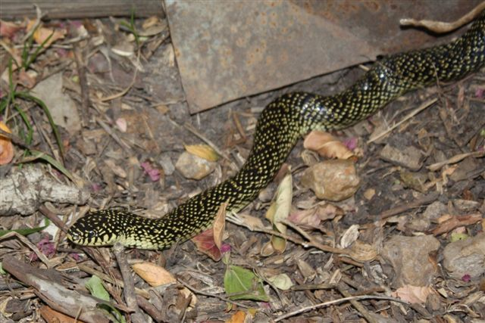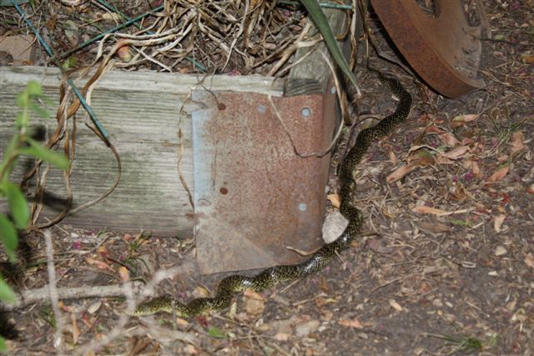
Photo by Katherine Bedrich Photo by Katherine Bedrich

The Intergraded Kingsnake (Lampropeltis Getula, Holbrooki X spendida) is the result of the overlapping ranges of two subspecies of Lampropeltis Getula, the Desert King Snake and the Speckled King Snake in central Texas.

DESCRIPTION

- Black body with orange or yellow speckling that forms a chain or blotch pattern on its back
- Stout body of uniform thickness for the entire length
- Average length is 3 to 4 feet

LIFE CYCLE

- Oviparous; females lay up to several dozen eggs from June to August
- Eggs hatch after two to two-and-a-half months of incubation
- Breeding takes place from May to late June (after a 2 to 3 month period of cooler weather)

BEHAVIOR

- Usually docile; a popular pet snake.
- When threatened, they will shake their tails like a rattlesnake.
- Also musk or defecate or bite when threatened.
- Diurnal, except during the hottest weather

HABITAT

- Open areas preferred, especially grassland
- Also oak woodland, abandoned farms, sand, riparian zones

FOOD

- Other snakes, including venomous snakes
- Amphibians, turtle eggs lizards, small mammals (which they kill by constriction)

SOURCES

- http://en.wikipedia.org/wiki/Lampropeltis_getula#Common_names
- http://www.austinreptileservice.net/blotches.html
- http://en.wikipedia.org/wiki/Lampropeltis_getula_holbrooki
- http://www.kingsnake.com/king/getula/ggetula.html
- Texas Snakes; a Field Guide, James R. Dixon and John E. Werler, UT Press, Austin, 2005, pp. 168-171.

