Texas Brown Snake
Storeria dekayi texana

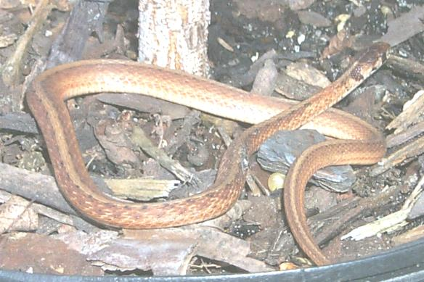 Source: Houstonherp.com

DESCRIPTION
- Fairly evenly colored brown to tan, sometimes brick red
- A faint lighter stripe down the middle of the back
- Dark brown spots around the eyes.
- Hatchlings measure 3-1/2 to 4-1/2 inches; adults average 12 inches

LIFE CYCLE
- Ovoviviparous, meaning internal fertilization; embryos develop inside eggs
- Hatch as live snakes.
- Mating occurs in spring
- Females bear 3-15 live young in August, early September

BEHAVIOR
- Non-venomous
- Defends itself by imitating venomous snake, coils, raises its head, and strikes out.
- Because of its diet of snails and slugs, it is the gardener’s friend

HABITAT
- Cool, dark, moist soil of woodlands;
- Thick grass mats and garden mulching in urban areas

FOOD
- Snails and slugs primarily
- Also insects, spiders and cricket frogs.

SOURCES
- http://www.texassnakes.net/index.htm
- www.houstonherp.com/TxBrown.html
- http://www.youtube.com/watch?v=Bds8P-88kq4 - a very good video displaying the difference between Texas Brown Snake and Southern Copperhead
- http://www.austinreptileservice.net/solid.html
- Wikipedia
- Personal Experience

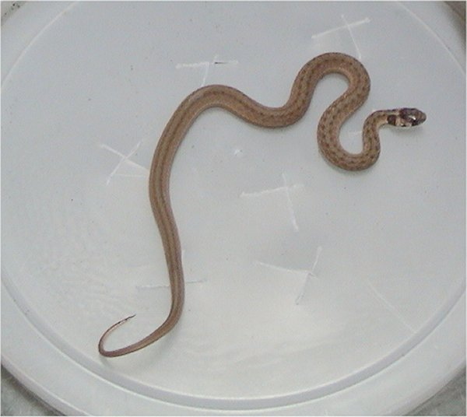
Photo by Adam Dawson.

