Texas Coral Snake

Micrurus tenor

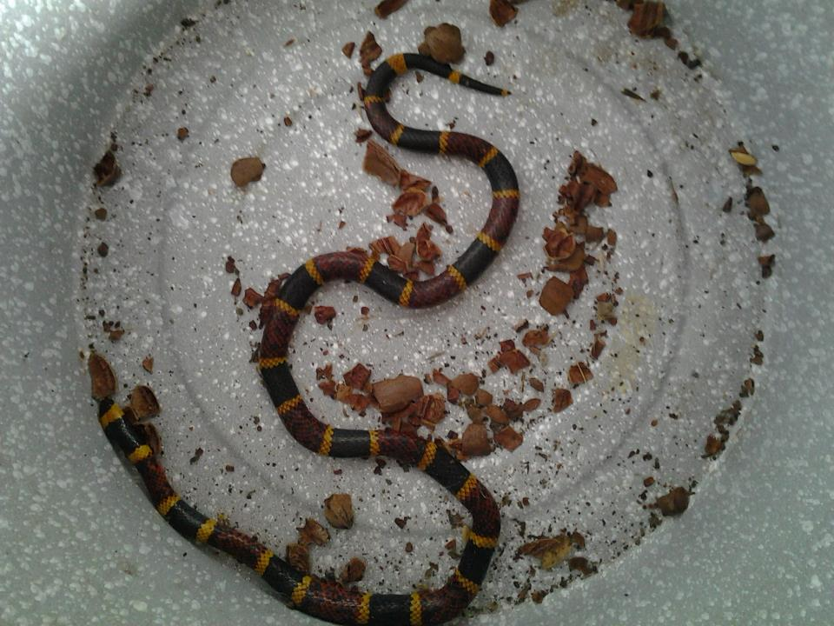
Photo by Dorothy Mayer, El Camino Real Chapter

DESCRIPTION
- Red, yellow and black bands encircling the body, with the red touching the yellow (“red and yellow, kill a fellow”).
- Small black head, very small mouth
- Blunt head, not much wider than neck
- Slender trunk, not much wider than a pen
- Averages 2-3feet.
- Venomous.

LIFE CYCLE
- Females lay 3-12 eggs in June
- Eggs hatch in September

BEHAVIOR
- Diurnal (active in daytime)
- Because of their small mouths and short fangs, they have to chew the victim to inject the venom.
- Secretive, reluctant to bite

HABITAT
- Primarily fossorial (living underground)
- Come to the surface when it rains or during breeding season
- Live in woodlands; also attracted to yards landscaped with dry wood or flagstones

FOOD
- small snakes
- lizards
- frogs
- nesting birds

SOURCES
- http://www.esi.utexas.edu/outreach/ols/lectures/ppts/39.pdf
- http://www.austinreptileservice.net/bands.html
- http://www.youtube.com/watch?v=eTRmjkFwKBE&feature=related - a video explaining about the Texas Coral Snake.
- http://www.houstonherp.com/Coral.htm
- http://en.wikipedia.org/wiki/Coral_snake
- Texas Snakes; a Field Guide, James R. Dixon and John E. Werler, UT Press, 2005, pp. 300-303.

