Timber Rattlesnake (Canebrake Rattlesnake)
Crotalus horridus

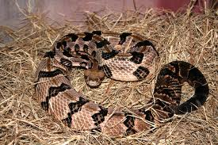
Photo by John Pruett

DESCRIPTION

- Wide head, narrow neck
- Background color is usually gray, tan or brown
- On the back are dark chevrons, or V-shaped bands
- Orange stripe of varying shades and width runs from head to tail, sometimes fading on the last third of the snake
- Tail is black or dark brown, tipped with rattles
- Average 3 to 4 feet in length
- Venomous

LIFE CYCLE

- Mating is in early spring, once every two or three years for females
- Sexual maturity is reached at 3 years for males; 4 years for females
- Eggs are kept inside female body until they are ready to hatch.
- Litter consists of 5 to 20 young; no parental care is provided
- Lifespan is up to 10 years.

BEHAVIOR

- Mild mannered
- Diurnal during spring and fall; become nocturnal during the heat of summer.
- Hibernate in cold weather in dens, limestone crevices, often with Copperheads and Black Rat Snakes (Elaphe obsolete)

HABITAT

- Prefer moist lowland forests, hilly woodlands or thickets near permanent water sources
- Pregnant females sun themselves on open, rocky ledges

FOOD

- Small mammals, primarily
- Also small birds, frogs, other snakes, especially garter snakes

SOURCES

- http://en.wikipedia.org/wiki/Crotalus_horridus
- http://www.tpwd.state.tx.us/huntwild/wild/species/timberrattlesnake/

