Western Ribbonsnake

Thamnophis proximus

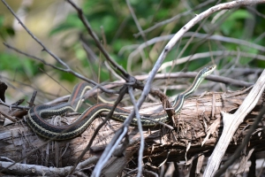

Photo by Thomas Marshall, http://balconesherping.wordpress.com/

DESCRIPTION
- Slender, medium bodied
- Black or brown, with 3 longitudinal light stripes
- Stripe down the center of the back is red in Central Texas, with other subspecies displaying bright yellow or pale orange
- Stripes down either side are pale yellow or cream
- Belly is pale
- Head is distinctly larger than neck
- Adults average 20-30 inches
- Eyes are moderately large, with round pupils

LIFE CYCLE
- Mate in spring
- Birth between July and September
- Average litter size is 8-13, ranging from 4-27
- Young are born live

HABITAT
- Lives along brushy or grassy margins next to still or moving bodies of water – ditches, tanks, rivers and streams
BEHAVIOR
- Usually diurnal, but nocturnal in the summer heat.
- Rainfall stimulates activity, probably because of the increased activity of its prey

FOOD
- Frogs, toads, salamanders, and their larvae
- Small fish
- Snails and slugs

SOURCES
- Texas Snakes; A Field Guide, James R. Dixon and John E. Werler, University of Texas Press, 2000, pp. 270-271.
- http://www.arkive.org/western-ribbon-snake/thamnaphis-proximus
- http://balconesherping.wordpress.com/

