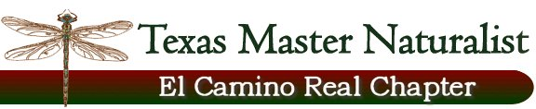
The Nature of Milam County
Floridus Milamexa Activity

May 6, 2017/9 a.m.-12 noon
Sugarloaf Mountain Bridge, Little River, Milam County

Participants:
Lead: Monique Reed; Members: Scott Berger, Linda Jo Conn, Joyce Conner, Sandra Dworaczyk, Donna Lewis, Billy Moore, Nancy Webber; Member Go-fer – Mike Conner; Brazos Valley Member: Cheryl Lewis;

Report:
Participants met at the bridge and set up a 10x10’ canopy with two working tables and chairs at the open back of a pickup truck. While Monique and others selected specimens, two of each were delivered to a recorder (Cheryl or Nancy) who then handed the specimens to a presser (Scott, Sandra, or Joyce). One of the specimens was collected of each species for the Herbarium and one for the chapter.

At the end of the morning, all of the specimens were placed into a press and taken to the Herbarium in College Station by Monique. Monique then cleaned them up and separated them into a total of four presses to be dried.

Monique reported that she had 68 different specimens (all, having two copies) or 136 individuals. She and Dale recommended that our chapter have a sequential numbering system which would bring our next specimen to number 169. Monique will confirm identification when the specimens are dry. This could take 1-2 weeks.

Dale Kruse will give the chapter archival specimen training at our July meeting, July 13, in Milano. At that time, our chapter specimens will be returned to us so that we can practice the archival process that he has taught us.

