Floridus milamexa
April 7, 2015

Members: Ann Collins, Linda Jo Conn, John Pruett, Katherine Bedrich

Location: FM 1600; Wilson-Ledbetter Park, Cameron.
Lat: 30.83983 Long: -096.98233 Elev: 335’

With high hopes of finding an un-mowed landscape, the group ventured to the park. Fortunately even though area was mowed, we found several plants still in bloom. On the east side of the dam, a nice stand of Baby Blue-eyes was waiting for us. The fence line provided grape vines, saw greenbrier, Carolina snailseed and poison ivy. Blue-eyed grass, stork’s bill and cranes bill were identified. While John recorded and Katherine pressed; Ann and Linda Jo ventured to other areas. Coming back with puccoon was a treat. They also decided to sample the Indian paintbrush; said it was not very tasty. Despite the manicured landscape, it turned out to be a good day for plant observation and identification.

Some fauna noted were: Northern mockingbird, Black swallowtail, and flies.

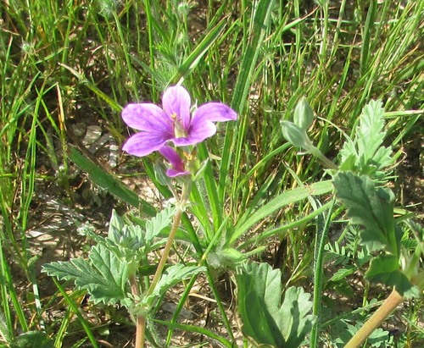
Erodium texanum
GERANIACEAE / Geranium Family
Texas Stork’s bill

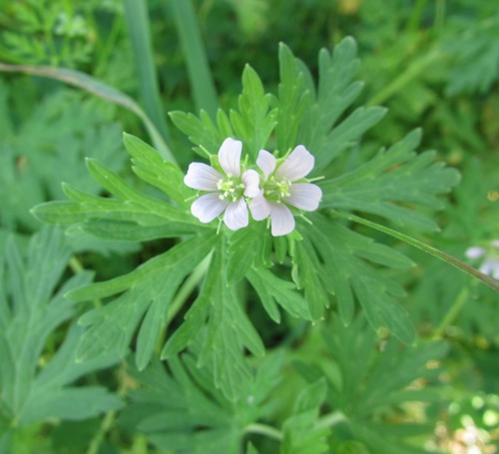
Geranium carolinianum
GERANIACEAE / Geranium Family
Carolina Cranesbill

Photos by: Linda Jo Conn

