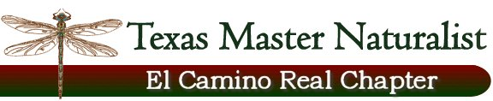

Floridus milamexa
February 29, 2016

Members: Linda Jo Conn, Katherine Bedrich, Ann Collins, John Pruett, Joyce Conner,
Darlene Anglen, Scott Berger, and Donna Lewis

Location: CR 264 by Sugarloaf Bridge
Lat: 30.82449 Long: -96.74378

With the warmer than usual winter temperature reaching close to 80’s, the group met near the Bridge to see with may be in bloom. Mexican plum / Prunus mexicana, scrambled egg’s /Corydalis sp., and deer pea vetch / Vicia ludoviciana were blooming. Baby blue eyes / Nemophilia phacelioides, gum bumelia / Bumelia lanuginose, Turk’s cap / Malvaviscus arboreus and greenbrier / Smilax bona-nox were recognized without flowers. Much of the vegetation was in the leafing stage.

Some fauna: Northern mockingbird, Eastern phoebe, Red-shouldered hawk, lady bugs, grasshoppers and small empty white snail shells.
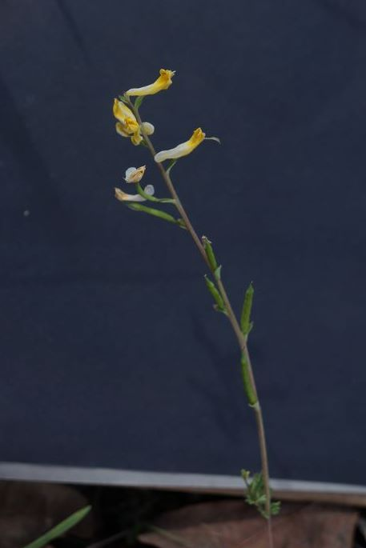

Corydalis sp.
Scrambled eggs
FUMITORY

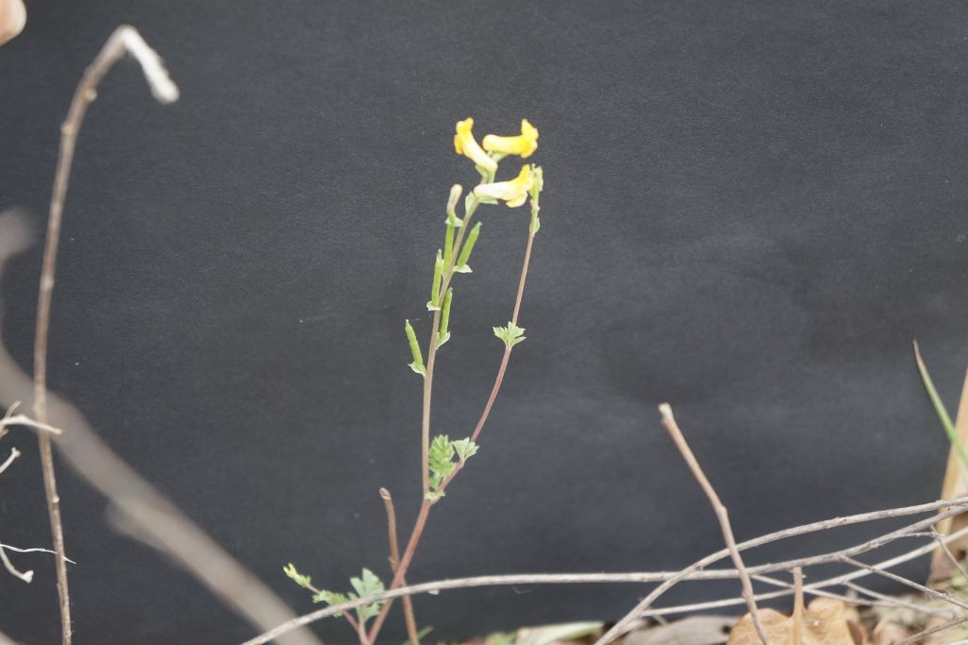
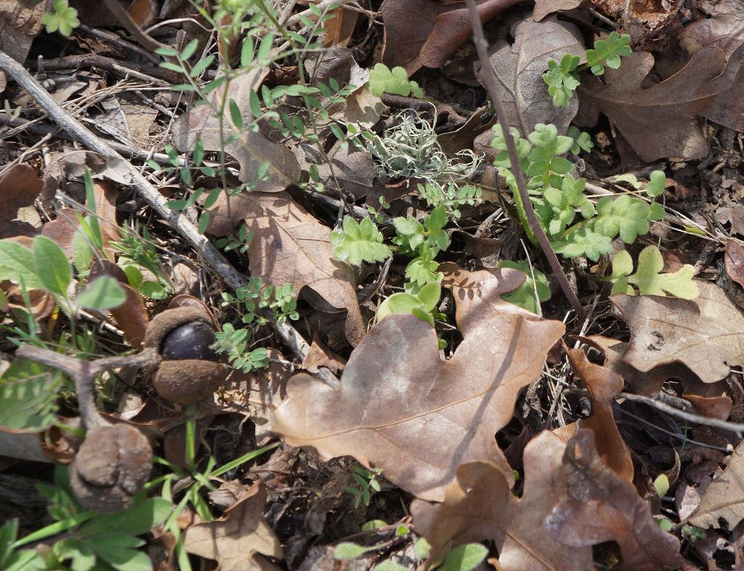
Baby blue-eye’s; Texas buckeye seeds

