Floridus milamexa
March 10, 2015 – Don and Cindy Travis’
Members: Cindy and Don Travis, Katherine Bedrich, Ann Collins

The group continued working on setting up the Chapter website page for the project. Documentation of flora observations in Milam County Texas has been set up on iNaturalist. The project is titled: Floridus milamexa. From the Chapter website you will be able to go to the iNaturalist site and gather information. and on

Information on the Chapter page will include data from the field collection sheet – Date, family, genus, species, common name, lat and long, ecoregion, voucher, seed, on the Trail, food and medicinal use, introduced invasive and wildlife use.

Next meeting to work on website page: April 7th – 1:30pm – Cindy and Don’s.

General meeting to re-visit the project: April 14th, 2015. Time and place to be decided after the 7th.

Cylindropuntia leptocaulis
CACTACEAE / Cactus Family
Christmas cactus, pencil cactus

County Road 203 Loop
January 2015

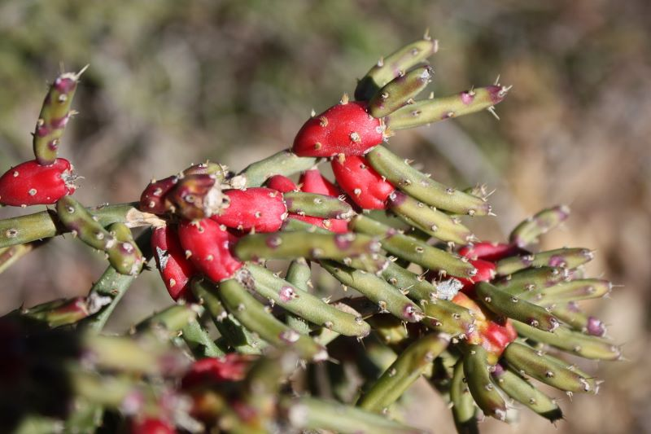

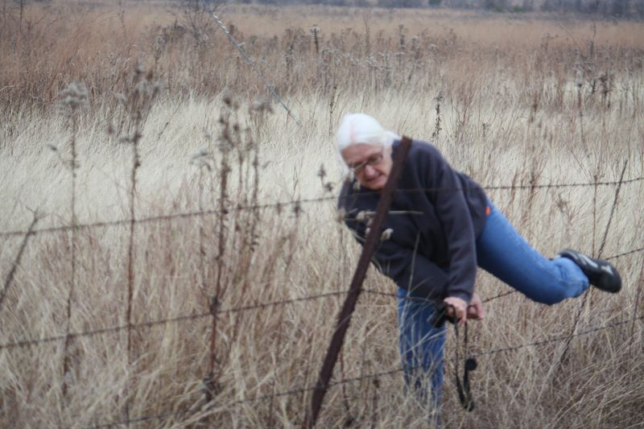
Female - caught

