Floridus Milamexa
March 25, 2015

Members: Ann Collins, Linda Jo Conn, John Pruett, Katherine Bedrich and Kim Summers

Met at El Camino Real Crossing sign (N 30.71799 / W -097.07836) on County Road 429.

Did not see many flowering plants, the soil is still cool and more sun is needed to promote flowering. Cedar elm, plantain, thistle, and a few other plants were identified. The soil in the drainage area may be going through a succession. During the initial stages of secondary succession following land alteration, plant communities will be dominated by fast-growing weeds that germinate from the local seed bank (those opportune plants which germinate on soil lacking in substantial nutrients). Secondary succession begins on soil from which the previous plant community has been removed.
Some fauna noted were: Mockingbird, ladybeetle, deer tracks, pillbug, and hairstreak butterfly.

Next field trip: We are moving to another location…Thursday, April 2nd – 9:30am at the meeting of FM 2095 and FM 3242.
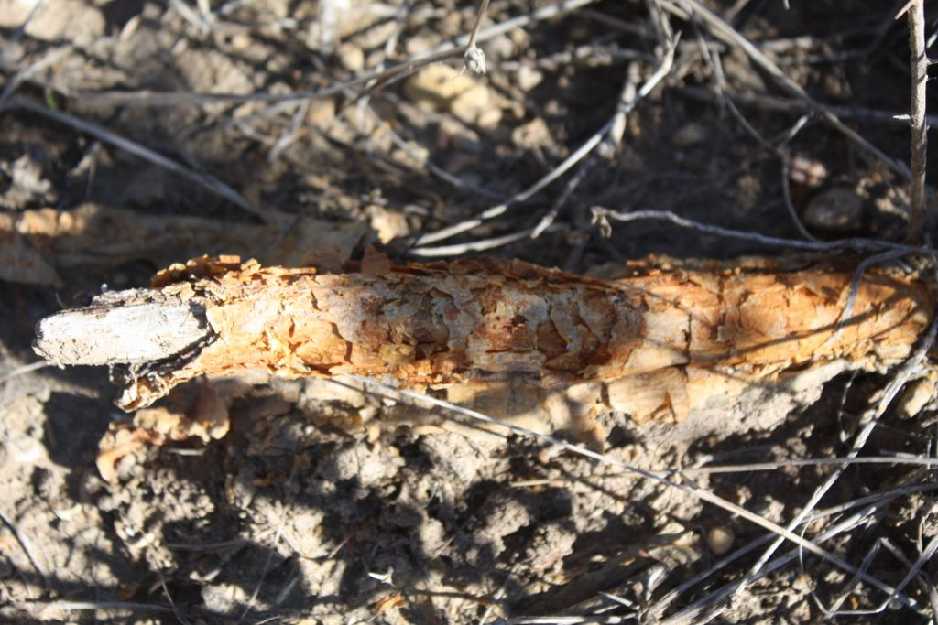
Maclura pomifera
MORACEAE, Mulberry Family
Root from an Osage orange, bois d’arc, horse apple

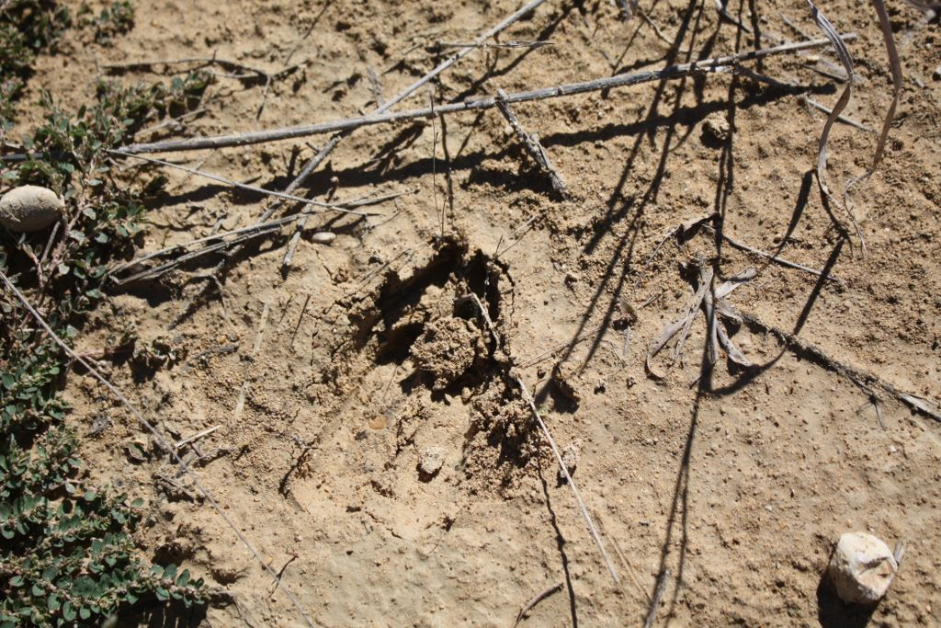
Odocoileus virginianus
CERVIDAE, Deer Family
White-tailed deer track

