Floridus Milamexa
November 12, 2014

Members: Linda Jo Conn, John Pruett, Katherine Bedrich

Meet at El Camino Real Crossing sign (N 30.71799 / W -097.07836) on the top of hill. Temperature was in the 40’s with the north wind blowing. We decided to move down the road, hoping to get out of the wind , but it followed us. After looking at a few plants, we all agreed a hot cup of coffee was what we wanted to find.

We moved to the warmth of The Bistro in Cameron and discussed the project.

- Visit with the County Commissioners; asking them to contact us before any major clearing on the roads. This will help us if a plant(s) needs to be saved.
- Work on a slide show with plant photos, project objectives, etc.
- Possible field trip to Sugarloaf for plant identification
- Find place to work on project
- Trip to S. M. Tracy Herbarium with Dale Kruse
- Contact Alamo Chapter about plant inventory list.
- Look for plants flowering in early spring
- Collecting and pressing plants.

Will meet in December with member to discuss next year.

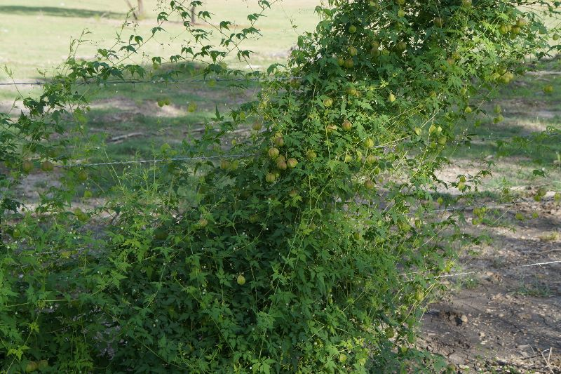

Balloon vine / Cardiospermus halicacabum

