Unit 12: Ornithology
Charles Jack Randel III, Texas A&M University
Nova J. Silvy, Regents Professor, Texas A&M University
Editorial Assistance: Mark Lockwood, Texas Parks and Wildlife
and Mary Anne Weber, Educational Director, Houston Audubon Society
Unit Goals
- Understand the causes of bird diversity
- Understand and discuss the habits of bird migration
- Identify the primary flyways of North America and Texas
- Explain bird behavioral characteristics in relation to environments and environmental changes
- Become aware of and communicate conservation concerns for birds
- Identify and communicate how birds function within ecosystems
- Develop an awareness of how bird populations are monitored and managed
Diversity of Birds
- Nearly 10,000 species, 29 orders. Occupy nearly every habitat. Texas second most diverse state (639) after California (657).
- 5 categories based on lifestyles and habitat:
- Land birds (terrestrials such as hawks, quail, songbirds)
- Freshwater species (some ducks, rails, herons)
- Seabirds (frigatebirds, boobies, pelicans)
- Flightless land birds (ratites)
- Underwater flyers (penguins, cormorants, anhingas)
- 12 groups based on body shape and lifestyle
- Long-legged waders (herons, flamingos, cranes)
- Duck-like (ducks, geese, pelicans, loons)
- Perching (sparrows, ravens, parrots, mockingbirds)
- Fowl-like (chicken, turkey, rails, gallinules, jacanas)
- Hawk-like (raptors, vultures)
- Owls
- Upland ground (quails, peacocks, grouse, roadrunners, nightjars)
- Hummingbirds
- Tree-clinging (woodpeckers, nuthatches, creepers)
- Upright-perching waterbirds (auks, puffins, cormorants)
- Gull-like (gulls, terns, albatrosses)
- Pigeon-like (pigeons, doves)
- Can also sort based on food, but can vary wildly within a taxa. Previous two groupings artificial, not taxonomic, but help understand diversity.

Why Do Different Birds Live in Different Places?
- Varied habitats allow for many different niches, some habitat requirements very specific.
- Endangered Red-cockade Woodpecker. Human reliant cavity nesters: Purple Martins
Migration
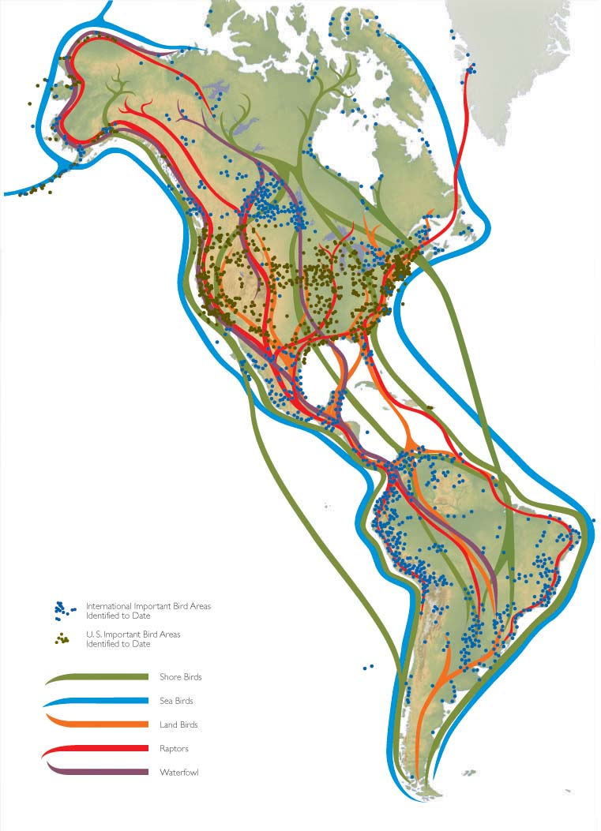
North American Flyway Map pg. 393
- Specific adaptations to particular environments, must also tolerate environmental changes.
- Migration closely timed to seasonal changes, yearly cycle.
- Better food supplies, milder climates, longer days in south during winter.
- Most Texas birds not year-round. Two flyways pass through:
- Mississippi Flyway
- Central Flyway
- Texas important as both wintering and summer nesting habitat. Upper coast critical.
- Many coastal refuges act as “migrant traps” after “fallout” episodes
How Do Birds Cope with Changes in Their Ecosystem?
- Limiting factors: Habitat, Climate, Food/Water, Disease/Parasites
Competition
- Use/defense of resource reduces availability to others. Aggression vs. Exploitation Competition
- Avoided by resource partitioning, claiming non-overlapping niches.
- Territory defense, varying size and scale. Hummingbird feeder vs. Bald Eagle territory.
- Physical confrontation usually avoided, threat/submission displays, advertise presence vocally.
Predation
- Mobbing: mass aggression in breeding grounds, confuse/divert predator
- Alarm calls: alert others to predator presence, often triggers mobbing
- Injury display: exaggerated, feigned injury to divert away from nest/young
- Cavity nesting: ½ of bird orders, better protection predators, #1 cause of nest failure. Allows bigger clutches.
- Colonial nesting: enhanced predator detection, larger mobs, heavy predation around edges, too many for predators to eat them all (predator saturation)
Parasitism and Disease
- Increase nestling mortality. Nest sanitation (removing feces), careful selection of nesting materials (fumigant effects). Greater issue in colonies, old nests.
- Salmonellosis: bacteria passed through feces. Problem at bird feeders, easy contamination.
- Trichomoniasis: pidgeon/dove parasite. Can’t swallow, drops contaminated food/water.
- Aspergillosis: fungus in damp feed, feeder debris. Spores inhaled, pneumonia/bronchitis.
- Avian pox: wart-like growths, passed by direct contact, shed viruses in food/feeders/insects
- Preventative measures: provide adequate space around feeders, clean regularly, use fresh, dry stored food.
Habitat Alteration
- Both positive, negative effects, species specific. Increase/decrease in resources, nesting areas.
- Important to consider both summer and winter grounds, flight corridors.
- Habitat management -> Fire -> restore grassland species
- Urbanization-> habitat fragmentation -> edge effect
Food Availability
- In constant flux, limiting factor. Particular behaviors in response to food shortages (food hoarding, seed caches, shrike impaling, wide dispersal).
- Factor in territoriality, family units may engage in cooperative feeding.
- Can affect timing of reproduction, clutch size. Some tropical species can have 2 breeding seasons.
Temperature Changes
- Endothermic: maintain constant high temperature, allows birds to live in extreme climates.
- Behavioral and physiological means of thermoregulation.
- Heat stress: panting, evaporative cooling, apteria (unfeathered areas)
- Heat loss: select warm microclimates, shelter. Huddle together. Smaller birds = higher surface area/mass ratio = more vulnerable to heat loss
How Do Birds Function in Ecosystems?
- Predators: control populations, reduce competition
- Prey: most predation occurs in nest, early life stages.
- Seed Dispersal: Thick bills = seed eaters. Store seeds, widely disperse in droppings.
- Pollinators: hummingbirds, orioles.
How are Birds Monitored?
- Point counts: conducted from set of predetermined points. Counts # of each species observed/heard within given area. Determine species present, habitats found in, population trends, local bird densities.
- Transects: # of birds, bird species along survey line. Means of counting depends on goal. Conducted annually to monitor fluctuations, esp. for species of concern. Estimate concentrations of game species for hunting limits, data comparison.
- Rare-Bird Reports: document occurrence of birds outside accepted range. Major draw for bird watchers.
- Public Involvement: Audubon Society’s Christmas Bird Count, Breeding Bird Survey, Great Backyard Bird Count. Rely on public participation, monitor population trends.

