Aquatic Vegetation Photo Collection
These are some example photos but keep in mind that most were taken quickly out in the field and can always be improved with the addition of a ruler or nice white background!
Large population in water column but still able to be identified
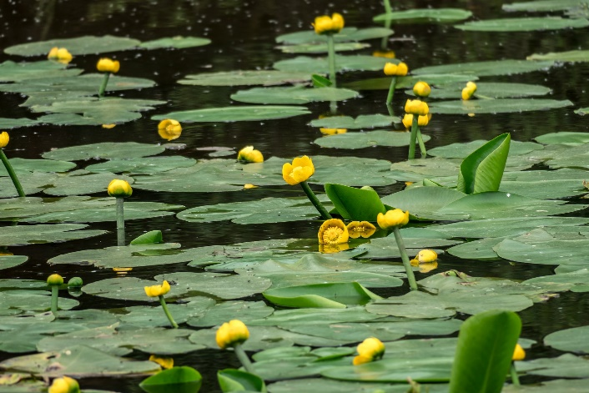
Leaf arrangement (preferably against a white background)
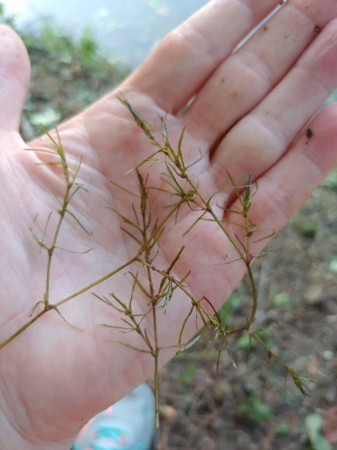
Seed body
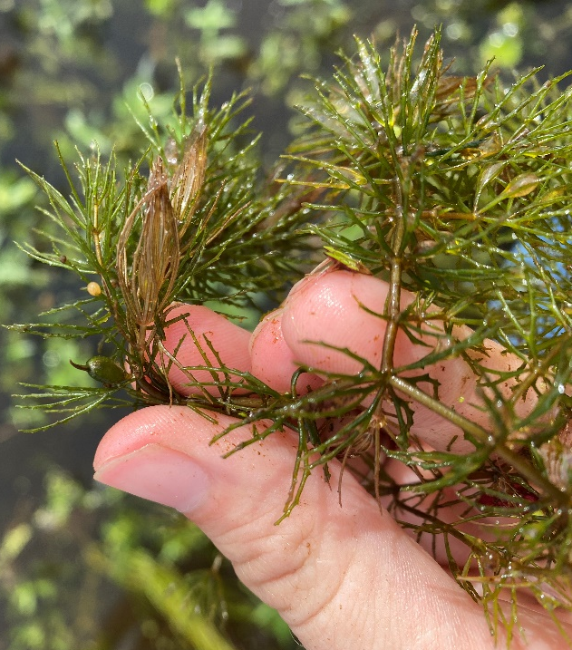
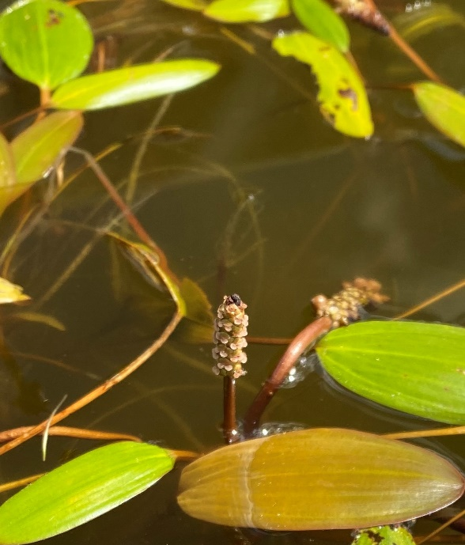
Other key characteristics
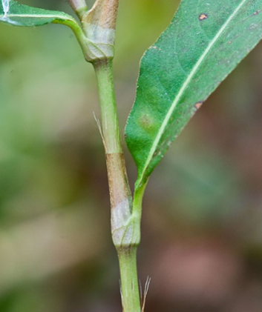
These plants listed below are just some of the plants and key characteristics I am in search of but all algae/aquatic plants are welcome! If key characteristics aren’t specified, I am looking for any and all. Rule of thumb: If it’s on the plant, most likely I would like a photo of it! Keep in mind some of these species are not very common at all.
Common name | Scientific name | Key characteristics
Chara | Chara spp. | Leaf arrangement
Nitella | Nitella spp.
Salvinia | Salvinia spp. | Leaf hairs
Baby pondweed | Potamogeton pusillus | Leaf arrangement  Leaf size
Brittle naiad | Najas marina | Leaf arrangement
Brittle waternymph | Najas minor
Southern naiad | Najas guadalupensis
Fanwort | Cabomba spp. | Leaf arrangement  Flower
Curly-leafed pondweed | Potamogeton crispus
Cutleaf watermilfoil | Myriophyllum pinnatum
Indian hygrophila | Hygrophila polysperma
Egeria | Egeria densa | Flower
Eurasian watermilfoil | Myriophyllum spicatum
Fineleaf pondweed | Stuckenia filiformis
Floating pondweed | Potamogeton natans
Gulf swampweed | Hygrophila lacustris
Horned pondweed | Zannichellia palustris
Hydrilla | Hydrilla verticillata
Illinois pondweed | Potamogeton illinoensis | Leaf arrangement  Seed head
Large-leaf pondweed | Potamogeton amplifolius
Leafy pondweed | Potamogeton foliosus
Parrot’s-feather | Myriophyllum aquaticum
Ribbonleaf pondweed | Potamogeton epihydrus
Richardson’s pondweed | Potamogeton richardsonii
Sago pondweed | Stuckenia pectinata
Variable-leaf pondweed | Potamogeton gramineus
Variable-leaf watermilfoil | Myriophyllum heterophyllum
Waterthread pondweed | Potamogeton diversifolius
Widgeon grass | Ruppia spp.

I am also looking for emergent aquatic plants. See the following link for a list: https://aquaplant.tamu.edu/plant-identification/category-emergent-plants/

