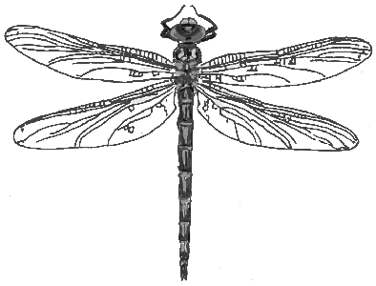

Llano Estacado Texas Master Naturalist™, Inc
Volunteer Project & Activity Request Form
To fill out the form electronically, click on the shaded box to type in information. Boxes will expand, so try to be as complete and specific as possible.

Project/Activity Name:
Partner Organization or Sponsor:

DESCRIBE PROJECT or ACTIVITY including the overall purpose and potential outcomes.
GIVE CONTACT INFO including phone numbers, emails and addresses for any organizations, people or places involved in the project.
Give the LOCATION of the project. Provide links to maps if available or give general description i.e. roadsides in Midland County.
LOGISTICS
(Start and Ending Dates/Times) If there is a specific time or deadline, please make note.
TRAINING or ORIENTATION Required and when volunteers will become available to start the project if known.
PROVIDE the Opportunity Category Code from the CMOP document pgs. 19-21 e.g. FR-Field Research. Can leave blank if unsure.
SPECIAL SKILLS or INTERESTS required e.g. ability to identify and photograph bees, use of eBird or iNaturalist, etc.
PERSONAL or OTHER EQUIPMENT NEEDED such aa binoculars, insect nets, camera, etc.
PHYSICAL DEMANDS with description of activities i.e. collecting milkweed, monarch tagging, hiking, public speaking, etc.
Provide a MEASUREABLE OUTCOME expected e.g. creating a butterfly brochure for the I-20 Butterfly Garden
REFERENCE MATERIALS
Llano Estacado Chapter Contact or expected Coordinator of Project
Submitted By with date:

When you are finished filling out the form, please save with a unique name in either Word or PDF format and submit file to llanoestacadotmn@gmail.com.

If there is a deadline, please mention this in your email submission. Volunteer projects and activities will be reviewed by the LETMN Board during our regular board meeting the first Monday of the month unless there is a deadline that must be met before then. The entry of the project/activity will also have to made to VMS, so please give time and consideration for being able to accomplish that.

THANKS for making a volunteer project or activity proposal for LETMN!

