Llano Estacado Master Naturalist Curriculum Guide
Unit 2: Archeology

History may be accurate, but archaeology is precise. -Doug Scott

Unit Goals: After completing this unit, volunteers should be able to:
- understand archeological concepts and methods
- become familiar with Texas cultural history
- become familiar with Texas archeological regions
- become familiar with antiquities laws

- Which of the following would you NOT include in the research design before undertaking an archeology project? (pg. 39-43)

- Review existing literature, records and cultural history.
- Obtain state antiquities permit for site.
- Obtain samples from the site for your private collection.
- Review geologic surveys of the site.

See pages 46-54 in your textbook and the website at https://txmn.org/llano/texas-archeology/ to answer questions 2-5.

- This cultural stage is characterized by dryer conditions and the development of hot rock cooking, use of manos and metates for crushing seeds, large size dart points, basketry and matting technology (dried squash weaved into mats as food storage), stashing of chert biface caches and use of snares and traps for birds and small game.

- Paleoindian
- Archaic
- Late Prehistoric
- Historic

- This cultural stage is characterized by the development of bows and arrows, horticultural practices, semi-permanent homes, increasing sedentary lifestyles, development of trade relations with distant groups for exotic items and ceramic technology (pottery).

- Paleoindian
- Archaic
- Late Prehistoric
- Historic

- This cultural stage is characterized by some of the earliest use of the atlatl with spears having fastened projectile points, no permanent settlements, family groups of 15-25 traveling in search of wild plant foods and hunting mammoths and mastodons.

- Paleoindian
- Archaic
- Late Prehistoric
- Historic

- This cultural stage is characterized by indigenous peoples of Texas coming in contact with Euro-American groups, exposure to new diseases, access to domesticated animals, new technologies of metal implements, dyed fabrics and influx of Apaches and Comanche to the Southern Plains.

- Paleoindian
- Archaic
- Late Prehistoric
- Historic

See pages 59-70 in your textbook and the website https://txmn.org/llano/texas-archeology/ to answer questions 6-8.

- Name the archeological region in Texas that is renowned for rock art motif pictographs, not found anywhere else in Texas. (See photos in textbook and links on website).

- Texas Plains
- Lower-Pecos Region
- Bexar County
- South Texas

- Which of the following is NOT a characteristic of the regional archeology of the Texas Plains?

- Local black and white decorated pottery.
- Prior to AD 1100, plants were the primary staple diet of nomadic groups.
- Apache groups traded with Puebloan groups from the west.
- Highly mobile Paleoindians.

- The Altithermal event in Texas can be best characterized by:

- Advancing ice sheets cooling the climate.
- Extreme drought.
- Increased rainfall events.
- Roswell alien invasion event.

- Information on the location and discoveries of all archeological sites in Texas is available to the public and can be found at the Texas Archeological Research Laboratory at the University of Texas, Austin.

- True
- False

Questions 10 through 15 are taken from Dr. Chris Lintz’s presentations. Also see the website for pictures and information to help you answer these questions. https://txmn.org/llano/texas-archeology/.

- Recovered objects, such as chipped stone tools, textiles, hides, bone and shell tools are considered:

- Artifacts
- Ecofacts
- Ventifact

- Recovered objects, such as seeds, charcoal, pollen, phytoliths and diatoms are considered:

- Artifacts
- Ecofacts
- Ventifacts

- Using the diagram below, examine drawing 3. Which statement is true?

- A is older than B
- A is younger than B
- A and B are the same age.

- Using the diagram below, examine drawing 2. Which statement is true?

- A is older than B
- A is younger than B
- A and B are the same age

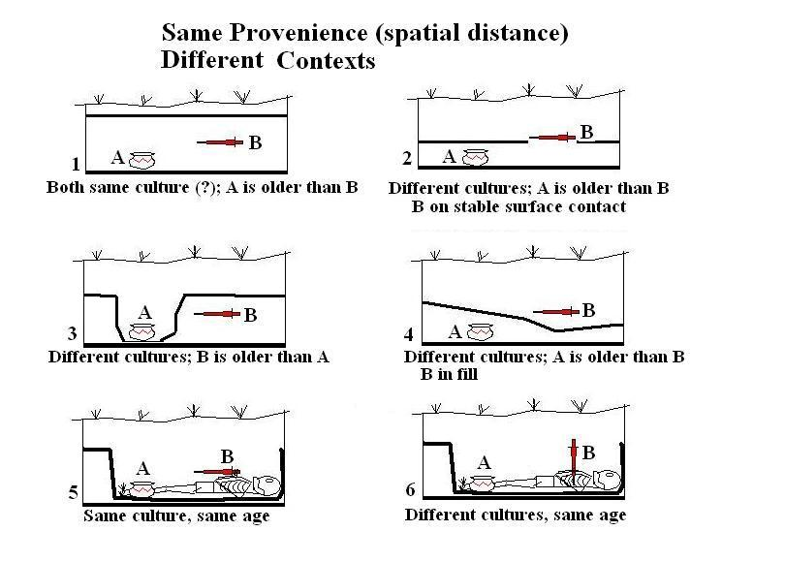

- Using the diagram below, what statement can you infer for the absence of Bison for the interval between 5000 – 8000 years ago?

- Climate was too cold to support growth of grasses to feed large populations of Bison.
- Climate was too dry to support growth of grasses to feed large populations of Bison.
- Bison found greener pastures in the Great Lakes Region.

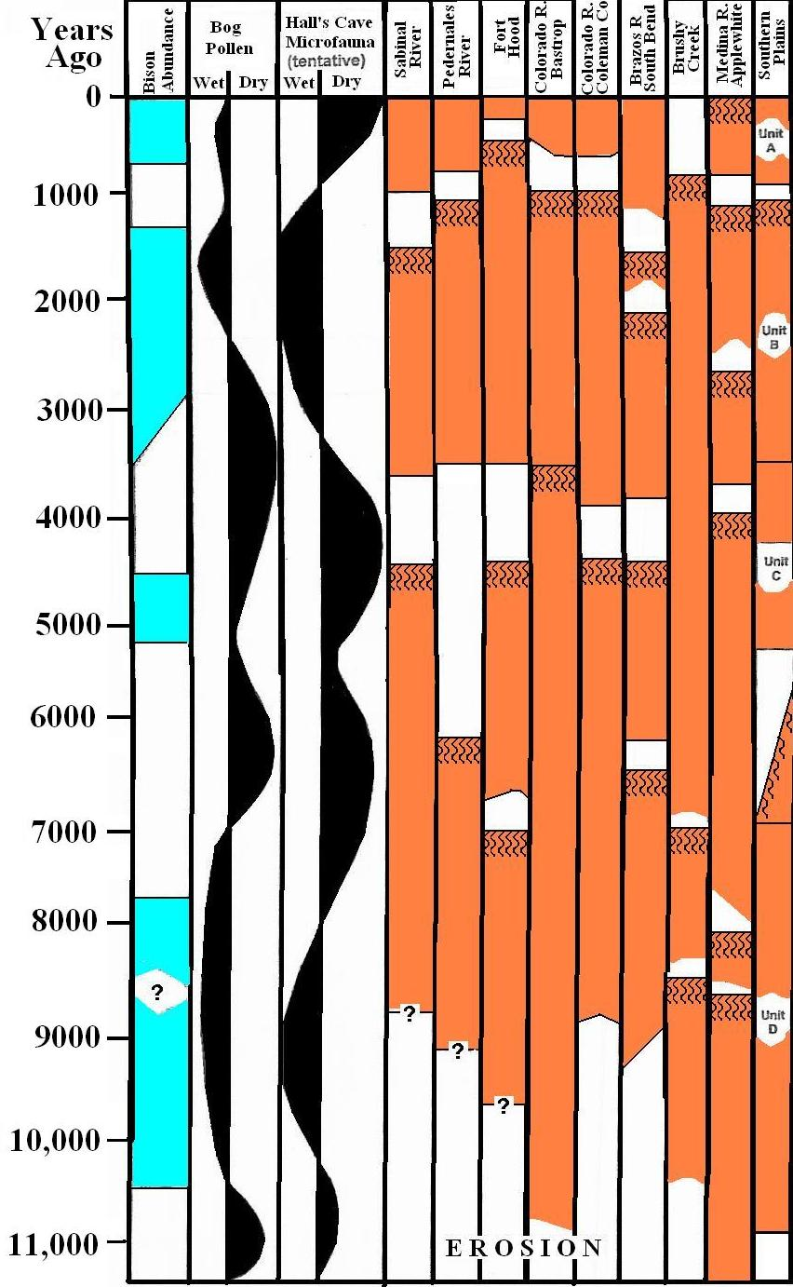
- As a Master Naturalists, do you consider the following statements True or False if you were to find a potential archeological site?

Do not collect or move artifacts unless endangered.
Mark the location with GPS, flags or use photos for documentation.
Notify the proper authorities

- True
- False

- Looking at the map of Texas archeological regions on page 59, which region is the Llano Estacado Chapter in?

- North Central Texas
- Texas Plains
- Trans-Pecos

- What did cultures of our region rely heavily upon for subsistence?

- Trading with other Indian populations
- Subsistence farming of wheat
- Buffalo hunting
- All of the above

