Llano Estacado Master Naturalist Curriculum Guide
Unit 7: Geology (and Soils)

Geologists have a saying-rocks remember. -Neil Armstrong

Unit Goals (Geology): After completing this unit, volunteers should be able to:
- become aware of the basic geologic processes of rock formation and the interactions which were instrumental in forming the geology of Texas.
- trace the geologic history of Texas.
- understand aquifers and groundwater.

- Looking at the Geologic Map in your textbook or given here, what is the Geologic Era of the majority of the surface rocks in Midland and surrounding counties?

- Paleozoic and Mesozoic
- Paleozoic and Cenozoic
- Mesozoic and Precambrian
- Cenozoic and Mesozoic

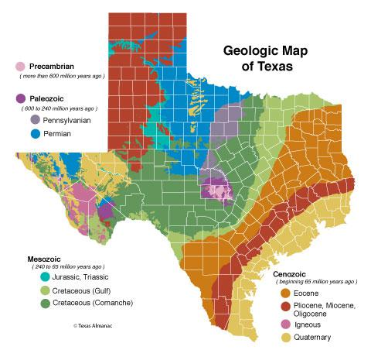

- Which of the following is one of the oldest exposed areas of rocks in Texas? (HINT: think of how each rock type is formed and which would be older; you can also look at the ages of the Geologic Map above).

- Enchanted Rock (Granite) near Fredericksberg
- Shales and sandstones in the Coastal Region
- Limestones in the Guadalupe Mountains
- Evaporites (Gypsum) in West Texas

- Read the section on plate tectonics in your textbook. Volcanic activity in West Texas (such as around the Alpine area) was caused by which of the following plate tectonic boundaries?

- Oceanic-Continental Subduction zone
- Continent-Continent Collision
- Transform faulting

- Looking at the chart on Texas geological events in your textbook, or the charts in the handouts posted on the website what dominant landscape in the Permian and the Cretaceous Periods was responsible for the formation of fossiliferous limestones and the Guadalupe Mountains?

- Shallow seas
- Volcanoes
- Basin and Range mountains
- Rivers and Deltas

- Very little rock evidence of the the Triassic and Jurassic Periods are exposed in Texas due to which of the following processes?

- Subduction and volcanism
- Uplift and erosion
- Flooding and formation of shallow seas
- Rifting and faulting

- What type of rocks are you most likely to find in the Edwards Plateau?

- Fossiliferous Limestone
- Evaporites like Gypsum
- Unconsolidated Gravels
- Rhyolite with columnar jointing

- Read the section on landforms of Texas. Which of the following is FALSE about the Balcones Escarpment?

- It has fault blocks of bedrock oriented in a northeastward direction.
- Its orientation causes rivers such as the Rio Grande to flow in a southwest
direction.
- Faulting was a result of continental uplift.
- It separates the Coastal Plains from the Hill Country

- Read the section on groundwater in your textbook. The Ogallala Aquifer lies on top of the Ogallala Formation deposited during the late Cenozoic. What type of rock is the Ogallala Formation?

- Igneous-Granite
- Igneous-Rhyolite
- Sedimentary-Sandstone
- Sedimentary-Limestone

BONUS
- Driving from Fort Worth to Midland, there are some stair-step like formations as elevation increases. These are called (Hint: look at the handout posted on the website):

- Cuestas
- Redbeds
- Marathon Fold Belts
- Mesas

