Llano Estacado Texas Master Naturalists Curriculum Guide
Unit 12: Ornithology

"A bird in hand is a certainty. But a bird in the bush may sing." -Bret Harte

Unit Goals: After completing this unit, volunteers should be able to:
- understand the causes for bird diversity
- understand and discuss the habits of bird migration
- identify primary flyways of North America and Texas
- explain bird behavioral characteristics to environments and environmental changes
- develop an awareness of how bird populations are monitored and managed
- identify and communicate how birds function within ecosystems
- Become aware of, and communicate conservation concerns for birds

- Explain two reasons for the richness or diversity of birds.

- List six features of birds that are adapted to different functions or environments e.g. modes of locomotion.

- Beak/bill d.
- e.
- f.

- List the 5 categories of birds based upon their lifestyle and habitat and give examples.

- Explain why birds migrate.

- Texas has two flyways or principle routes used by North American Birds.
True or False More than 50% of all recorded Texas birds are migratory.
(Circle the correct answer).

This is the CENTRAL FLYWAY

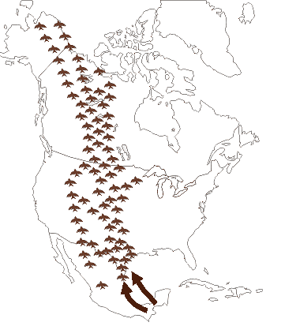

This is the MISSISSIPPI FLYWAY

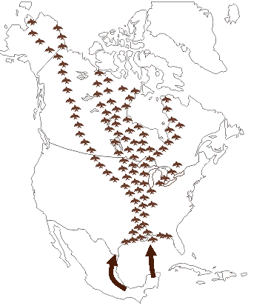

Source: https://tpwd.texas.gov/huntwild/wild/birding/migration/flyways/
- List the four factors that limit bird populations.

- c.
- d.

- Draw a food web on a separate piece of paper that has birds as consumers and prey and that contains plants, insects and mammals that you would find on the Llano Estacado. Use words, basic drawings or downloaded images to create your food web. You can do your drawing by hand or in a file, but be prepared to upload your food web. In addition to your textbook, here is a link with easy to read info and examples: https://www.treehugger.com/what-is-a-food-web-definition-types-and-examples-4796577

EXAMPLE:
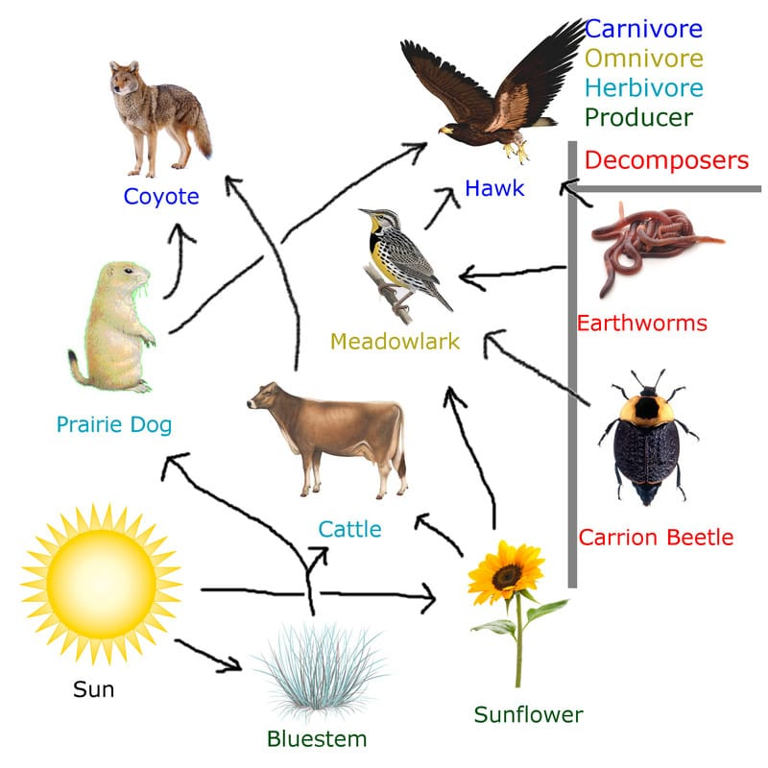

You will be given instructions on uploading your food web in the online review.

- List and describe 4 strategies for deterring predators.

- Name two birds that are pollinators in Texas.

- Be able to discuss some conservation concerns for birds, what are some major contributions to bird decline and how can you as a Master Naturalists make a difference.

