Llano Estacado Texas Master Naturalists Curriculum Guide Unit 20: Rangeland Ecology and Management
mysterious, awesome, indescribably magnificent world in itself.” -Henry Miller “The moment one gives close attention to any thing, even a blade of grass, it becomes a
Unit Goals: After completing this unit, volunteers should be able to:
- define and describe rangeland
- define rangeland management
- describe why range management is different from agricultural vocations
- list the basic component categories of range management
- list and describe the four founding principles of grazing management
- understand and be able to communicate the importance of land management goals
- describe how native grasses grow
- describe, compare and contrast rangeland management tools
- develop an awareness of grazing, brush and weed issues and management on Texas rangelands
- Define and describe rangeland.
- List the two basic components of rangeland management according to Holechek et. al. (2001) (p. 639)
a.
b.
- What makes rangeland management unique from agricultural vocations? (pp. 639-640)
- What should be the primary grazing management goal? (p. 642)

- Describe some management tools that can be used to sustain different populations of both domestic or livestock and other native wildlife within the same rangeland without detriment to the land. (pp. 641, 647 and others)

- In order to accomplish grazing managements goals, an understanding of how grasses grow is necessary. Fill out the following chart with missing information on what grasses need to grow.
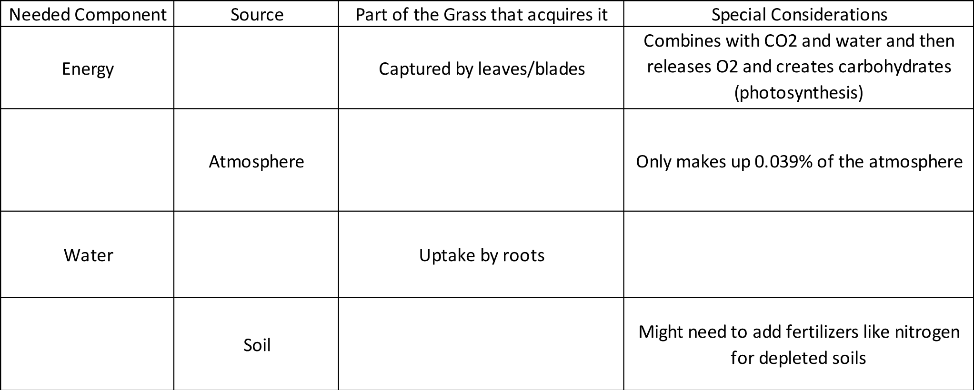
- Explain why a resting period of non-use for grassland management is important in preventing overgrazing. (p. 644)

- What is stocking rate and why is it so important for a grazing system? (pp. 641, 646)
- List some positives and negatives for brush and weeds. Give examples of each that occur in Texas.
BRUSH:
WEED:
- Fill out the grasses handout (given out at session).

