Llano Estacado Master Naturalist Curriculum Guide
Unit 4: Ecological Regions of Texas

Look deep into Nature and then you will understand everything better.
Albert Einstein

Unit Goals: After completing this unit, volunteers should be able to:
- identify and differentiate the features of Texas’ ecological regions and subregions,
- understand and communicate the use of different maps devoting various ecological regions of Texas,
- explain some of the key factors underpinning the ecological diversity in Texas.

- List three reasons why ecoregion maps vary.

- List six factors that Texas Ecological Regions represent.

- List three other ways we can classify natural environments.

- Ecological Regions of Texas
Instructions: Label and color each ecoregion and list one interesting fact for each.

1. Pineywoods, receives 36-50” of rainfall per year.
2.
3.
4.
5.
6.
7.
8.
9.
10.
11.

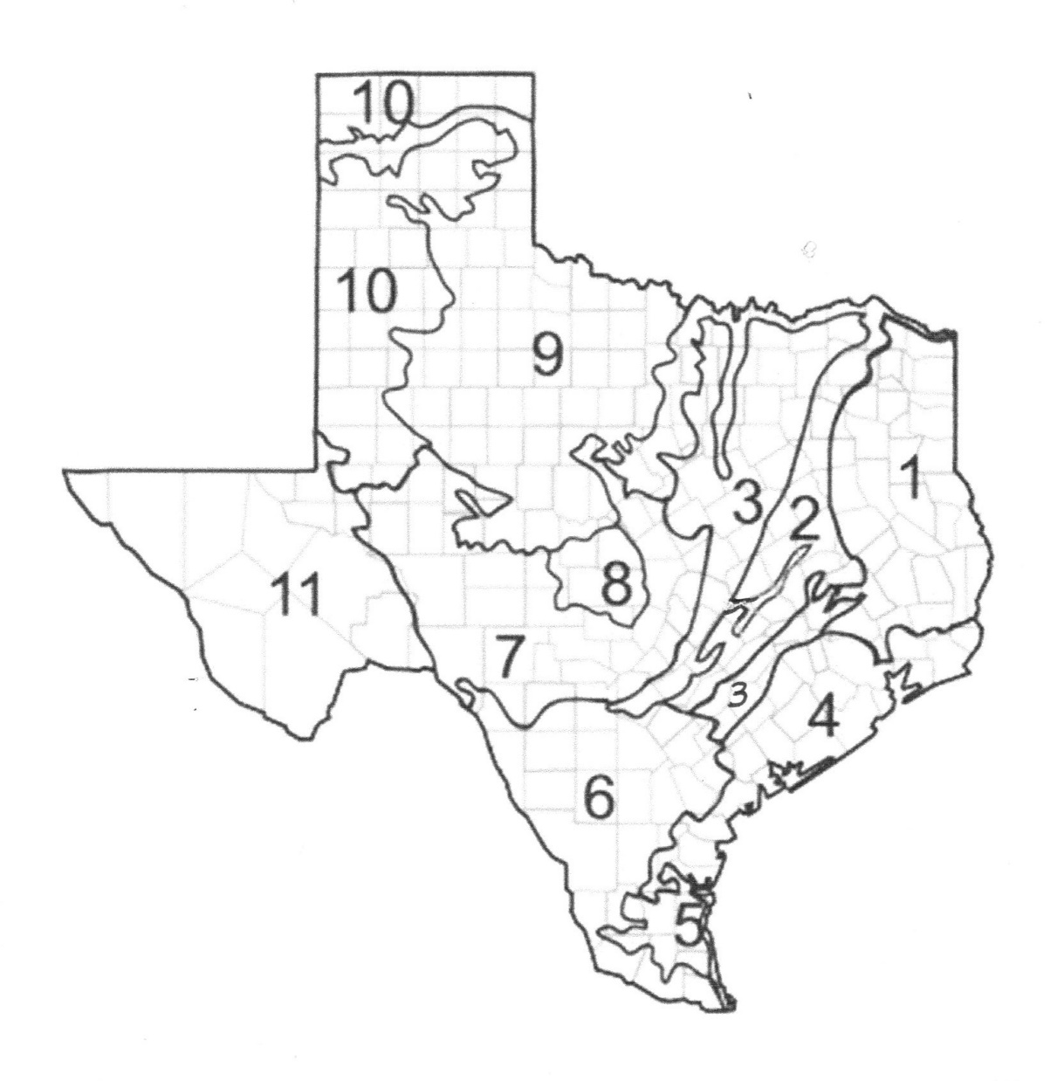

- Three ecoregions, Trans-Pecos, High Plains and Edwards Plateau come together in Midland County. Write a short description of one of them.

Additional Ecoregion References

Exploring Texas Ecoregions. This is Smith and Campbell’s elementary school curriculum on Ecoregions and contains some concise summaries of the eleven ecoregions.
https://tpwd.texas.gov/publications/pwdpubs/media/pwd_bk_w7000_0030.pdf

Gould Ecoregions of Texas
http://www.tpwd.state.tx.us/publications/pwdpubs/media/pwd_mp_e0100_1070ac_34.pdf

Texas Ecoregions: map is the same as in the TMN textbook
http://www.sbs.utexas.edu/bio373l/docs/Texas%20ecoregions/ecoregions_tx_color_map.pdf

Texas Ecoregions. Although this Texas Parks and Wildlife website and map uses Gould’s ten ecoregions, it has information and videos of some of our textbook’s eleven ecoregions. In Gould’s ecoregions, the Gulf Coast Prairies and Marshes includes the Coastal Sand Plains and the Oak Woods and Prairies is divided into the Post Oak Savannah and Cross Timbers
https://tpwd.texas.gov/education/hunter-education/online-course/wildlife-conservation/texas-ecoregions

