**DISCLAIMER**

Unit 5 Ecological Concepts is a very meaty and dense chapter with lots of information. You will re-visit many of the concepts and the language of the discipline that is introduced in this chapter so think of this as an introduction. I have included a glossary to make it easy to reference some of the words. When I think about ecological concepts, I try and keep in mind five simple rules:

1. The Sun is the primary source of energy for life on Earth.
2. The building blocks of life must be recycled,
3. All organisms are supported by energy and resources.
4. All organisms interact with their environment.
5. To survive, all organisms must fit how and where they live.

Glossary

**Levels of Organization**

**Abiotic** – not living

**Biotic** – living

**Organism** – a single living thing

**Population** – several organisms of the same species in the same place at the same time

**Community**- populations that live in the same place at the same time

**Ecosystem** – communities plus abiotic factors

**Energy Flow**

**Producer** – an organism which makes food

**Consumer** – an organism that eats another living organism

**Ecological Relationships**

**Resources** – things an organism needs to live: food, water and shelter

**Habitat** – where individuals of a species live: contains food, water, and shelter to meet the organism’s needs

**Niche** – the role of an organism in its community

**Population Dynamics**

**Carrying capacity** - valid and sustainable population numbers species in a given habitat

**Density dependent** – A factor whose effects on the size or growth of population vary with the population density

**Density independent** - A factor that affects the size of a population independent or regardless of the population density, i.e. abiotic factors

**Extrinsic** – control factors that involve an interaction with one or more species in the community, e.g. predation, parasitism, interspecific competition

**Intrinsic** – control factors that involve the population’s ability to respond and adjust to their own density. e.g. intraspecific competition, territoriality immigration, emigration

**Ecological Succession**

**Ecological succession** – the observed process of change in the species structure of an ecological community over time. The community begins with relatively few pioneering plants and animals and develops through increasing complexity until it becomes stable or self-perpetuating as a climax community.

**Primary succession** – In primary succession pioneer species as well as other abiotic factors like wind and water start to “normalize” the habitat.

**Secondary succession** – succession that occurs after the initial succession has been disrupted (e.g. fire) and some plants and animals still exist. It is usually faster than primary succession

**Biodiversity**

**Biodiversity –** variety of species, individuals (genetic material) and ecosystems

**Threatened –** number of a species are declining

**Endangered –** number of a speciesare dangerously low

**Extinct –** no more individuals of a species are left alive on Earth

**Ecosystem Services**: Services provided by ecosystems can be characterized as:

**Regulating** – such as climate control, water purification, flood control

**Supporting** – such as nutrient cycling, primary production, soil formation

**Provisioning** – products such as fiber, food, wood, medicine

**Cultural** – beauty, heritage, education, recreation, spiritual, inspiration

Llano Estacado Master Naturalist Curriculum Guide

Unit 5: Ecological Concepts

A chain is only as strong as its weakest link.

We are all connected.

Unit Goals: After completing this unit, volunteers should be able to:

* explain the ecological principles that apply to individual organisms, populations, communities, and ecosystems,
* explain the balances that exist between ecosystems and the factors necessary to keep ecosystems in balance,
* explain how different ecosystems are determined largely by different environmental factors,
* describe the hydrologic cycle, the nitrogen cycle, and the carbon cycle,
* explain succession and climax and list the factors responsible for each,
* illustrate a food web and explain the importance of trophic relationships,
* define biodiversity and understand the importance of managing for biodiversity,
* identify ecological factors relevant to a threatened species,
* understand the laws and the procedures necessary for protecting species.

1. **Levels of Organization**

Ecologists study how living things (organisms) interact with one another and the physical environment in which they live. So, they consider both the living, \_\_\_\_\_\_\_\_ factors and the\_\_\_\_\_\_\_\_\_\_\_, abiotic factors.

Ecologists think about and organize life on earth into a scheme of greater and more complex divisions from a cellular level through organisms to the biosphere. This helps to think about the interrelationships between biotic and abiotic factors and how life on earth is connected. A group of individuals of the same species form a population, groups of populations form a community, an ecosystem is a local community interacting with all the interrelated abiotic factors. A biome can be thought of as a collection of ecosystems in a regional area and the biosphere can be thought of as a collection of biomes.

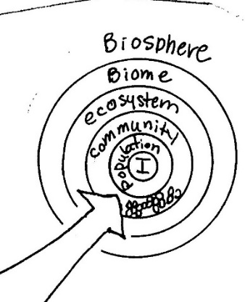

Color the levels that refer to biotic factors (just organisms) green and color the levels that refer to both biotic and abiotic factors orange.

1. **Energy Flow**

Within an ecosystem, ecologists are concerned with how energy is produced and used. We can organize organisms together by how they obtain\_\_\_\_\_\_\_, the stored form of energy. These groups are called trophic levels. The organisms in an ecosystem that capture energy, primarily the sun’s energy are called

\_\_\_\_\_\_\_\_\_\_\_\_\_\_\_. Organisms that get their energy from the bodies of other organisms are called consumers. Animals are \_\_\_\_\_\_\_\_\_\_\_\_\_\_since they cannot produce their own energy. Depending on what trophic level they are on they can be classified as primary, secondary, or even tertiary consumers. Herbivores, carnivores and omnivores also describe how that organism gets their energy for life. Detritivores or \_\_\_\_\_\_\_\_\_\_\_\_\_\_break down dead organisms for their energy and in doing so, they release the building blocks of life which are recycled in various biogeochemical cycles. A single sequence of producers, primary consumer, secondary consumer is called a food chain. The sum of many food chains is a\_\_\_\_\_\_\_ \_\_\_\_\_\_\_\_. The arrows in a food chain or a food web indicate the direction of energy flow.

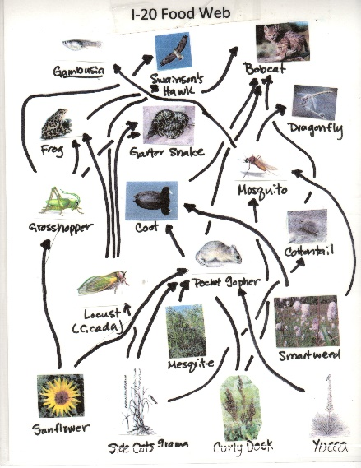

From this food web give an example of:

|  |  |
| --- | --- |
| Producer/Autotroph |  |
| 1o Consumer/Herbivore |  |
| 2o Consumer/1oCarnivore |  |
| 3o Consumer/ 2o Carnivore |  |

To help us understand ecosystems, we can model an ecosystem in terms of the number of organisms at each trophic level, the amount of biomass at each trophic level, or the amount of energy at each trophic level by using a bar to represent the relative size of the trophic level. An energy pyramid is a diagram of the energy flow from one trophic level to the next. This tells us how ecologically efficient a given ecosystem is. If the ecological efficiency is low, there may not be enough energy to support the top carnivores. Since all organisms must be supported by energy, we can see that if the amount of available energy at a producer level drops that will affect the amount of energy at the next trophic level and thus the number of higher order consumers that can be supported. A plant harnesses about 1% of the sun's energy that falls on its leaves. Each member of a trophic level in turn, passes on about 10% of the available energy to the next trophic level. The other 90% of the energy is lost through basic or animal metabolic processes (digestion, growth, movement) or is passed on to detritovores (\_\_\_\_\_\_\_\_\_\_\_\_\_\_\_) or released into the atmosphere as heat. By looking at the relative shape of these pyramids, we can understand why some highly productive ecosystems such as some ocean ecosystems can support a fourth or even higher order consumer.

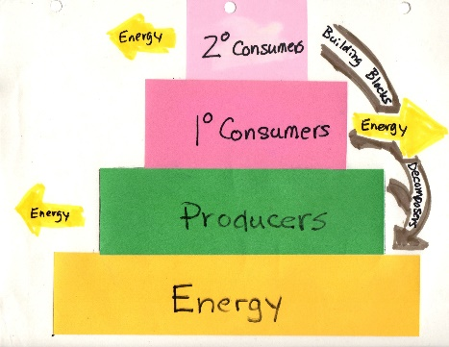

1. **Building Blocks of Life**

In addition to energy, all organisms need the building blocks of life of which the most important are the elements CHNOPS (Carbon, Hydrogen, Nitrogen, Oxygen, Phosphorus, and Sulfur) Although details of each cycle may vary these elements are continually cycled between biotic organisms and abiotic reservoirs in the environment. These reservoirs can include the soil, oceans, sediments, rocks and the atmosphere.

Carbon is the backbone of life on Earth. Plants use CO2 in photosynthesis to produce sugar and oxygen. Animals and plants release CO2 through respiration. CO2 is also released when stored organic matter like \_\_\_\_\_\_\_\_\_\_\_or \_\_\_\_\_\_\_\_\_ \_\_\_\_\_\_\_are burned. Changes in the carbon cycle impact each reservoir; excess carbon in the atmosphere warms the land and oceans; excess carbon in the ocean increases the ocean acidity. We are already experiencing the effects of global warming on our weather and the resulting climate change will impact food production, water resources, frequency and severity of storms, and plant and animal communities. Although strictly speaking the water is not an element, water is also assimilated by organisms and then release back into the reservoirs of the ocean, atmosphere and ground water. For more on cycles checkout some of the interactive sites in the references.

From your book, pg. 195: What group of organisms fix atmospheric nitrogen?

From pg. 198: Water from the \_\_\_\_\_\_\_\_\_\_\_\_\_\_ \_\_\_\_\_\_\_\_\_\_\_\_\_makes agriculture and life on the High Plains possible.

1. **Ecological Relationships**

Ecologists use ecological relationships between organisms to understand and explain the distribution of species. All organisms are supported by resources: food, water, and shelter, which an organism finds in its habitat. Habitats are commonly referred to by the dominant vegetation in a given area but can also include other physical factors. The amount of resources in a habitat limits the number of organisms of the same or different species that can be supported; individuals of the same species in the same habitat are in constant competition for the same resources. Ecologist use the term \_\_\_\_\_\_\_\_\_to help understand how different species can live in the same habitat. A niche can be thought of as the role an organism has in its environment. It describes all biotic and abiotic factors an organism needs to survive. We can describe a niche by listing all the attributes for that particular factor. These attributes might include where an organism lives, how it eats, what time of the day it is active, what special needs it has and how it reproduces. No two species can occupy the same niche; Gause’s competitive exclusion principle says that when two species do occupy the same niche, the species that uses the niche more efficiently will out compete the inefficient species which will eventually be eliminated. Species having very precise requirements for resources, are said to have a narrow niche; species that can exist under a wide range of conditions are said to be generalists and have a broad niche. Species with narrow niches are greatly affected by environmental change.

Swainson’s Hawks and Great Horned Owls are found out at the I-20 Wildlife Preserve. They share the same habitat and this chart describes some attributes of their niches, name one difference that allows them to share the same habitat.

|  |  |  |
| --- | --- | --- |
|  | Great Horned Owl  *Bubo virginianus* | Swainson’s Hawk  *Buteo swainsoni* |
| Size | About 23”  Silent flight | About 21”  Broad wings, short tail |
| Food | Mostly mammals (rabbits, skunks, rodents, birds, snakes | Small rodents, birds and insects |
| Nests | Typically, above ground in trees or ledge 20-60’ above ground | Tree or large shrub, 15-30’ of above ground |
| Habitat | Forests, woodlots, stream sides | Open prairie or plains, grasslands |
| Range | Throughout North America | primarily in western US |
| Behavior | Nocturnal | Diurnal |
| Watches form perch and swoops down | Circles on updrafts; will take insects in air or on ground |
| Solitary, does not migrate | Migrates in flocks |
| Status | Numbers holding up well | Numbers in decline |

Ecologists also use specialized terms to describe types of interactions between two species.

Circle the correct answer:  **T** or **F** All relationships benefit one species.

A \_\_\_\_\_\_\_\_\_\_ \_\_\_\_\_\_\_\_\_in an ecosystem “supports” other species in a specific ecosystem. Those other species may depend upon keystone species for different resources. For instance, in our short grass prairie ecosystems, prairie dogs provide food for predators such as coyotes, Black footed ferrets and hawks; shelter for other burrowing animals such as burrowing owls, black footed ferrets and snakes. Their burrows provide conduits for rain and their digging increases soil fertility.

1. **Population Dynamics**

Ecologists want to understand why and how the abundance of organisms, so they study how the population of a species change over time: \_\_\_\_\_\_\_\_\_\_\_ \_\_\_\_\_\_\_\_\_. \_\_\_\_\_\_\_\_\_, “birth rate”, \_\_\_\_\_\_\_\_\_\_ “death rate”, \_\_\_\_\_\_\_\_\_\_\_\_\_\_“movement in” and \_\_\_\_\_\_\_\_\_\_\_\_\_“movement out” all affect the number of individuals/area or\_\_\_\_\_\_\_\_\_\_\_\_ \_\_\_\_\_\_\_\_\_\_\_. \_\_\_\_\_\_\_\_\_\_\_\_ factors like the age of a population, sex ratio and how many young survive and \_\_\_\_\_\_\_\_\_\_\_factors, like disease or predation can affect the growth rate of a population. As population density grows, individuals start competing for resources. This competition can be \_\_\_\_\_\_ - specific, between individuals of the same species or inter- specific, \_\_\_\_\_\_\_\_\_\_\_individuals of other species. The \_\_\_\_\_\_\_\_\_\_\_ \_\_\_\_\_\_\_\_\_\_\_\_is the maximum population size that can be supported by the habitat. \_\_\_\_\_\_\_\_\_\_factors can be any biotic or abiotic factors that affects the number of resources in the habitat. They can be density-independent like a fire or they can be density-dependent, becoming more intense as the population increases. An example would be the amount of food for animal or the amount of light for a plant. We can manage for the quality of a habitat but any change we make might increase the carrying capacity for one species but \_\_\_\_\_\_\_\_\_\_\_it for another. Ecosystems are always changing, so that when populations reach a steady state, they fluctuate slightly above and below the carrying capacity.

1. **Ecological Succession**

\_\_\_\_\_\_\_\_\_\_\_\_\_\_is the progression of different community types at a particular place over time until a self-replacing \_\_\_\_\_\_\_community is reached. \_\_\_\_\_\_\_\_\_\_\_succession starts from scratch on bare ground to a final stable state; secondary succession begins where communities have experienced a \_\_\_\_\_\_\_\_\_\_\_\_ event such as fire. A climax community is typically a forest. Our short-grass prairie ecosystems have been managed historically by fire and grazing. Ward County (Monahans State Park) technically has one of the largest oak forests in the United States!

1. **Biodiversity**

Biodiversity can be thought of as the variety of species, genetics (individuals) and ecosystems. Generally, the greater the biodiversity means a healthier, more stable system and a system that is better equipped to withstand change. Monocultures such as our front lawns are inherently unstable and require inputs such as fertilizer or mowing to maintain. Humans are uniquely tied to biodiversity, this web of life. Biodiversity provides the ecosystem services on which our lives depend. We in turn can negatively impact biodiversity through the HIPPO factors or we can positively impact biodiversity by working to mitigate those negative factors. The choice is ours.

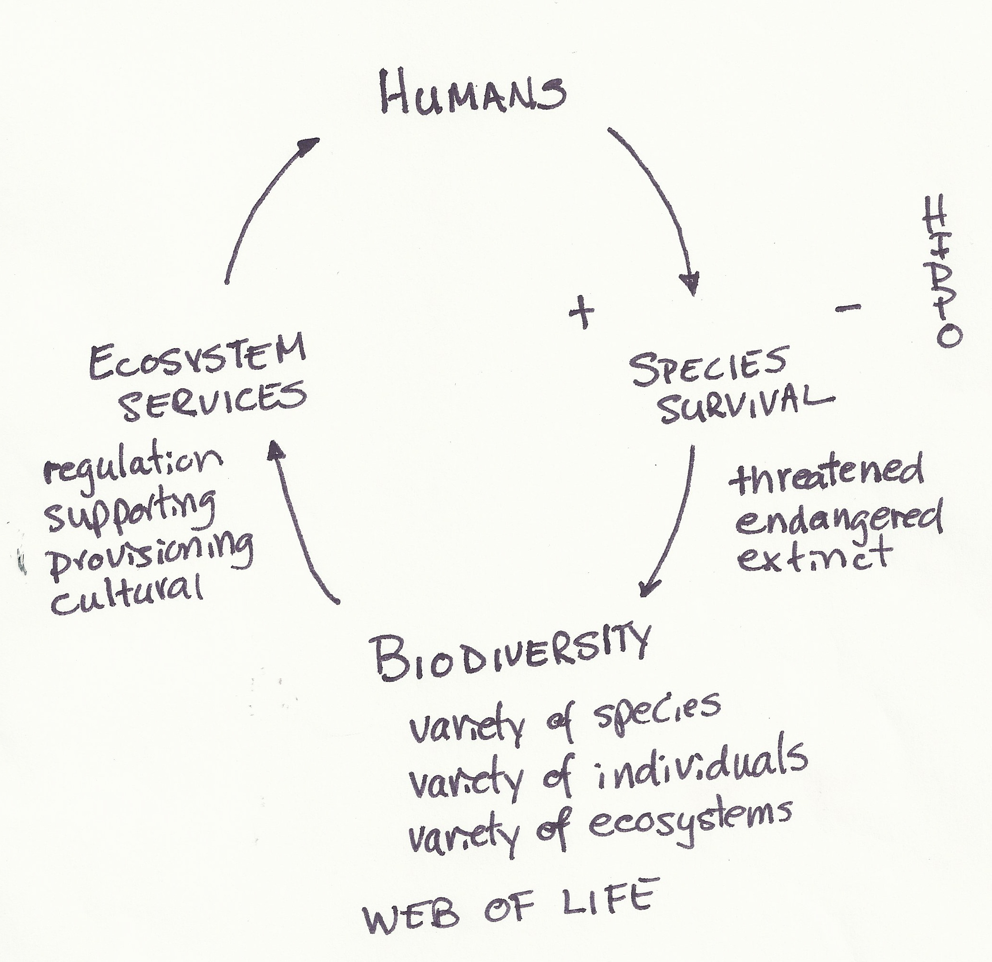

Services provided by ecosystems can be characterized as:

**Regulating:** such as climate control, water purification, flood control

**Supporting:** such as nutrient cycling, primary production, soil formation

**Provisioning:** products such as fiber, food, wood, medicine

**Cultural:** beauty, heritage, education, recreation, spiritual, inspiration

**Rare** – species needs special care

**Threatened –** number of a species are declining

**Endangered –** number of a speciesare dangerously low

**Extinct –** no more individuals of a species are left alive on Earth

**The HIPPO Factors**

|  |  |
| --- | --- |
| **Human Impacts** | **Example** |
| **Habitat loss** | * as habitat is lost, organisms that can’t adapt or move away die * organisms with a very narrow range of resources, a narrow niche, are most vulnerable. * ecosystems are weakened as they lose species * Texas example: black tailed prairie dog and Comanche Springs pupfish * local example: loss of shortgrass prairie |
| **Introduced species** | * also referred to as non-native, alien, or exotic species * can out compete a native species for resources * cause a decrease in native populations * Texas example: fire ant * local example: King Ranch bluestem |
| **Population** | * Earth’s population is 7.7 billion and growing * causes loss of resources, food water and shelter, which organisms also need * Texas example: expansion of major cities into rural land * local example: swift fox loss of habitat |
| **Pollution** | * chemical pollution affects organism health and reproduction * organism can get entangled or injured by physical trash * Texas example: sea turtles eating and getting entangle by plastic trash in Gulf * local example: American bumblebee use of herbicides and insecticides |
| **Overuse** | * individuals of a species are hunted or collected until their numbers are drastically reduced * threatened, endangered, extinct * Texas example: buffalo herds on the Llano Estacado * local: collection of Texas Horned lizard as pets |

Llano Estacado Master Naturalist Curriculum Guide **ANSWERS**

Unit 5: Ecological Concepts

A chain is only as strong as its weakest link.

We are all connected.

Unit Goals: After completing this unit, volunteers should be able to:

* explain the ecological principles that apply to individual organisms, populations, communities, and ecosystems,
* explain the balances that exist between ecosystems and the factors necessary to keep ecosystems in balance,
* explain how different ecosystems are determined largely by different environmental factors,
* describe the hydrologic cycle, the nitrogen cycle, and the carbon cycle,
* explain succession and climax and list the factors responsible for each,
* illustrate a food web and explain the importance of trophic relationships,
* define biodiversity and understand the importance of managing for biodiversity,
* identify ecological factors relevant to a threatened species,
* understand the laws and the procedures necessary for protecting species.

1. **Levels of Organization**

Ecologists study how living things (organisms) interact with one another and the physical environment in which they live. So, they consider both the living, biotic factors and the nonliving, abiotic factors.

Ecologists think about and organize life on earth into a scheme of greater and more complex divisions from a cellular level through organisms to the biosphere. This helps to think about the interrelationships between biotic and abiotic factors and how life on earth is connected. A group of individuals of the same species form a population, groups of populations form a community, an ecosystem is a local community interacting with all the interrelated abiotic factors. A biome can be thought of as a collection of ecosystems in a regional area and the biosphere can be thought of as a collection of biomes.



Color the levels that refer to biotic factors (just organisms) green and color the levels that refer to both biotic and abiotic factors orange.

1. **Energy Flow**

Within an ecosystem, ecologists are concerned with how energy is produced and used. We can organize organisms together by how they obtain food, the stored form of energy. These groups are called trophic levels. The organisms in an ecosystem that capture energy, primarily the sun’s energy are called producers. Organisms that get their energy from the bodies of other organisms are called consumers. Animals are consumers since they cannot produce their own energy. Depending on what trophic level they are on they can be classified as primary, secondary, or even tertiary consumers. Herbivores, carnivores and omnivores also describe how that organism gets their energy for life. Detritivores or decomposers break down dead organisms for their energy and in doing so, they release the building blocks of life which are recycled in various biogeochemical cycles. A single sequence of producers, primary consumer, secondary consumer is called a food chain. The sum of many food chains is a food web. The arrows in a food chain or a food web indicate the direction of energy flow.



From this food web give an example of:

|  |  |
| --- | --- |
| Producer/Autotroph | Sunflower |
| 1o Consumer/Herbivore | Grasshopper |
| 2o Consumer/1oCarnivore | Frog |
| 3o Consumer/ 2o Carnivore | Bobcat |

To help us understand ecosystems, we can model an ecosystem in terms of the number of organisms at each trophic level, the amount of biomass at each trophic level, or the amount of energy at each trophic level by using a bar to represent the relative size of the trophic level. An energy pyramid is a diagram of the energy flow from one trophic level to the next. This tells us how ecologically efficient a given ecosystem is. If the ecological efficiency is low, there may not be enough energy to support the top carnivores. Since all organisms must be supported by energy, we can see that if the amount of available energy at a producer level drops that will affect the amount of energy at the next trophic level and thus the number of higher order consumers that can be supported. A plant harnesses about 1% of the sun's energy that falls on its leaves. Each member of a trophic level in turn, passes on about 10% of the available energy to the next trophic level. The other 90% of the energy is lost through basic or animal metabolic processes (digestion, growth, movement) or is passed on to detritovores (decomposers) or released into the atmosphere as heat. By looking at the relative shape of these pyramids, we can understand why some highly productive ecosystems such as some ocean ecosystems can support a fourth or even higher order consumer.



1. **Building Blocks of Life**

In addition to energy, all organisms need the building blocks of life of which the most important are the elements CHNOPS (Carbon, Hydrogen, Nitrogen, Oxygen, Phosphorus, and Sulfur) Although details of each cycle may vary these elements are continually cycled between biotic organisms and abiotic reservoirs in the environment. These reservoirs can include the soil, oceans, sediments, rocks and the atmosphere.

Carbon is the backbone of life on Earth. Plants use CO2 in photosynthesis to produce sugar and oxygen. Animals and plants release CO2 through respiration. CO2 is also released when stored organic matter like wood or fossil fuels are burned. Changes in the carbon cycle impact each reservoir; excess carbon in the atmosphere warms the land and oceans; excess carbon in the ocean increases the ocean acidity. We are already experiencing the effects of global warming on our weather and the resulting climate change will impact food production, water resources, frequency and severity of storms, and plant and animal communities.

Although strictly speaking the water is not an element, water is also assimilated by organisms and then release back into the reservoirs of the ocean, atmosphere and ground water. For more on cycles checkout some of the interactive sites in the references.

From your book, pg. 195: What group of organisms fix atmospheric nitrogen? Bacteria

From pg. 198: Water from the Ogallala Aquifer makes agriculture and life on the High Plains possible.

1. **Ecological Relationships**

Ecologists use ecological relationships between organisms to understand and explain the distribution of species. All organisms are supported by resources: food, water, and shelter, which an organism finds in its habitat. Habitats are commonly referred to by the dominant vegetation in a given area but can also include other physical factors. The amount of resources in a habitat limits the number of organisms of the same or different species that can be supported; individuals of the same species in the same habitat are in constant competition for the same resources. Ecologist use the term niche to help understand how different species can live in the same habitat. A niche can be thought of as the role an organism has in its environment. It describes all biotic and abiotic factors an organism needs to survive. We can describe a niche by listing all the attributes for that particular factor. These attributes might include where an organism lives, how it eats, what time of the day it is active, what special needs it has and how it reproduces. No two species can occupy the same niche; Gause’s competitive exclusion principle says that when two species do occupy the same niche, the species that uses the niche more efficiently will out compete the inefficient species which will eventually be eliminated. Species having very precise requirements for resources, are said to have a narrow niche; species that can exist under a wide range of conditions are said to be generalists and have a broad niche. Species with narrow niches are greatly affected by environmental change.

Swainson’s Hawks and Great Horned Owls are found out at the I-20 Wildlife Preserve. They share the same habitat and this chart describes some attributes of their niches, name one difference that allows them to share the same habitat. Migrations, hunting time, some food types

|  |  |  |
| --- | --- | --- |
|  | Great Horned Owl  *Bubo virginianus* | Swainson’s Hawk  *Buteo swainsoni* |
| Size | About 23”  Silent flight | About 21”  Broad wings, short tail |
| Food | Mostly mammals (rabbits, skunks, rodents, birds, snakes | Small rodents, birds and insects |
| Nests | Typically, above ground in trees or ledge 20-60’ above ground | Tree or large shrub, 15-30’ of above ground |
| Habitat | Forests, woodlots, stream sides | Open prairie or plains, grasslands |
| Range | Throughout North America | primarily in western US |
| Behavior | Nocturnal | Diurnal |
| Watches form perch and swoops down | Circles on updrafts; will take insects in air or on ground |
| Solitary, does not migrate | Migrates in flocks |
| Status | Numbers holding up well | Numbers in decline |

Ecologists also use specialized terms to describe types of interactions between two species.

T or **F** All relationships benefit one species.

A keystone species in an ecosystem “supports” other species in a specific ecosystem. Those other species may depend upon keystone species for different resources. For instance, in our short grass prairie ecosystems, prairie dogs provide food for predators such as coyotes, Black footed ferrets and hawks; shelter for other burrowing animals such as burrowing owls, black footed ferrets and snakes. Their burrows provide conduits for rain and their digging increases soil fertility.

1. **Population Dynamics**

Ecologists want to understand why and how the abundance of organisms, so they study how the population of a species change over time: population dynamics. Natality, “birth rate”, mortality ‘death rate”, immigration “movement in” and emigration “movement out” all affect the number of individuals/area or population density. Intrinsic factors, like the age of a population, sex ratio and how many young survive and extrinsic factors, like disease, predation can affect the growth rate of a population. As population density grows, individuals start competing for resources. This competition can be intra- specific, between individuals of the same species or inter- specific, between individuals of other species. The carrying capacity is the maximum population size that can be supported by the habitat. Limiting factors can be any biotic or abiotic factor that affects the number of resources in the habitat. They can be density-independent like a fire or they can be density-dependent, becoming more intense as the population increases. An example would be the amount of food for animal or the amount of light for a plant. We can manage for the quality of a habitat but any change we make might increase the carrying capacity for one species but decrease it for another. Ecosystems are always changing, so that when populations reach a steady state, they fluctuate slightly above and below the carrying capacity.

1. **Ecological Succession**

Succession is the progression of different community types at a particular place over time until a self-replacing climax community is reached. Primary succession starts from scratch on bare ground to a final stable state; secondary succession begins where communities have experienced a damaging event such as fire. A climax community is typically a forest. Our short-grass prairie ecosystems have been managed historically by fire and grazing. Ward County (Monahans State Park) technically has one of the largest oak forests in the United States!

1. **Biodiversity**

Biodiversity can be thought of as the variety of species, genetics (individuals) and ecosystems. Generally, the greater the biodiversity means a healthier, more stable system and a system that is better equipped to withstand change. Monocultures such as our front lawns are inherently unstable and require inputs such as fertilizer or mowing to maintain. Humans are uniquely tied to biodiversity, this web of life. Biodiversity provides the ecosystem services on which our lives depend. We in turn can negatively impact biodiversity through the HIPPO factors or we can positively impact biodiversity by working to mitigate those negative factors. The choice is ours.



Services provided by ecosystems can be characterized as:

**Regulating:** such as climate control, water purification, flood control

**Supporting:** such as nutrient cycling, primary production, soil formation

**Provisioning:** products such as fiber, food, wood, medicine

**Cultural:** beauty, heritage, education, recreation, spiritual, inspiration

**Rare** – species needs special care

**Threatened –** number of a species are declining

**Endangered –** number of a speciesare dangerously low

**Extinct –** no more individuals of a species are left alive on Earth

**The HIPPO Factors**

|  |  |
| --- | --- |
| **Human Impacts** | **Example** |
| **Habitat loss** | * as habitat is lost, organisms that can’t adapt or move away die * organisms with a very narrow range of resources, a narrow niche, are most vulnerable. * ecosystems are weakened as they lose species * Texas example: black tailed prairie dog and Comanche Springs pupfish * local example: loss of shortgrass prairie |
| **Introduced species** | * also referred to as non-native, alien, or exotic species * can out compete a native species for resources * cause a decrease in native populations * Texas example: fire ant * local example: King Ranch bluestem |
| **Population** | * Earth’s population is 7.7 billion and growing * causes loss of resources, food water and shelter, which organisms also need * Texas example: expansion of major cities into rural land * local example: swift fox loss of habitat |
| **Pollution** | * chemical pollution affects organism health and reproduction * organism can get entangled or injured by physical trash * Texas example: sea turtles eating and getting entangle by plastic trash in Gulf * local example: American bumblebee use of herbicides and insecticides |
| **Overuse** | * individuals of a species are hunted or collected until their numbers are drastically reduced * threatened, endangered, extinct * Texas example: buffalo herds on the Llano Estacado * local: collection of Texas Horned lizard as pets |

Additional References

Cox, M. accessed 2020. In Quercus Veritas. <http://www.texasescapes.com/MikeCoxTexasTales/In-Quercus-Veritas.htm>

Ecological Society of America. 2020. What is Ecology? <https://www.esa.org/about/what-does-ecology-have-to-do-with-me/>

For Turtles Exploring Science and technology. 2020. The flow of energy through plants and animals. <http://www.ftexploring.com/me/me2.html>

Khan Academy. 2020. What is Ecology? <https://www.khanacademy.org/science/biology/ecology/intro-to-ecology/a/what-is-ecology>

\_\_\_\_\_\_\_\_\_\_\_\_\_\_\_\_. 2020. Trophic levels review. <https://www.khanacademy.org/science/high-school-biology/hs-ecology/trophic-levels/a/hs-trophic-levels-review>

\_\_\_\_\_\_\_\_\_\_\_\_\_\_\_\_\_\_.2020. the carbon cycle. <https://www.khanacademy.org/science/biology/ecology/biogeochemical-cycles/a/the-carbon-cycle>

National Center for Ecological Analysis and Synthesis. 2020. Learn about ecology. <http://kids.nceas.ucsb.edu/ecology/ecoindex.html> If you have young people in your life this has ideas to share.

Nickell, M. 2016. Keystone species. <https://sibleynaturecenter.org/photo-essays/keystone-species>

Riebeek, H. 2011. The carbon cycle. NASA Earth Observatory. <https://earthobservatory.nasa.gov/features/CarbonCycle>

Texas Invasive Species Institute. 2020. <http://www.tsusinvasives.org/home/>

Texas Parks and Wildlife Department, Wildlife Division, Diversity and Habitat Assessment Programs. 2020. TPWD County Lists of Protected Species and Species of Greatest Conservation Need. <https://tpwd.texas.gov/gis/rtest/>

The Nature Education Knowledge Project. 2020. Ecology. <https://www.nature.com/scitable/knowledge/ecology-102/>

USGS. 2020. The Water Cycle for schools and kids. [https://www.usgs.gov/special-topic/water-science-school/science/water-cycle-schools-and-kids?qt-science\_center\_objects=0#qt-science\_center\_objects](https://www.usgs.gov/special-topic/water-science-school/science/water-cycle-schools-and-kids?qt-science_center_objects=0" \l "qt-science_center_objects)

Checkout the water cycle for beginner, intermediate and advanced students.



